Table of Contents
PureExpress Delta Ribosome Kit Protocol 3
Nano-Glo® Luciferase Assay Protocol 5
Figure. Plate map for in vitro assay. 5
Table. Samples used in in vitro assay. 5
Figure. Wells marked for assay in 96-well plate. 6
Figures. In vitro assay readings at gain settings of 135, 150, 100, and 135. 8
Figure. Relative luminescence values of dilution samples 1-10 for the first plate reading (Gain 135). 8
Overnight Cultures 8
Pelleting LVS Cells for Ribosome Purification 9
Hemoglobin 2% Solution 10
Notes on Kasugamycin Test with in vitro Assay 10
Calculations for in vitro assay with Kasugamycin 11
PureExpress Delta Ribosome Kit Protocol 12
Cloning Project for pKR187 13
Supplemented Brain Heart Infusion Broth with Cysteine (sBHIc) 13
Receiving Primers Protocol for KROL622 & KROL623 14
Nano-Glo® Luciferase Assay Protocol 14
Figures. In vitro assay readings with gain setting of 100 at approx. T=0, 5, and 10 min. 16
Figure. In vitro assay reading with gain setting of 135 with filter set to 460/40. 16
Figure. Chart of relative luminescence values for first plate read. 17
PCR (20 uL Reaction) 17
PCR Gel 19
Figure 1. 20 uL PCR Gel with Products 1 and 2 for pKR187 20
PCR (20 uL Reaction) 20
Supplementing BHI media 22
PCR Gel 23
Figure. 20 uL PCR Gel with Products 1 and 2 for pKR187 23
Measuring LVS Growth Curves in MHB and BHI Media 24
Table. Initial OD600 values of LVS cultures in MHB and BHI media. 24
Table. OD600 values of LVS cultures in MHB and BHI media after 2 hours. 25
Preparation of Ribosomes 25
NanoDrop of Purified Ribosomes 25
Measuring LVS Growth Curves in MHB and BHI Media 26
Table. Initial OD600 values of LVS cultures in MHB and BHI media. 26
Table. OD600 values of LVS cultures in MHB and BHI media after 2 hours. 26
Table. OD600 values of LVS cultures in MHB and BHI media after 4 hours. 27
Table. OD600 values of LVS cultures in MHB and BHI media after 6 hours. 27
Table. OD600 values of LVS cultures in MHB and BHI media after 8 hours. 27
PCR (100 uL Reaction) 28
Measuring LVS Growth Curves in MHB and BHI Media (continued) 30
Table. OD600 values of LVS cultures in MHB and BHI media after 23 hours. 30
PCR Purification and Dilution of PCR Products 1 and 2 30
PCR (100 uL Reaction)(Overlap Extension PCR) 30
PCR Purification of Overlap Extended PCR Product 32
PCR Gel 33
Figure. 20 uL PCR Gel for pKR187 34
PureExpress Delta Ribosome Kit Protocol 34
PCR Gel 36
Figure. 20 uL PCR Gel for pKR187 36
Restriction Digest 3 37
Figures. Restriction digest gel for pKR187, before and after cutting out bands. 38
QIAquick Gel Extraction Kit 39
Table. Nanodrop readings of the pKR187 insert and backbone. 40
Ligation 40
Transforming Chemically Competent E. coli (pKR187 Ligation) 41
Preparing Electrocompetent LVS 42
Miniprep of pKR187 44
Table. Nanodrop concentrations for pKR187 samples. 44
Figure. Sequencing submission form for pKR187 samples. 45
Measuring LVS Growth Curves in MHB and BHI Media 45
Bibliography 46

Friday, September 1, 2023

To Do:
- Nanodrop phenol-chloroform extracted plasmids
- Run in vitro assay for luminescence standard curve
- Aliquot 0.1x EB
- Make CHAH plates
Results and Data:
Took Nanodrop readings for phenol-chloroform extracted plasmids.
Sample ID | ng/µl | A260 (Abs)
PCE_pKR204 | 294.1 | 5.883
PCE_pKR205 | 413.8 | 8.276
PCE_pKR206 | 566.5 | 11.33
PCE_pKR207 | 433.3 | 8.666
PCE_pKR208 | 1104.9 | 22.098
PCE_pKR208 | 1127.8 | 22.556

I discarded the following extra 100 uM primer stocks from the -20C freezer: KROL350 (10/09/20), KROL628 (03/25/23), KROL672 (06/17/23), and KROL673 (06/17/23).
I made CHAH and CHAH-Kan plates.
Next week, I will transfer the phenol-chloroform extraction waste from the 50 mL conical to a glass bottle, label it accordingly, and use this glass bottle in the future for extractions.

PureExpress Delta Ribosome Kit Protocol
- Set up PCR reaction tubes.
Tube | DNA | Ribosomes
1 | Phenol:chloroform purified pKR208 | PURExpress
2 | Phenol:chloroform purified pKR208 | PURExpress
3 | Phenol:chloroform purified pKR208 | Nuclease-free water
- Thaw all components on ice. Pulse-spin in microfuge to collect solutions to bottom of tubes. If Solution A has precipitates, mix well prior to assembling reaction. Do not vortex Solution B.
  - Solution A
  - Phenol-chloroform purified pKR208
  - Kit ribosomes
- Dilute DNA in 0.1xEB to a concentration of 125 ng/uL.
Sample | Concentration (C1) | Desired Conc. (C2) | Desired Volume (V2) | Sample Volume (V1) | Buffer Volume
Phenol:chloroform purified pKR208 | 1127.8 ng/uL | 125 ng/uL | 20 uL | 2.22 uL | 17.78 uL
- Add components in the following order:
Solution A 10 uL
Factor Mix 3 uL
Ribosomes 4.5 uL
Template DNA 2 uL (250 ng template DNA per 25 μl reaction)
Water 10.5 uL

Total 30 uL
- Mix gently and pulse-spin in microfuge to collect mixture at the bottom of the tube
- Incubate at 37C for 2-4 hours in thermocycler (incubator is preferred to water bath). I incubated for 2 hours, 15 minutes in the thermocycler.
- Stop the reaction by placing tubes on ice.
- Freeze at -20C.
Monday, September 4, 2023

To Do:
- Patch out plate of LVS
Results and Data:
I patched out a plate of KRLVS 120 from freezer aliquots onto CHAH and put it in the 37C incubator.
Tuesday, September 5, 2023

To Do:
- Run in vitro assay for luminescence standard curve
- Aliquot 0.1x EB
- Make 2 L MHB and supplement
- Inoculate overnight LVS cultures in MHB
Results and Data:

Nano-Glo® Luciferase Assay Protocol
- Prepare plate map and list samples and controls
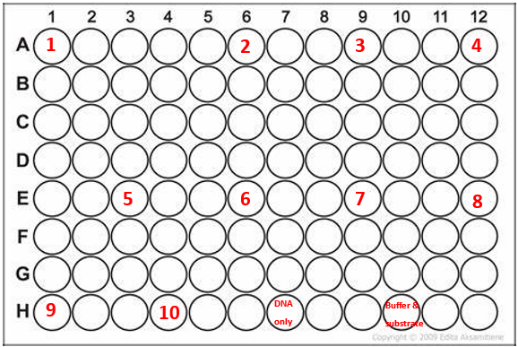

Figure. Plate map for in vitro assay.

Table. Samples used in in vitro assay.
Sample ID | Well | Dilution Factor | Notes
1 | A1 | 1.000
2 | A6 | 0.500
3 | A9 | 0.250
4 | A12 | 0.125
5 | E3 | 0.063
6 | E6 | 0.031
7 | E9 | 0.016
8 | E12 | 0.008
9 | H1 | 0.004
10 | H4 | 0.002
DNA only | H7 |  | DNA only control
Buffer and substrate | H10 |  | Buffer and substrate control
- Thaw Nano-Glo® Luciferase Assay Buffer and Nano-Glo® Luciferase Assay Substrate on ice – mix by pipetting
- Prepare appropriate volume of reconstituted reagent by combining one volume of substrate with 50 volumes of buffer – mix by pipetting
  - Example: for 250 uL of reagent mix 250 uL of buffer with 5 uL of substrate (I mixed 200 uL buffer with 4 uL substrate.)
- I thawed the in vitro assay reactions on ice.
- I marked the wells in the plate that will be used for the assay (see below).
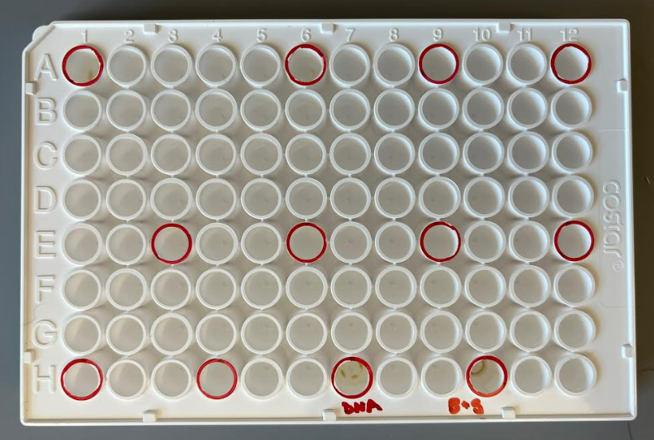

Figure. Wells marked for assay in 96-well plate.
- I brought the 96-well plate, an aliquot of H10M10A50 buffer, the reconstituted reagent, and the reactions 1-3 on ice as well as a 200 uL pipettor and tips (should have also brought the flash drive) to the Matthew Ramsey lab.
- I turned on the plate reader and waited for it to initialize.
- Matthew helped me set up a protocol for the experiment which we entitled, “KMR23_luminescence.” This protocol turns off temperature control, starts with 5 seconds of orbital shaking, and reads luminescence without a filter (using the “Hole” setting) with a gain of 135. We set the integration time to 1 second, and Matthew said that 1-2 seconds is best for this setting.
- I created a new experiment based on this protocol entitled, “230905_BM_luminescence” (originally entitled “230509_BM_luminescence” by mistake).
- Added 60 uL buffer to wells 2-10 and 30 uL buffer to “buffer and substrate” well.
- Added 30 uL reaction volumes from reactions 1-3 to wells 1 and 2 and “DNA only” well.
- Added 30 uL substrate to wells 1 and 2 and to the wells for “DNA only” and for “buffer and substrate.”
- Set timer for 3 minutes
  - Pipetted 60 uL from well 2 to well 3, then 60 uL from well 3 to well 4, and so on. Removed 60 uL from well 10 after final transfer.
- Read the plate on the appropriate settings. (I read the plate at the following gain settings: 135, 150, 100, and 135 again. It took approximately 2 minutes, 15 seconds to read the plate and an additional minute to change the settings, so if the first read was at time 0, then the second read was at approximately time 3:15, the third at time 6:30, and the last at time 9:45.)
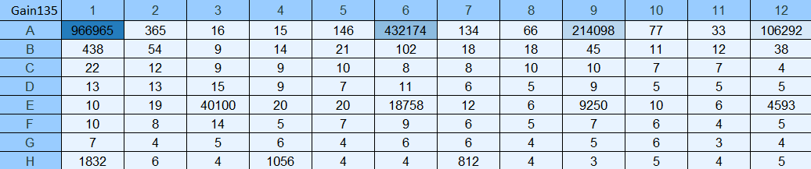
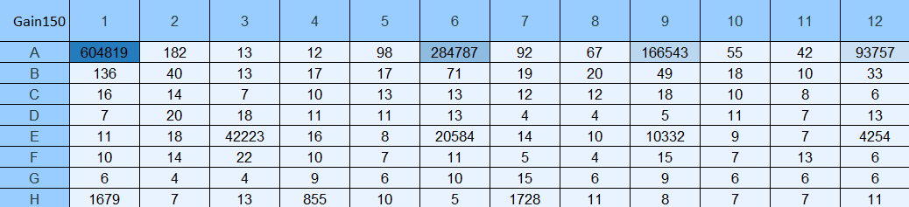
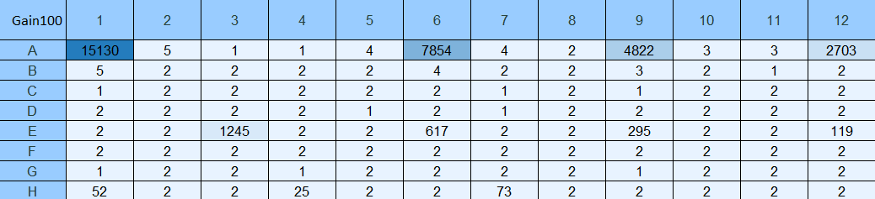
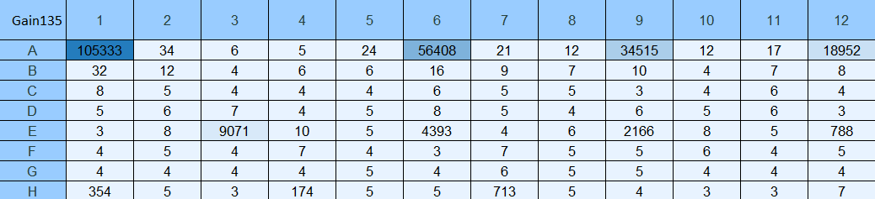

Figures. In vitro assay readings at gain settings of 135, 150, 100, and 135.
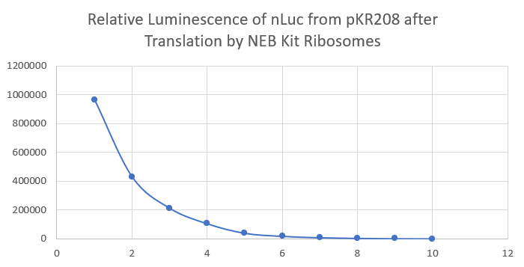

Figure. Relative luminescence values of dilution samples 1-10 for the first plate reading (Gain 135).
I aliquoted 0.1xEB from the 50 mL conical to 12x1.5 mL microcentrifuge tubes.
I made 2 L of MHB.
Wednesday, September 6, 2023

To Do:
- Supplement MHB
- Inoculate overnight LVS cultures in MHB
- Make hemoglobin
- Wash dishes and label with purple tape
- Coordinate with Steve for French press
- Update luminescence charts
Results and Data:
The ultracentrifuge tubes we use are Product #355618. The Dutta lab has a 50.2 Ti rotor.

I supplemented 4x500 mL MHB with 10 mL IsoVitalex, 5 mL 2.5% iron pyrophosphate, and 5 mL 10% glucose. When I got to flasks 1c and 1d, I wasn’t sure which one I had supplemented with IsoVitalex. I thought I had supplemented 1d, so I supplemented 1c, but I may have supplemented 1c twice and 1d not at all.

Overnight Cultures
- Labeled a sterile microfuge tube and added 1 mL supplemented MHB (sMHB) aseptically.
- Scraped up loopfuls of cells from the plate and added to microfuge tube.
- Resuspended cells to homogeneity using a pipette.
- Prepared cuvettes to check OD 600 by labeling one per sample and adding 900 uL sMHB.
- Added 100 uL resuspended cells to appropriate cuvettes.
- Checked OD 600. Calculated OD 600 of resuspended cells (10x observed OD 600), and recorded both observed and calculated OD:
  - LVS pF: 1.311 observed OD, 13.11 calculated OD
- Calculated volume of resuspended cells necessary to obtain a final OD 600 of 0.003 in 500 mL.
  - LVS pF: (0.003 OD 600 )*(500,000ul)/(13.11 OD 600 ) = 114.4 uL
- To appropriately labeled 500 mL flasks from prep of supplemented MHB above, added volume of resuspended cells calculated to obtain final OD 600 of 0.003.
- Incubated flasks at 37°C shaking overnight, starting incubation at 6:22 PM.

Thursday, September 7, 2023

To Do:
- Pellet LVS cultures
- Make hemoglobin
- Make iron pyrophosphate
- Make sucrose cushion buffers
- Coordinate with Steve for French press
- Update luminescence charts
- Run in vitro assay with Kasugamycin
Results and Data:

Pelleting LVS Cells for Ribosome Purification
- Checked OD600 of flasks at 9:30 AM and found them to be the following:
Sample | OD600
1a | 0.243
1b | 0.281
1c | 0.222
1d | 0.245

- This seems to be the perfect time to capture the cultures at just the right OD. There is a range from 0.22 to 0.28 with two of them being almost exactly between 0.2 and 0.3. I calculated the time between starting incubation and reading ODs to be 15 hours and 8 minutes. This means that I could start the cultures at 6 PM and take them out at 9 AM or start them at 5:30 PM and take them out at 8:30 AM.
- *Take a 1 mL sample for whole cell proteins. Add equal amounts OD of 1x SLB (i.e. 0.3 OD, add 0.3 mL 1x SLB). Store sample at -20C.* (I forgot to do this step.)
- I poured the cultures into 250 mL bottles and put the bottles in the -20C freezer at 9:40 AM. At 9:50 AM, I transferred the bottles to a bin with ice.
- I harvested the cells by centrifuging with ThermoScientific Multifuge X Pro Series centrifuge (F14-6x250 LE rotor) at 4C for 5 mins at 11,300xg. I spun four bottles at a time, starting the first spin at 10:08 AM and the second spin at 10:18 AM.
- Resuspended the cell pellet in 30 ml H10M10A50 and pelleted the cells in a 50 mL screw-cap tube with ThermoScientific Multifuge X Pro Series centrifuge (F13-14x50cy rotor) at 4C for 15 mins at 7,720xg, starting the spin at 11:08 AM.
- Took the mass of the cell pellet and found it to be 1.84g. This is just over the mass of the last E. coli pellet (1.70g) which was made from 1 L of culture and less than the mass of the last LVS pellet (2.07g) which was grown to an OD of ~0.33 from 1.5 L of culture, so the mass of LVS grown to an OD of 0.2-0.3 might be about half that of MRE600 grown to an OD of 0.6-0.8, and additionally, LVS grown to a higher OD will have a greater cell density.
- Froze the cell pellet at -80C.

Hemoglobin 2% Solution
Add 6g freeze-dried hemoglobin to a 500 mL flask along with a large stir bar.
Add 300mL of ddiH₂O (type I).
Place the flask on a stir plate and stir for a few minutes to dissolve the hemoglobin.
Add aluminum foil and autoclave tape to the top of the flask.
Autoclave on a 20-minute liquid cycle with water in the bin.
Cool down (ideally to ~55C – can be in water bath set to 56C) and store in 4C fridge.

I made 2.5% Iron pyrophosphate (1.25g iron pyrophosphate in 50mL of ddiH₂O (type 1), dissolved overnight, fresh solution every 2 weeks (filter-sterilized).

Notes on Kasugamycin Test with in vitro Assay
Question: Can Kasugamycin inhibit translation in vitro?
Read paper on this topic.
Toeprinting assay (incubate ribosomes w/mRNA – stalled initiation, primer with reverse transcriptase, stalls, Ksg inhibits ribosome activity in this assay)
Use kit ribosomes, your ribosomes, and three different concentrations of Ksg (1mM, 50uM, and 5uM), and see if you get a dose-dependent inhibition of translation.
Add drug to in vitro assay along with Solution A, Factor Mix, ribosomes, and template DNA. This will ensure that the drug interacts with the ribosomes before translation begins.
Research questions:
- How does bS21 affect the ribosome structure?
- How does the antibiotic affect the ribosome structure?
- How does the antibiotic affect the ribosome when different homologs of bS21 are bound?
Kasugamycin binds near bS21.

Calculations for in vitro assay with Kasugamycin
The molar mass for Kasugamycin (Ksg) is 379.366 g/mol.
To find molarity of our Ksg stock, which is at a concentration of 50 mg/mL, I use the following conversions:

1 mol | 1 g | 50 mg | 1000 mL
379.366 g | 1000 mg | 1 mL | 1 L

and get a value of 0.132 M or 132 mM.

The three concentrations of Ksg that I want to use in the assay are 1 mM, 50 uM (0.05 mM), and 5 uM (0.005 mM). If I want to add 1 uL of Ksg stock to each 30 uL in vitro assay reaction, then I need to make three different Ksg stocks with appropriate concentrations. If I use the equation C1V1=C2V2, and I set V1 as 1 uL, then I can find the appropriate concentrations for each stock, which would be C1. C2 would be one of the three desired concentrations (1 mM, 0.05 mM, and 0.005 mM) and V2 would be the reaction volume (30 uL).

C1V1=C2V2  C1(1 uL) = (1 mM)(30 uL)  C1 = (1 mM)(30 uL)/(1 uL)  C1 = 30 mM | C1V1=C2V2  C1(1 uL) = (0.05 mM)(30 uL)  C1 = (0.05 mM)(30 uL)/(1 uL)  C1 = 1.5 mM | C1V1=C2V2  C1(1 uL) = (0.005 mM)(30 uL)  C1 = (0.005 mM)(30 uL)/(1 uL)  C1 = 0.15 mM

To prepare the three diluted stocks, I will start from the 132 mM Ksg stock and dilute with water. If I use C1V1=C2V2 again, substituting either 5 uL or 1 uL for V1, which will be the volume I take from the original stock, I can find the final volume I will need to prepare for the diluted stocks, which will be V2. C1 will be 132 mM, and C2 will be one of the three desired concentrations (30 mM, 1.5 mM, and 0.15 mM).

C1V1=C2V2  (132 mM)(5 uL) = (30 mM)V2  V2 = (132 mM)(5 uL)/(30 mM)  V2 = 22 uL  22 uL – 5 uL Ksg = 17 uL water | C1V1=C2V2  (132 mM)(5 uL) = (1.5 mM)V2  V2 = (132 mM)(5 uL)/(1.5 mM)  V2 = 440 uL  440 uL – 5 uL Ksg = 435 uL water | C1V1=C2V2  (132 mM)(1 uL) = (0.15 mM)V2  V2 = (132 mM)(1 uL)/(0.15 mM)  V2 = 880 uL  880 uL – 1 uL Ksg = 879 uL water

Stock 1 will be 5 uL Ksg + 17 uL water.
Stock 2 will be 5 uL Ksg + 435 uL water.
Stock 3 will be 1 uL Ksg + 879 uL water.

Monday, September 11, 2023

To Do:
- Make sucrose cushion buffers
- Coordinate with Steve for French press
- Run in vitro assay with Kasugamycin
Results and Data:
Helped Jake Grecco set up his lab notebook and bench space, and we talked about scheduling and projects. We set up Google Drive and a Notion page and discussed media prep and cloning.

I made stocks 1, 2, and 3 of Kasugamycin from previous entry (9/7/23).

PureExpress Delta Ribosome Kit Protocol
- Set up PCR reaction tubes.
Tube | DNA | Ribosomes | Purpose
1 | Phenol:chloroform purified pKR208 | PURExpress | 1mM Ksg
2 | Phenol:chloroform purified pKR208 | PURExpress | 50uM Ksg
3 | Phenol:chloroform purified pKR208 | PURExpress | 5uM Ksg
4 | Phenol:chloroform purified pKR208 | PURExpress | no abx
5 | Phenol:chloroform purified pKR208 | Nuclease-free water | control
- Thaw all components on ice. Pulse-spin in microfuge to collect solutions to bottom of tubes. If Solution A has precipitates, mix well prior to assembling reaction. Do not vortex Solution B.
  - Solution A
  - Factor Mix
  - Phenol-chloroform purified pKR208
  - Kit ribosomes
- Dilute DNA in 0.1xEB to a concentration of 125 ng/uL.
Sample | Concentration (C1) | Desired Conc. (C2) | Desired Volume (V2) | Sample Volume (V1) | Buffer Volume
Phenol:chloroform purified pKR208 | 1127.8 ng/uL | 125 ng/uL | 20 uL | 2.22 uL | 17.78 uL
- Add components in the following order:
Solution A | 10 uL
Factor Mix | 3 uL
Ribosomes | 4.5 uL
Template DNA | 2 uL
Kasugamycin | 1 uL
Water | 9.5 uL
Total | 30 uL

Tube | Solution A | Factor Mix | Ribosomes | DNA (125 ng/uL) | Kasugamycin | Water
1 | 10 uL | 3 uL | 4.5 uL PURExpress | 2 uL Phenol:chloroform purified pKR208 | 1 uL 30 mM Ksg stock | 9.5 uL
2 | 10 uL | 3 uL | 4.5 uL PURExpress | 2 uL Phenol:chloroform purified pKR208 | 1 uL 1.5 mM Ksg stock | 9.5 uL
3 | 10 uL | 3 uL | 4.5 uL PURExpress | 2 uL Phenol:chloroform purified pKR208 | 1 uL 0.15 mM Ksg stock | 9.5 uL
4 | 10 uL | 3 uL | 4.5 uL PURExpress | 2 uL Phenol:chloroform purified pKR208 | 0 uL | 9.5 uL
5 | 10 uL | 3 uL | 4.5 uL Nuclease-free water | 2 uL Phenol:chloroform purified pKR208 | 0 uL | 9.5 uL

- Mix gently and pulse-spin in microfuge to collect mixture at the bottom of the tube
- Incubate at 37C for 2-4 hours in thermocycler (incubator is preferred to water bath) (incubated for 2 hours, 10 minutes)
- Stop the reaction by placing tubes on ice.
- Freeze at -20C.

Cloning Project for pKR187
Went over cloning project for pKR187. We have 100 uM primer stocks in the fridge for KROL622 and KROL 623, so we will need to reconstitute these and make 10 uM stock primers. Then, we can start the PCR reaction.
Notes from the plasmid database: “Overlap extension products from pKR152: P1- KROL622 and KROL326; P2- KROL623 and KROL550; Overlap PCR- KROL326 and KROL550, KpnI/NotI digested.”
Tuesday, September 12, 2023

To Do:
- Make BHI media
- Reconstitute KROL622 and KROL623 and make working stocks
- Make sucrose cushion buffers
- Coordinate with Steve for French press
- Run in vitro assay with Kasugamycin
Results and Data:

Supplemented Brain Heart Infusion Broth with Cysteine (sBHIc)
For 500 mL:
- Combine in a 1 L bottle:
  - 18.5 g BHI
  - .5 g L-cysteine hydrochloride
  - If preparing sBHIc with 5% KCl, add 25 g KCl (and be sure to label the bottle!)
- Add 480 mL type I ddiH₂0, shake to mix
- Autoclave 30’, let cool
- Store media in the dark for up to 1 month prior to adding supplements

Receiving Primers Protocol for KROL622 & KROL623
By: Hannah Trautmann
- Spin primers at maximum speed in tabletop centrifuge for 3 minutes so desiccated primers go to the bottom of the tube.
- Add 0.1x EB to a final concentration of 100 uM. Calculate this by multiplying the reported nm by 10 and adding that volume in ul (i.e. 12.7 nmoles = add 127 uL of 0.1xEB).
- Put on 42°C heat block for 5 minutes to help primers dissolve
- Vortex and brief spin.
- Label tubes with KROL numbers on the top and put in the appropriate 100 uM stock box in the -20°C freezer.
- If a PCR primer, make a 10 uM stock by diluting 20 uL of the 100 uM stock into 180 uL of 0.1xEB. Label with purple sticker and put in appropriate freezer box.
- Put Certificate of Analysis sheet in “Oligos Spec Sheet” binder and shipping sheet in Invoices box.

Nano-Glo® Luciferase Assay Protocol
- Prepare plate map and list samples and controls
 | 1 | 2 | 3 | 4 | 5 | 6 | 7 | 8 | 9 | 10 | 11 | 12
A | 1. 1 mM Ksg |  |  |  |  | 2. 50 uM Ksg |  |  |  |  | 3. 5 uM Ksg
B
C
D
E | 4. No abx |  |  |  |  | 5. Water + substrate |  |  |  |  | 6. 5 uM Ksg?
F
G
H |  |  |  | H10M10A50 Buffer + substrate |  |  |  |  | H10M10A50 Buffer
- Thaw reactions on ice
- Thaw Nano-Glo® Luciferase Assay Buffer and Nano-Glo® Luciferase Assay Substrate on ice – mix by pipetting
- Prepare appropriate volume of reconstituted reagent by combining one volume of substrate with 50 volumes of buffer – mix by pipetting
  - For 280 uL of reagent mix 280 uL of buffer with 5.6 uL of substrate
- Bring 96-well plate, an aliquot of H10M10A50 buffer, the reconstituted reagent, a small waste beaker, and the reactions on ice as well as a 200 uL pipettor and tips to the plate reader
- Add reactions to designated wells
- Turn on the plate reader and wait for it to initialize
- Select appropriate protocol
- Add equal volume of assay substrate to reaction volume (30 uL) – mix by pipetting
- Set timer for 3 minutes
- Read the plate on the appropriate settings
Note: Ensure luminescence values remain within the linear range of 10^3 and 10^8
- Read again after 5 minutes and after 10 minutes
- Read again with filter set to 460/40
- Export data as Excel file and save to flash drive
For some reason, the brightest signal came from the well with 1 mM Kasugamycin (A1 - the highest concentration – 1 mM Ksg) and the faintest signal (among the reaction wells) came from the well with no Kasugamycin (E1 - the lowest concentration – 0 mM Ksg). This is the opposite of what I would expect, since Kasugamycin should inhibit translation. I also saw that overall signal decreased over time. The approximate times for the plate reads were 00:45 after starting the first read (the first read was interrupted initially by a message that the gain was too high, so I turned it down from 135 to 100), 05:10, and 10:08.
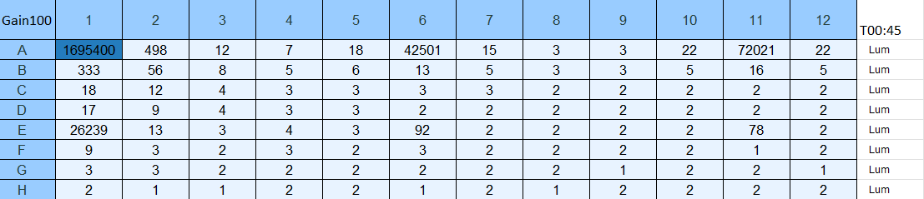
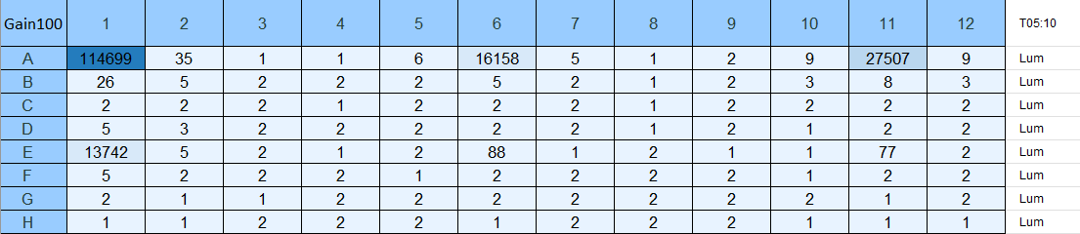
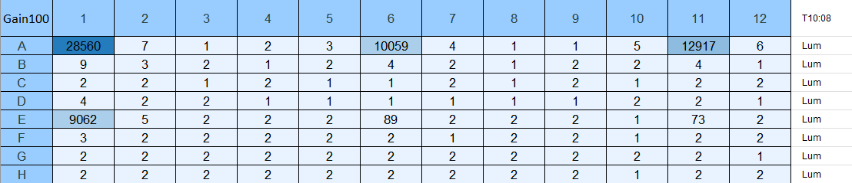

Figures. In vitro assay readings with gain setting of 100 at approx. T=0, 5, and 10 min.

I tried reading the plate with the filter set to 460 nm +/-40 nm, because the emission wavelength of nLuc is 460 nm. I wanted to see there was any contribution to total luminescence by anything else in the reaction wells, and if capturing only the light emitted from nLuc would result in a more reasonable distribution of luminescence values for the different concentrations of Kasugamycin, but this was not the case. I will have to run this assay again. This final read was conducted approximately 14:25 after beginning reads for the assay.

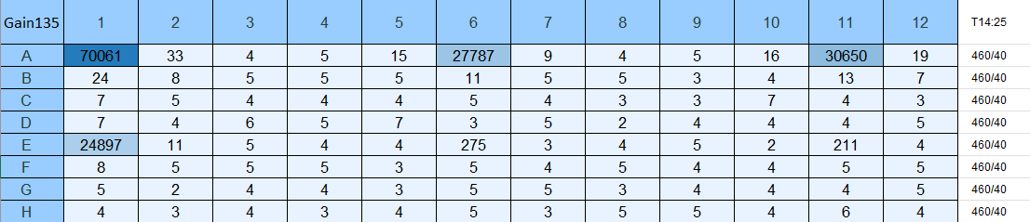

Figure. In vitro assay reading with gain setting of 135 with filter set to 460/40.

Figure. Chart of relative luminescence values for first plate read.

Here, it is shown that the luminescence values generally increased for higher concentrations of Kasugamycin. The exception is that between reaction wells 2 and 3, the luminescence values decreased for higher values of Kasugamycin.

Wednesday, September 13, 2023

To Do:
- Supplement BHI media
- Set up test PCR and run gel
- Make sucrose cushion buffers
- Make agarose gel
Results and Data:

PCR (20 uL Reaction)
- Set up table below to specify which primers and source DNA will be used. Be sure to include at least 1 positive and 1 negative control for each PCR experiment.
Reaction Number | Plasmid/Region | Source DNA | Primers | Length (bps)
1 | pKR152 | same | KROL622,  KROL326 | 212
2 | pKR152 | same | KROL623,  KROL550 | 103
3 | + control | LVS gDNA | KROL15, KROL16 | 441
4 | - control | - | KROL622,  KROL326 | -
5 | - control | - | KROL623,  KROL550 | -

- Use PCR_worksheet.xlsx to make establish the specifics of what will be added.
- For reaction 1, the concentrated stock of pKR205 was used.
- For reactions 1-3, the pipette was set to 4 uL instead of 0.4 uL when adding plasmid/gDNA/water.
- For reaction number 4, the 100 ng/uL stock of pKR205 was used and the proper volume of plasmid was used (0.4 uL).
Master Mix
- 74.4 uL diH2O
- 24 uL buffer
- 9.6 uL dNTPs
- 2.4 uL Primestar Polymerase
Individual Reactions Volumes
- 0.6 uL forward primer
- 0.6 uL reverse primer
- 0.4 uL template
- 18.4 uL MM
- Acquire and label PCR tubes.
- Get a container of ice to keep the components on.
- Acquire the following components and put them on ice. If any of the solutions are frozen, be sure to vortex the microfuge tube in order to dissolve it (tubes with frozen components may not be homogenized). Centrifuge the microfuge tubes to get any solution out of the microfuge tube cover. DO NOT vortex the enzyme itself or any solution with enzyme because vortexing will expose it to oxygen and degrade it.
  - Molecular grade H2O in 1.5 mL microfuge tube
  - KOD/primestar buffer
  - dNTPs
  - oligo F (10uM)
  - oligo R (10uM)
  - template (eg. LVS gDNA, plasmid, colony, etc.)
  - KOD/primestar enzyme: kept in the freezer until it is used as it is expensive and should be added last
- Prepare a master-mix in a 1.5 mL microfuge tube by adding the following according to the worksheet and using micropipettes:
  - Add ddiH2O
  - Add dNTPs
  - Add KOD buffer
  - Add KOD enzyme
- Mix the master-mix solution by pipetting up and down. Do not vortex to mix.
- Add appropriate volume of master mix to each PCR tube.
- Add appropriate volume of each experiment specific primer (forward and reverse) to PCR tubes.
- Add appropriate volume of template (or ddiH2O to negative controls) to PCR tubes.
- Close PCR tubes until the caps are tight.
- Pulse spin gently in picofuge microcentrifuge.
- Place the PCR Tubes in the thermocycler on STN 1 – the following settings should be in place:
  - Heat at 94 degrees for 2 minutes
  - 94 degrees C for 20 seconds
  - 50 degrees C for 30 seconds
  - 68 degrees C for 1 minute/kb (adjust based on expected size of product - 30s in this case)
  - Go back to step 2
  - Repeat 32x
  - 68 degrees C for 5 minutes
  - 12 degrees C for infinity

H¹⁰M¹⁰A⁵⁰
10 mM Hepes KOH pH7.6 6 ml 1M Hepes KOH pH 7.6
10 mM MgCl₂ 6 ml 1M MgCl₂
50 mM NH₄Cl 6 ml 5M NH₄Cl
H₂O to 600 mL
600 ml
H¹⁰M¹⁰A⁵⁰⁰ + 20 % sucrose
10 mM Hepes KOH pH7.6 1 ml 1M Hepes KOH pH 7.6 300 uL 1 M HEPES
10 mM MgCl₂ 1 ml 1M MgCl₂ 300 uL 1M MgCl₂
500 mM NH₄Cl 10 ml 5M NH₄Cl 3 ml 5M NH₄Cl
Sucrose 20 g 6 g
H₂O to 100 ml H₂O to 30 ml
100 ml 30 ml
H¹⁰M¹⁰A⁵⁰ + 40 % sucrose
10 mM Hepes KOH pH7.6 2 ml 1M Hepes KOH pH 7.6 400 uL 1M HEPES
10 mM MgCl₂ 2 ml 1M MgCl₂ 400 uL 1M MgCl₂
50 mM NH₄Cl 2 ml 5M NH₄Cl 400 uL 5M NH₄Cl
Sucrose 80 g 16 g
H₂O to 200 ml H₂O to 40 ml
200 ml 40 ml

PCR Gel
- Melt 1% agarose gel at 300C and let cool in water bath to 50-55C.
- Put the gel cast into the gel rig sideways.
- Add 50 mL of 1% agarose gel into a flask with 5 uL SYBR safe solution, swirl the flask to mix, and then pour into the gel rig.
- Insert a comb to mold wells in the gel.
- Let sit until the 1% agarose – 1x SYBR safe solution has cooled and solidified into a gel.
- Carefully remove the comb.
- Pour 100 ml of 1x TAE buffer solution into the gel tank (add just enough to submerge the gel itself slightly).
- Add 4 uL 6x loading dye to 20 uL PCR solutions.
- Load 10 µL of 2x log ladder into the first well.
- Load 15 µL of the PCR-dye mixture into the wells sequentially.
- Insert the electrodes and run the gel at 113 volts for 30 minutes.
- Look at the gel with the GelDoc and image in Image Lab.
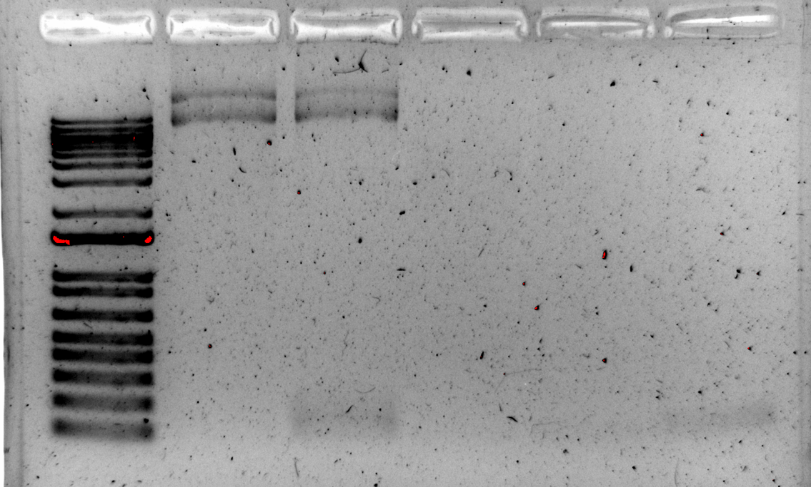

Figure 1. 20 uL PCR Gel with Products 1 and 2 for pKR187

Next time, I will dilute the plasmid 1:100. We will rerun this PCR tomorrow to see if we get clearer results.

Thursday, September 14, 2023

To Do:
- Supplement BHI media
- Set up test PCR and run gel
- Make sucrose cushion buffers
- Make agarose gel
Results and Data:

PCR (20 uL Reaction)
- Set up table below to specify which primers and source DNA will be used. Be sure to include at least 1 positive and 1 negative control for each PCR experiment.
Reaction Number | Plasmid/Region | Source DNA | Primers | Length (bps)
1 | pKR152 | same | KROL622,  KROL326 | 212
2 | pKR152 | same | KROL623,  KROL550 | 103
3 | + control | pKR152 | KROL550,  KROL326 | 290
4 | - control | - | KROL550,  KROL326 | -

- Use PCR_worksheet.xlsx to make establish the specifics of what will be added.
Total reaction volume | 20
Total number of reactions | 4
 |  |  |  | Factor
Component | Stock concentration | Final concentration | 1 rxn volume | 5
ddiH2O |  |  | 12.4 | 62
PrimeSTAR GXL Buffer | 5x | 1x | 4.0 | 20
dNTPs | 2.5 mM | 0.2 mM | 1.6 | 8
oligo F | 10 uM | 0.3 uM | 0.6 | indiv
oligo R | 10 uM | 0.3 uM | 0.6 | indiv
template | 100 ng/ul | 2 ng/ul | 0.4 | indiv
PrimeSTAR GXL DNA Polymerase | 1.25 U/ul | 0.025 U/ul | 0.4 | 2
 |  | Total volume | 20 | 98

- Acquire and label PCR tubes.
- Get a container of ice to keep the components on.
- Acquire the following components and put them on ice. If any of the solutions are frozen, be sure to vortex the microfuge tube in order to dissolve it (tubes with frozen components may not be homogenized). Centrifuge the microfuge tubes to get any solution out of the microfuge tube cover. DO NOT vortex the enzyme itself or any solution with enzyme because vortexing will expose it to oxygen and degrade it.
  - Molecular grade H2O in 1.5 mL microfuge tube
  - KOD/primestar buffer
  - dNTPs
  - oligo F (10uM)
  - oligo R (10uM)
  - template (eg. LVS gDNA, plasmid, colony, etc.)
  - KOD/primestar enzyme: kept in the freezer until it is used as it is expensive and should be added last
- Prepare a master-mix in a 1.5 mL microfuge tube by adding the following according to the worksheet and using micropipettes:
  - Add ddiH2O
  - Add dNTPs
  - Add KOD buffer
  - Add KOD enzyme
- Mix the master-mix solution by pipetting up and down. Do not vortex to mix.
- Add appropriate volume of master mix to each PCR tube.
- Add appropriate volume of each experiment specific primer (forward and reverse) to PCR tubes.
- Add appropriate volume of template (or ddiH2O to negative controls) to PCR tubes.
- Close PCR tubes until the caps are tight.
- Pulse spin gently in picofuge microcentrifuge.
- Place the PCR Tubes in the thermocycler on STN 1 – the following settings should be in place:
  - Heat at 94 degrees for 2 minutes
  - 94 degrees C for 20 seconds
  - 50 degrees C for 30 seconds
  - 68 degrees C for 1 minute/kb (adjust based on expected size of product - 30s in this case)
  - Go back to step 2
  - Repeat 32x
  - 68 degrees C for 5 minutes
  - 12 degrees C for infinity

Supplementing BHI media
- If aliquots of supplements are already made, thaw at room temperature (keeping heme-histidine away from light)
- Aseptically add:
  - 5 mL 1 mg/mL β-NAD
  - 5 mL 1 mg/mL heme-histidine
  - 12.5 mL 20% glucose
- Use media within 2 weeks

H¹⁰M¹⁰A⁵⁰
10 mM Hepes KOH pH7.6 6 ml 1M Hepes KOH pH 7.6
10 mM MgCl₂ 6 ml 1M MgCl₂
50 mM NH₄Cl 6 ml 5M NH₄Cl
H₂O to 600 mL
600 ml
H¹⁰M¹⁰A⁵⁰⁰ + 20 % sucrose
10 mM Hepes KOH pH7.6 1 ml 1M Hepes KOH pH 7.6 300 uL 1 M HEPES
10 mM MgCl₂ 1 ml 1M MgCl₂ 300 uL 1M MgCl₂
500 mM NH₄Cl 10 ml 5M NH₄Cl 3 ml 5M NH₄Cl
Sucrose 20 g 6 g
H₂O to 100 ml H₂O to 30 ml
100 ml 30 ml
H¹⁰M¹⁰A⁵⁰ + 40 % sucrose
10 mM Hepes KOH pH7.6 2 ml 1M Hepes KOH pH 7.6 400 uL 1M HEPES
10 mM MgCl₂ 2 ml 1M MgCl₂ 400 uL 1M MgCl₂
50 mM NH₄Cl 2 ml 5M NH₄Cl 400 uL 5M NH₄Cl
Sucrose 80 g 16 g
H₂O to 200 ml H₂O to 40 ml
200 ml 40 ml

PCR Gel
- Melt 1% agarose gel at 300C and let cool in water bath to 50-55C.
- Put the gel cast into the gel rig sideways.
- Add 50 mL of 1% agarose gel into a flask with 5 uL SYBR safe solution, swirl the flask to mix, and then pour into the gel rig.
- Insert a comb to mold wells in the gel.
- Let sit until the 1% agarose – 1x SYBR safe solution has cooled and solidified into a gel.
- Carefully remove the comb.
- Pour 100 ml of 1x TAE buffer solution into the gel tank (add just enough to submerge the gel itself slightly).
- Add 4 uL 6x loading dye to 20 uL PCR solutions.
- Load 10 µL of 2x log ladder into the first well.
- Load 15 µL of the PCR-dye mixture into the wells sequentially.
- Insert the electrodes and run the gel at 113 volts for 30 minutes (ran for 34 minutes).
- Look at the gel with the GelDoc and image in Image Lab.
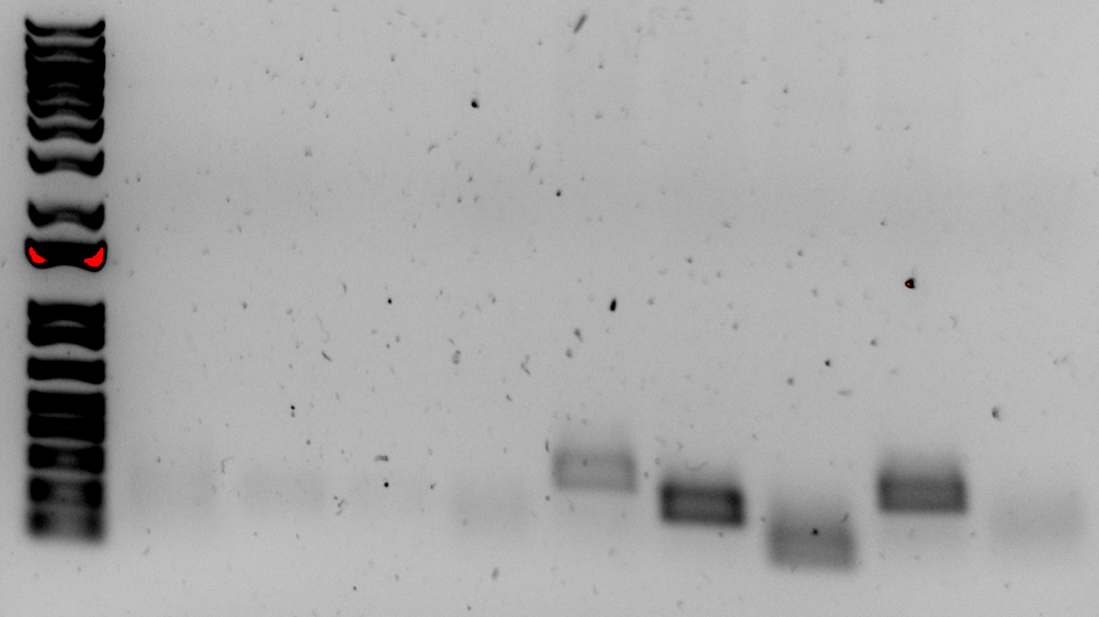

Figure. 20 uL PCR Gel with Products 1 and 2 for pKR187

L 1 2 2 3 4 1 2 3 4

Friday, September 15, 2023

To Do:
- Supplement BHI media
- Set up test PCR and run gel
- Make sucrose cushion buffers
- Make agarose gel
Results and Data:

Measuring LVS Growth Curves in MHB and BHI Media

- On 9/14/23, a freezer aliquot of LVS (KRLVS120) was patched onto a plate of CHAH and placed in the 37C incubator.
- Today, 700 uL supplemented MHB (sMHB) was added to a sterile microfuge tube aseptically.
- Loopfuls of cells were scraped up from the plate and added to the microfuge tube.
- The cells were resuspended to homogeneity using a pipette.
- A cuvette was prepared to check OD 600 by adding 900 uL sMHB, and 100 uL resuspended cells was added to the cuvette.
- The OD 600 was measured. The OD 600 of resuspended cells was calculated by multiplying the observed OD 600 by ten, and both the observed and calculated ODs were recorded:
  - LVS pF: 0.689 observed OD, 6.89 calculated OD
- The volume of resuspended cells necessary to obtain a final OD 600 of 0.008 (this value should have been 0.08) in 9 mL was calculated.
  - LVS pF: (0.008 OD 600 )*(9,000ul)/(6.89 OD 600 ) = 10.45 uL (this volume should have been 104.5 uL)
- 9 mL of supplemented MHB media was added to three culture tubes, and 9 mL of supplemented BHI media was added to three other culture tubes.
- The volume of resuspended cells necessary to obtain a final OD 600 of 0.008 (should have been 0.08) from step 7 was used to inoculate each of the six culture tubes.
- The culture tubes were vortexed, and 1 mL was removed from each to measure the OD:

Table. Initial OD600 values of LVS cultures in MHB and BHI media.
Sample ID | OD600
MHB 1 | 0.013
MHB 2 | 0.010
MHB 3 | 0.010
BHI 1 | -0.018
BHI 2 | -0.007
BHI 3 | -0.003

- The culture tubes were incubated at 37°C shaking, starting incubation at 10:10 AM.
- The culture tubes were removed at 12:11 AM, and the ODs were checked by adding 0.5 mL from each culture tube to a cuvette along with 0.5 mL of fresh media (MHB or BHI) and measuring in the spectrophotometer:

Table. OD600 values of LVS cultures in MHB and BHI media after 2 hours.
Sample ID | Measured OD600 | Calculated OD600
MHB 1 | 0.051 | 0.102
MHB 2 | 0.005 | 0.010
MHB 3 | 0.004 | 0.008
BHI 1 | -0.009 | negative value
BHI 2 | -0.008 | negative value
BHI 3 | -0.002 | negative value
Since the initial calculations for inoculation were incorrect, we chose to repeat this experiment again at a later date. It is unclear why the OD600 values for the BHI media were negative. Maybe the OD600 were so close to zero that the machine had trouble reading the values, or maybe, because the cells used to inoculate the cultures had been suspended in MHB media, which is lighter, the BHI media was diluted slightly.

Preparation of Ribosomes
Microfuge the suspension for 5 minutes at max speed and keep the supernatant.
Layer 1 ml of ribosomes onto 15 ml H¹⁰M¹⁰A⁵⁰ + 40 % sucrose. Centrifuge in a 70 Ti rotor at 30,000 rpm, 14 hours, 4 °C.

Saturday, September 16, 2023

To Do:
- Resuspend ribosome pellets and freeze ribosomes
- Make CHAH plates
Results and Data:

NanoDrop of Purified Ribosomes
Take the A260 of a 1:200 dilution of ribosomes (in water). Multiply the resulting A260 by 200, then divide by 14.5 to give you the concentration in microgram per microliter. Take that number and divide by 2.7, and that will give you the concentration in pmol per microliter.

Sample | A260 | ug/uL | pmol/uL
LVS_1 | 0.12 | 1.655 | 0.613
LVS_2 | 0.487 | 6.717 | 2.488
MRE600 | 1.431 | 19.738 | 7.310

The yield we obtained for the second LVS sample was high enough to use for an in vitro assay. The first LVS sample was low, so I will need to optimize wash steps to minimize loss of ribosomes since it seems like the pellet should have been large enough to yield a concentration similar to that of the second sample.

Monday, September 18, 2023

To Do:
- Measure LVS growth curves
- Test PCR and gel
- 100 uL PCR
- Obtain Nanodrop concentrations of purified ribosomes
Results and Data:

Measuring LVS Growth Curves in MHB and BHI Media

- On 9/16/23, a freezer aliquot of LVS (KRLVS120) was patched onto a plate of CHAH and the plate was placed on the benchtop at room temperature.
- Today, 700 uL supplemented MHB (sMHB) was added to a sterile microfuge tube aseptically.
- Loopfuls of cells were scraped up from the plate and added to the microfuge tube.
- The cells were resuspended to homogeneity using a pipette.
- A cuvette was prepared to check OD 600 by adding 900 uL sMHB, and 100 uL resuspended cells was added to the cuvette.
- The OD 600 was measured. The OD 600 of resuspended cells was calculated by multiplying the observed OD 600 by ten, and both the observed and calculated ODs were recorded:
  - LVS pF: 0.855 observed OD, 8.55 calculated OD
- The volume of resuspended cells necessary to obtain a final OD 600 of 0.08 in 9 mL was calculated.
  - LVS pF: (0.08 OD 600 )*(9,000ul)/(8.55 OD 600 ) = 84.2 uL
- 9 mL of supplemented MHB media was added to three culture tubes, and 9 mL of supplemented BHI media was added to three other culture tubes.
- The volume of resuspended cells (84.2 uL) necessary to obtain a final OD 600 of 0.08 from step 7 was used to inoculate each of the six culture tubes.
- The culture tubes were vortexed, and 1 mL was removed from each to measure the OD:

Table. Initial OD600 values of LVS cultures in MHB and BHI media.
Sample ID | OD600
MHB 1 | 0.079
MHB 2 | 0.081
MHB 3 | 0.078
BHI 1 | 0.082
BHI 2 | 0.089
BHI 3 | 0.081

- The culture tubes were incubated at 37°C shaking, starting incubation at 10 AM.
- The culture tubes were removed and the ODs were checked at 12:20 PM by adding 0.5 mL from each culture tube to a cuvette along with 0.5 mL of fresh media (MHB or BHI) and reading in the spectrophotometer. The measured OD600 values were multiplied by two to obtain the calculated OD600 values.

Table. OD600 values of LVS cultures in MHB and BHI media after 2 hours.
Sample ID | Measured OD600 | Calculated OD600
MHB 1 | 0.096 | 0.192
MHB 2 | 0.096 | 0.192
MHB 3 | 0.096 | 0.192
BHI 1 | 0.105 | 0.210
BHI 2 | 0.108 | 0.216
BHI 3 | 0.114 | 0.228

- The culture tubes were removed and the ODs were checked at 2:20 PM by adding 0.5 mL from each culture tube to a cuvette along with 0.5 mL of fresh media (MHB or BHI) and reading in the spectrophotometer. The measured OD600 values were multiplied by two to obtain the calculated OD600 values.

Table. OD600 values of LVS cultures in MHB and BHI media after 4 hours.
Sample ID | Measured OD600 | Calculated OD600
MHB 1 | 0.160 | 0.320
MHB 2 | 0.175 | 0.350
MHB 3 | 0.160 | 0.320
BHI 1 | 0.231 | 0.462
BHI 2 | 0.224 | 0.448
BHI 3 | 0.222 | 0.444

- The culture tubes were removed and the ODs were checked at 4:20 PM by adding 0.5 mL from each culture tube to a cuvette along with 0.5 mL of fresh media (MHB or BHI) and reading in the spectrophotometer. The measured OD600 values were multiplied by two to obtain the calculated OD600 values.

Table. OD600 values of LVS cultures in MHB and BHI media after 6 hours.
Sample ID | Measured OD600 | Calculated OD600
MHB 1 | 0.249 | 0.498
MHB 2 | 0.257 | 0.514
MHB 3 | 0.246 | 0.492
BHI 1 | 0.419 | 0.838
BHI 2 | 0.418 | 0.836
BHI 3 | 0.415 | 0.830

- The culture tubes were removed and the ODs were checked at 5:50 PM by adding 0.2 mL from each culture tube to a cuvette along with 0.8 mL of fresh media (MHB or BHI) and reading in the spectrophotometer. The measured OD600 values were multiplied by five to obtain the calculated OD600 values.

Table. OD600 values of LVS cultures in MHB and BHI media after 8 hours.
Sample ID | Measured OD600 | Calculated OD600
MHB 1 | 0.148 | 0.740
MHB 2 | 0.143 | 0.715
MHB 3 | 0.134 | 0.670
BHI 1 | 0.268 | 1.340
BHI 2 | 0.270 | 1.350
BHI 3 | 0.277 | 1.385

PCR (100 uL Reaction)
- Set up table below to specify which primers and source DNA will be used. Be sure to include at least 1 positive and 1 negative control for each PCR experiment.
Reaction Number | Plasmid/Region | Source DNA | Primers | Length (bps)
1 | pKR152 | same | KROL622,  KROL326 | 212
2 | pKR152 | same | KROL623,  KROL550 | 103
3 | + control | pKR152 | KROL550,  KROL326 | 290
4 | - control | - | KROL550,  KROL326 | -

- Use PCR_worksheet.xlsx to make establish the specifics of what will be added.
Total reaction volume | 100
Total number of reactions | 4
 |  |  |  | Factor
Component | Stock concentration | Final concentration | 1 rxn volume | 5
ddiH2O |  |  | 62.0 | 310
PrimeSTAR GXL Buffer | 5x | 1x | 20.0 | 100
dNTPs | 2.5 mM | 0.2 mM | 8.0 | 40
oligo F | 10 uM | 0.3 uM | 3.0 | indiv
oligo R | 10 uM | 0.3 uM | 3.0 | indiv
template | 100 ng/ul | 2 ng/ul | 2.0 | indiv
PrimeSTAR GXL DNA Polymerase | 1.25 U/ul | 0.025 U/ul | 2.0 | 10
 |  | Total volume | 100 | 490
- Acquire and label PCR tubes.
- Get a container of ice to keep the components on.
- Acquire the following components and put them on ice. If any of the solutions are frozen, be sure to vortex the microfuge tube in order to dissolve it (tubes with frozen components may not be homogenized). Centrifuge the microfuge tubes to get any solution out of the microfuge tube cover. DO NOT vortex the enzyme itself or any solution with enzyme because vortexing will expose it to oxygen and degrade it.
  - Molecular grade H2O in 1.5 mL microfuge tube
  - KOD/primestar buffer
  - dNTPs
  - oligo F (10uM)
  - oligo R (10uM)
  - template (eg. LVS gDNA, plasmid, colony, etc.)
  - KOD/primestar enzyme: kept in the freezer until it is used as it is expensive and should be added last
- Prepare a master-mix in a 1.5 mL microfuge tube by adding the following according to the worksheet and using micropipettes:
  - Add ddiH2O
  - Add dNTPs
  - Add KOD buffer
  - Add KOD enzyme
- Mix the master-mix solution by pipetting up and down. Do not vortex to mix.
- Add appropriate volume of master mix to each PCR tube.
- Add appropriate volume of each experiment specific primer (forward and reverse) to PCR tubes.
- Add appropriate volume of template (or ddiH2O to negative controls) to PCR tubes.
- Close PCR tubes until the caps are tight.
- Pulse spin gently in picofuge microcentrifuge.
- Place the PCR Tubes in the thermocycler on STN 1 – the following settings should be in place:
  - Heat at 94 degrees for 2 minutes
  - 94 degrees C for 20 seconds
  - 50 degrees C for 30 seconds
  - 68 degrees C for 1 minute/kb (adjust based on expected size of product - 25s in this case)
  - Go back to step 2
  - Repeat 32x
  - 68 degrees C for 5 minutes
  - 12 degrees C for infinity

Tuesday, September 19, 2023

To Do:
- Continue measuring LVS growth curves
- PCR purification of products 1 and 2
- Dilute PCR products 1:10
- 100 uL overlap extension PCR
- PCR purification of complete product
- In vitro assay with Kasugamycin
- In vitro assay with LVS ribosomes
- Make CHA mix
Results and Data:

Measuring LVS Growth Curves in MHB and BHI Media (continued)
- The culture tubes were removed and the ODs were checked at 9:20 AM by adding 0.1 mL from each culture tube to a cuvette along with 0.9 mL of fresh media (MHB or BHI) and reading in the spectrophotometer. The measured OD600 values were multiplied by ten to obtain the calculated OD600 values.

Table. OD600 values of LVS cultures in MHB and BHI media after 23 hours.
Sample ID | Measured OD600 | Calculated OD600
MHB 1 | 0.230 | 2.300
MHB 2 | 0.231 | 2.310
MHB 3 | 0.231 | 2.310
BHI 1 | 0.482 | 4.820
BHI 2 | 0.501 | 5.010
BHI 3 | 0.525 | 5.250

PCR Purification and Dilution of PCR Products 1 and 2
Jake and I PCR purified products 1 and 2 from yesterday’s 100 uL PCR reaction and then diluted them 1:10 in 0.1xEB (20 uL PCR product to 180 uL 0.1xEB) to use for today’s 100 uL PCR.

- All centrifugation steps are carried out at 17,900 x g (13,000 rpm) in a conventional table-top microcentrifuge at room temperature.
- Add 5 volumes Buffer PB to 1 volume of the PCR reaction and mix. If the color of the mixture is orange or violet, add 10 µl 3 M sodium acetate, pH 5.0, and mix. The color of the mixture will turn yellow.
- Place a QIAquick column in a provided 2 ml collection tube or into a vacuum manifold. For details on how to set up a vacuum manifold, refer to the QIAquick Spin Handbook.
- To bind DNA, apply the sample to the QIAquick column and centrifuge for 30–60 s or apply vacuum to the manifold until all the samples have passed through the column. Discard flow-through and place the QIAquick column back in the same tube.
- To wash, add 750 µl Buffer PE to the QIAquick column, centrifuge for 30–60 s or apply vacuum. Discard flow-through and place the QIAquick column back into the same tube.
- Centrifuge the QIAquick column once more in the provided 2 ml collection tube for 1 min to remove residual wash buffer.
- Place each QIAquick column in a clean 1.5 ml microcentrifuge tube.
- To elute DNA, add 50 µl Buffer EB (10 mM Tris·Cl, pH 8.5) or water (pH 7.0–8.5) to the center of the QIAquick membrane and centrifuge the column for 1 min. For increased DNA concentration, add 30 µl elution buffer to the center of the QIAquick membrane, let the column stand for 1 min and then centrifuge.

PCR (100 uL Reaction)(Overlap Extension PCR)
- Set up table below to specify which primers and source DNA will be used. Be sure to include at least 1 positive and 1 negative control for each PCR experiment.
Reaction Number | Plasmid/Region | Source DNA | Primers | Length (bps)
1 | PCR product 1 and PCR product 2 | same | KROL326,  KROL550 | 290
2 | + control | pKR152 | KROL326,  KROL550 | 290
3 | - control | - | KROL326,  KROL550 | -

- Use PCR_worksheet.xlsx to make establish the specifics of what will be added.
Total reaction volume | 100
Total number of reactions | 3
 |  |  |  | Factor
Component | Stock concentration | Final concentration | 1 rxn volume | 4
ddiH2O |  |  | 62.0 | 248
PrimeSTAR GXL Buffer | 5x | 1x | 20.0 | 80
dNTPs | 2.5 mM | 0.2 mM | 8.0 | 32
oligo F | 10 uM | 0.3 uM | 3.0 | indiv
oligo R | 10 uM | 0.3 uM | 3.0 | indiv
template | 100 ng/ul | 2 ng/ul | 2.0 | indiv
PrimeSTAR GXL DNA Polymerase | 1.25 U/ul | 0.025 U/ul | 2.0 | 8
 |  | Total volume | 100 | 392
- Acquire and label PCR tubes.
- Get a container of ice to keep the components on.
- Acquire the following components and put them on ice. If any of the solutions are frozen, be sure to vortex the microfuge tube in order to dissolve it (tubes with frozen components may not be homogenized). Centrifuge the microfuge tubes to get any solution out of the microfuge tube cover. DO NOT vortex the enzyme itself or any solution with enzyme because vortexing will expose it to oxygen and degrade it.
  - Molecular grade H2O in 1.5 mL microfuge tube
  - KOD/primestar buffer
  - dNTPs
  - oligo F (10uM)
  - oligo R (10uM)
  - template (eg. LVS gDNA, plasmid, colony, etc.)
  - KOD/primestar enzyme: kept in the freezer until it is used as it is expensive and should be added last
- Prepare a master-mix in a 1.5 mL microfuge tube by adding the following according to the worksheet and using micropipettes:
  - Add ddiH2O
  - Add dNTPs
  - Add KOD buffer
  - Add KOD enzyme
- Mix the master-mix solution by pipetting up and down. Do not vortex to mix.
- Add appropriate volume of master mix to each PCR tube.
- Add appropriate volume of each experiment specific primer (forward and reverse) to PCR tubes.
- Add appropriate volume of template (or ddiH2O to negative controls) to PCR tubes (we added 1 uL of diluted PCR product 1 and 1 uL of diluted PCR product 2 to reaction 1).
- Close PCR tubes until the caps are tight.
- Pulse spin gently in picofuge microcentrifuge.
- Place the PCR Tubes in the thermocycler on STN 1 – the following settings should be in place:
  - Heat at 94 degrees for 2 minutes
  - 94 degrees C for 20 seconds
  - 50 degrees C for 30 seconds
  - 68 degrees C for 1 minute/kb (adjust based on expected size of product - 25s in this case)
  - Go back to step 2
  - Repeat 32x
  - 68 degrees C for 5 minutes
  - 12 degrees C for infinity

PCR Purification of Overlap Extended PCR Product
I PCR purified the overlap extended PCR product from 100 uL PCR reaction and then ran 15 uL on a test gel along with other PCR products to verify expected products/bands.

- All centrifugation steps are carried out at 17,900 x g (13,000 rpm) in a conventional table-top microcentrifuge at room temperature.
- Add 5 volumes Buffer PB to 1 volume of the PCR reaction and mix. If the color of the mixture is orange or violet, add 10 µl 3 M sodium acetate, pH 5.0, and mix. The color of the mixture will turn yellow.
- Place a QIAquick column in a provided 2 ml collection tube or into a vacuum manifold. For details on how to set up a vacuum manifold, refer to the QIAquick Spin Handbook.
- To bind DNA, apply the sample to the QIAquick column and centrifuge for 30–60 s or apply vacuum to the manifold until all the samples have passed through the column. Discard flow-through and place the QIAquick column back in the same tube.
- To wash, add 750 µl Buffer PE to the QIAquick column, centrifuge for 30–60 s or apply vacuum. Discard flow-through and place the QIAquick column back into the same tube.
- Centrifuge the QIAquick column once more in the provided 2 ml collection tube for 1 min to remove residual wash buffer.
- Place each QIAquick column in a clean 1.5 ml microcentrifuge tube.
- To elute DNA, add 50 µl Buffer EB (10 mM Tris·Cl, pH 8.5) or water (pH 7.0–8.5) to the center of the QIAquick membrane and centrifuge the column for 1 min. For increased DNA concentration, add 30 µl elution buffer to the center of the QIAquick membrane, let the column stand for 1 min and then centrifuge.

PCR Gel
- Melt 1% agarose gel at 300C and let cool in water bath to 50-55C.
- Put the gel cast into the gel rig sideways.
- Add 6 uL of SYBR safe solution to gel rig and then 60 mL of 1% agarose gel (I added less, about 35 mL?, and the gel was thin).
- Insert a comb to mold wells in the gel.
- Let sit until the 1% agarose – 1x SYBR safe solution has cooled and solidified into a gel.
- Carefully remove the comb.
- Pour 100 ml of 1x TAE buffer solution into the gel tank (add just enough to submerge the gel itself slightly).
- Add 4 uL 6x loading dye to 20 uL PCR solutions.
- Load 10 µL of 2x log ladder into the first well.
- Load 15 µL of the PCR-dye mixture into the wells sequentially.
- Insert the electrodes and run the gel at 113 volts for 30 minutes (ran for 34 minutes).
- Look at the gel with the GelDoc and image in Image Lab.
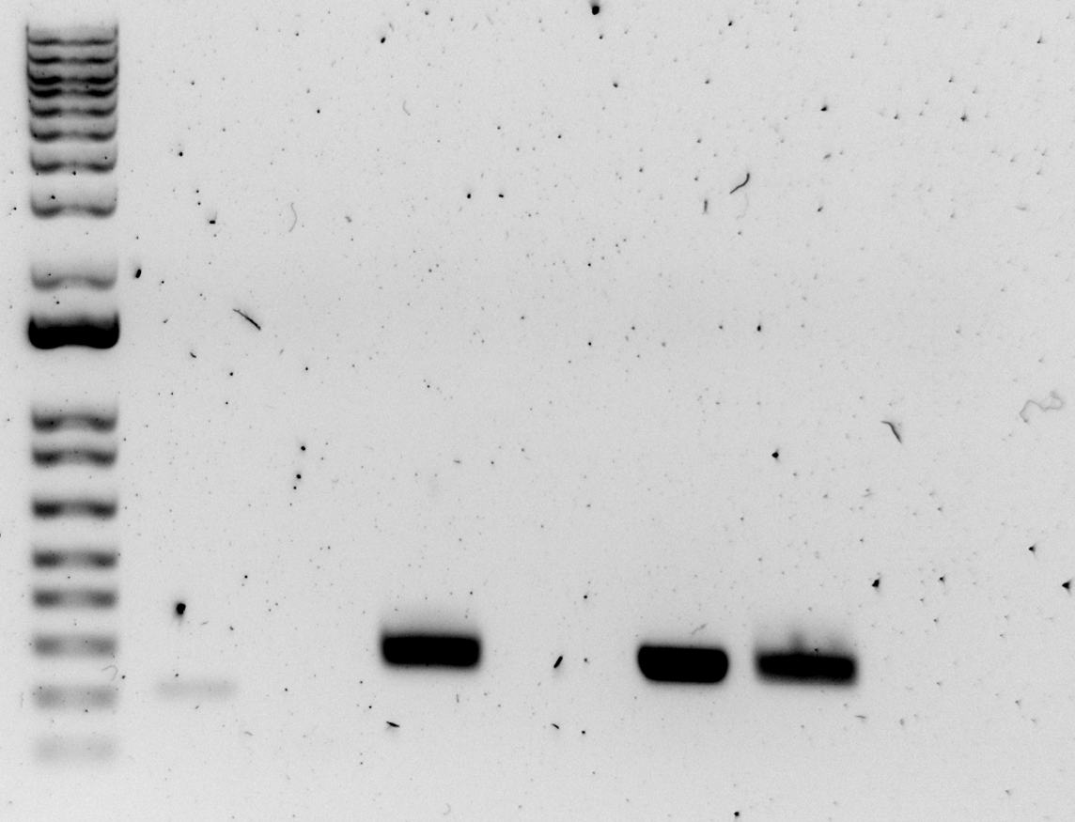
PCR product 1 9/18
FTL0420
212 bp
Diluted 1:10
PCR product 2 9/18
FTL0215
103 bp
Diluted 1:10
Pos. Control 9/18
from pKR152
290 bp
Neg. Control 9/18
PCR product 9/19
FTL0420/0215
290 bp
Pos. Control 9/19
from pKR152
290 bp
Neg. Control 9/19

Figure. 20 uL PCR Gel for pKR187

There was no band for the second PCR product from 9/18 which was diluted 1:10 today. I will run this gel again tomorrow using the undiluted PCR product. There were no bands for the negative controls, which is good. The overlap extended PCR product looked like its expected size, but I will still have to verify that PCR product 2 came out alright before I am confident in moving forward with this product.

PureExpress Delta Ribosome Kit Protocol
- Set up PCR reaction tubes.
Tube | Reaction Type
1 | PURExpress kit ribosomes
2 | 6/7 E. coli 1
3 | 6/7 E. coli 2
4 | 6/7 E. coli 3
5 | 9/16 E. coli
6 | 9/16 LVS
7 | DNA only
- Thaw all components on ice. Pulse-spin in microfuge to collect solutions to bottom of tubes. If Solution A has precipitates, mix well prior to assembling reaction. Do not vortex Solution B.
  - Solution A
  - Factor Mix
  - Kit ribosomes
  - Phenol-chloroform purified pKR144
  - Prev. E. coli
  - Recent E. coli and LVS
- Dilute ribosomes to 2.488 pmol/uL in H10M10A50 buffer, enough for a final volume of 15 uL per reaction (37.2 pmol per reaction).
 | Concentration (C1) | Desired Concentration (C2) | Desired Volume (V2) | Sample Volume (V1)(uL) | Buffer Volume (uL)
Kit Ribosomes | 13.3 pmol/uL | 2.488 pmol/uL | 20 uL | 3.74 | 16.26
6/7 E. coli 1 | 8.587 pmol/uL | 2.488 pmol/uL | 20 uL | 5.79 | 14.21
6/7 E. coli 2 | 10.65 pmol/uL | 2.488 pmol/uL | 20 uL | 4.67 | 15.33
6/7 E. coli 3 | 8.199 pmol/uL | 2.488 pmol/uL | 20 uL | 6.07 | 13.93
9/16 E. coli | 7.310 pmol/uL | 2.488 pmol/uL | 20 uL | 6.81 | 13.19
9/16 LVS | 2.488 pmol/uL | 2.488 pmol/uL | 20 uL | 20 | 0
- Dilute DNA in 0.1xEB to a concentration of 125 ng/uL.
Sample | Concentration (C1) | Desired Conc. (C2) | Desired Volume (V2) | Sample Volume (V1) | Buffer Volume
Phenol:chloroform purified pKR144 | 457.4 ng/uL | 125 ng/uL | 20 uL | 5.47 uL | 14.53 uL
- Add components in the following order:
Solution A | 10 uL
Factor Mix | 3 uL
Ribosomes | 15 uL
Template DNA | 2 uL
Total | 30 uL

Tube | Solution A | Factor Mix | Ribosomes (2.488 pmol/uL) | DNA (125 ng/uL)
1 | 10 uL | 3 uL | 15 uL PURExpress kit ribosomes | 2 uL Phenol:chloroform purified pKR144
2 | 10 uL | 3 uL | 15 uL 4/29 E. coli | 2 uL Phenol:chloroform purified pKR144
3 | 10 uL | 3 uL | 15 uL 5/20 E. coli | 2 uL Phenol:chloroform purified pKR144
4 | 10 uL | 3 uL | 15 uL 6/7 E. coli 1 | 2 uL Phenol:chloroform purified pKR144
5 | 10 uL | 3 uL | 15 uL 9/16 E. coli | 2 uL Phenol:chloroform purified pKR144
6 | 10 uL | 3 uL | 15 uL 9/16 LVS | 2 uL Phenol:chloroform purified pKR144
7 | 10 uL | 3 uL | 15 uL Nuclease-Free Water | 2 uL Phenol:chloroform purified pKR144
- Mix gently and pulse-spin in microfuge to collect mixture at the bottom of the tube
- Incubate at 37C for 2 hours in thermocycler
- Stop the reaction by placing tubes on ice
- Freeze at -20C
Wednesday, September 20, 2023

To Do:
- Test gel with PCR products 1 and 2 from 9/18
- Restriction digest and gel
- Luminescence assay with LVS
- Make CHA mix
Results and Data:
Jake and I ran a PCR gel with undiluted PCR products 1 and 2 (as well as positive and negative controls) from 9/18 to verify the presence of PCR product 2.

PCR Gel
- Melt 1% agarose gel at 300C and let cool in water bath to 50-55C.
- Put the gel cast into the gel rig sideways.
- Add 6 uL of SYBR safe solution to gel rig and then 60 mL of 1% agarose gel.
- Insert a comb to mold wells in the gel.
- Let sit until the 1% agarose – 1x SYBR safe solution has cooled and solidified into a gel.
- Carefully remove the comb.
- Pour 100 ml of 1x TAE buffer solution into the gel tank (add just enough to submerge the gel itself slightly).
- Add 4 uL 6x loading dye to 20 uL PCR solutions. (I added 2 uL 6x loading dye to 10 uL PCR solutions.)
- Load 10 µL of 2x log ladder into the first well.
- Load 15 µL of the PCR-dye mixture into the wells sequentially.
- Insert the electrodes and run the gel at 113 volts for 30 minutes.
- Look at the gel with the GelDoc and image in Image Lab.
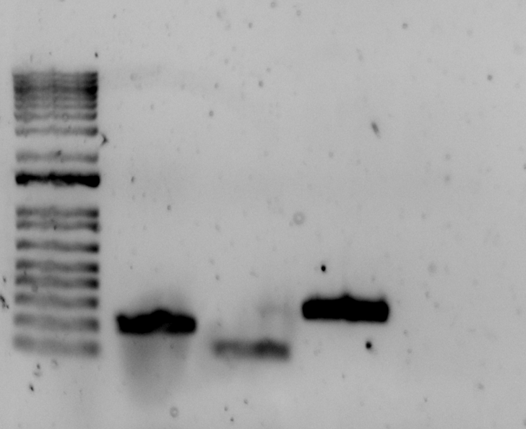

Figure. 20 uL PCR Gel for pKR187

Made more agarose gel and 1x TAE buffer.

Restriction Digest 3
- Make a reaction table with desired digests:
Tube | DNA | Enzyme(s) | DNA Volume (uL) | H2O Volume (uL)
1 | PCR product FTL0420/0215 | KpnI, NotI | 15 | -
2 | pKR145 Backbone | KpnI, NotI | 5 | 10
- Set up master mix table:
Master Mix:
Components | Volumes in 1 reaction (uL) | Volumes in Master Mix 3x (uL)
H2O | 10.8 | 32.4
10x rCutsmart Buffer | 3.0 | 9.0
DNA | (15.0) | -
Enzyme (KpnI) | 0.6 | 1.8
Enzyme (NotI) | 0.6 | 1.8
Total | 30.0 (15.0 actual b/c of DNA)
- Add indicated amounts of H2O and 10x buffer to master mix tube (MM).
- Add indicated amount of DNA to individual tubes for digest (1.5 mL microfuge tubes for digests in incubator, PCR strip tubes for reactions incubated in the thermocycler).
- Add indicated amount of each enzyme to the master mix tube (MM).
- Mix the master mix by pipetting up and down.
- Add master mix to individual tubes. Volume to add to each tube is the volume in 1 reaction minus the DNA volume (15 ul).
- Incubate at 37°C for 1 hour or up to overnight.
- Set heat block to 80C.
- Prepare gel using 100 mL gel and 12 uL SYBR safe dye.
- If using digest for plasmid construction then after incubation at 37°C, add 0.5ul of CIP enzyme to backbone tube, mix by pipetting and put back in 37°C incubator for 10 minutes. (this step removes the phosphates from the ends of the plasmid to prevent re-ligation). If using the new Quick CIP:
  - Add 1 uL of Quick CIP enzyme to backbone tube and mix by pipetting.
  - Put back in 37°C incubator for 10 minutes.
  - Put at 80C for 2 minutes to inactivate the CIP enzyme.
- Load 10 uL ladder.
- Add 6 uL dye into 30 uL reaction and load into gel, leaving space between samples.
- Run digests on gel at 113V.
- Image gel, cut out bands, and image a second time.
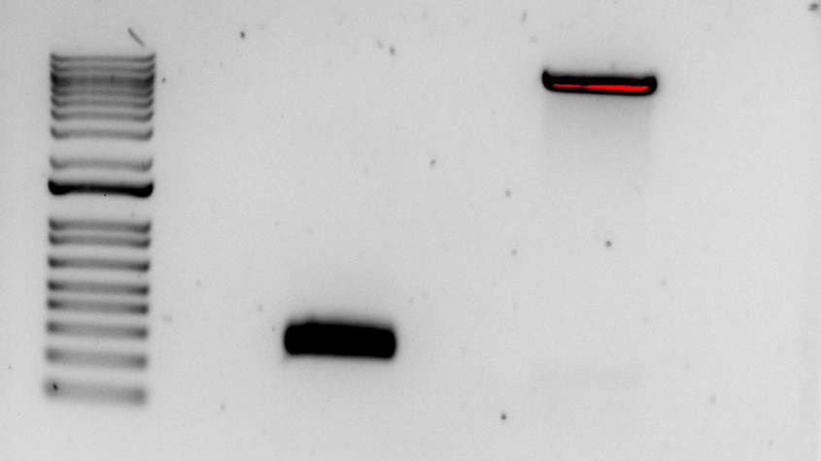
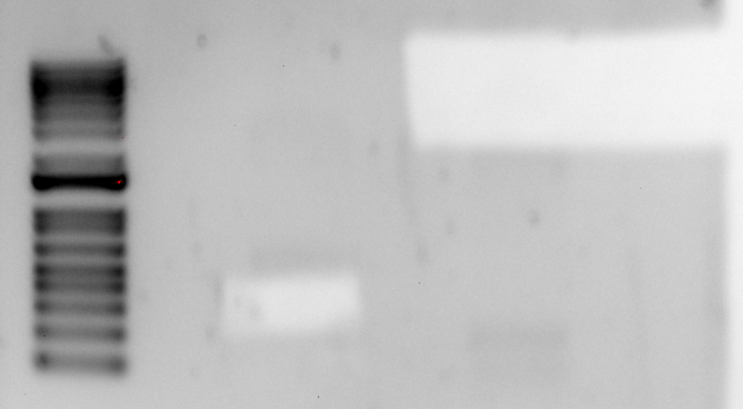

Figures. Restriction digest gel for pKR187, before and after cutting out bands.

Thursday, September 21, 2023

To Do:
- Gel purification for pKR187
- Ligation for pKR187
- Transformation for pKR187
- Make electrocompetent LVS
- Make CHA mix
Results and Data:

QIAquick Gel Extraction Kit
- All centrifugation steps are carried out at 17,900 x g (13,000 rpm) in a conventional table-top microcentrifuge.
- Excise the DNA fragment from the agarose gel with a clean, sharp scalpel.
- Weigh the gel slice in a colorless tube. Add 3 volumes Buffer QG to 1 volume gel (100 mg gel ~100 μl). The maximum amount of gel per spin column is 400 mg. For >2% agarose gels, add 6 volumes Buffer QG.
 | Gel Weight (mg) | Gel Volume (uL) | Buffer Volume (uL)
PCR product FTL0215 UTR
pKR145 Backbone
- Incubate at 50°C for 10 min (or until the gel slice has completely dissolved). Vortex the tube every 2–3 min to help dissolve gel. After the gel slice has dissolved completely, check that the color of the mixture is yellow (similar to Buffer QG without dissolved agarose). If the color of the mixture is orange or violet, add 10 μl 3 M sodium acetate, pH 5.0, and mix. The mixture turns yellow.
- Add 1 gel volume isopropanol to the sample and mix.
- Place a QIAquick spin column in a provided 2 ml collection tube or into a vacuum manifold. To bind DNA, apply the sample to the QIAquick column and centrifuge for 1 min or apply vacuum to the manifold until all the samples have passed through the column. Columns have a max of agarose they can handle, so you might have to split in two. Discard flow-through and place the QIAquick column back into the same tube. For sample volumes >800 μl, load and spin/apply vacuum again.
- If DNA will subsequently be used for sequencing, in vitro transcription, or microinjection, add 500 μl Buffer QG to the QIAquick column and centrifuge for 1 min or apply vacuum. Discard flow-through and place the QIAquick column back into the same tube. (Repeated this step one more time to get rid of residual agarose.)
- To wash, add 750 μl Buffer PE to QIAquick column and centrifuge for 1 min or apply vacuum. Discard flow-through and place the QIAquick column back into the same tube. (Repeated this step one more time.)
  - Note: If the DNA will be used for salt-sensitive applications (e.g., sequencing, bluntended ligation), let the column stand 2–5 min after addition of Buffer PE.
  - Centrifuge the QIAquick column in the provided 2 ml collection tube for 1 3 min to remove residual wash buffer.
- Place QIAquick column into a clean 1.5 ml microcentrifuge tube.
- To elute DNA, add 50 μl Buffer 0.1X EB (10 mM Tris·Cl, pH 8.5) or water to the center of the QIAquick membrane and centrifuge the column for 1 min. For increased DNA concentration, add 30 μl Buffer EB to the center of the QIAquick membrane, let the column stand for 1 min, and then centrifuge for 1 min. After the addition of Buffer 0.1X EB to the QIAquick membrane, increasing the incubation time to up to 4 min can increase the yield of purified DNA.
- If purified DNA is to be analyzed on a gel, add 1 volume of Loading Dye to 5 volumes of purified DNA. Mix the solution by pipetting up and down before loading the gel.
Took Nanodrop readings of the insert and backbone and stored them in Jake Grecco’s box in the -20C freezer.

Table. Nanodrop readings of the pKR187 insert and backbone.
Sample ID | ng/µl | A260 (Abs)
pKR187_insert | 37.9 | 0.757
pKR187_backbone | 22.4 | 0.449

Ligation
- Make a reaction table with desired ligations. Always include a backbone only control for each plasmid backbone used.
Tube | Product ID | Insert | Backbone
1 | pKR187 | KpnI, NotI digested, purified PCR | KpnI, NotI digested, purified pKR145
2 | Control (backbone only) | - | KpnI, NotI digested, purified pKR145
- Set up master mix tables:
Component | Reaction 1 (uL) | Reaction 2 (uL) | Master Mix (3x)
H₂O | 11.5 | 11.5 | 34.5
10x ligase buffer | 2.0 | 2.0 | 6
Insert | 4.0 | - | -
Backbone | 2.0 | 2.0 | 6
Ligase | 0.5 | 0.5 | 1.5
TOTAL | 20.0 | 20.0 | 48
- Obtain ice to assemble and keep the reactions on. This is important, as the reaction happens at 16C and the ligase buffer (which contains ATP) needs to be kept cold in order to avoid degradation. Bring over a 10 uL aliquot of 10X ligase buffer from the miscellaneous buffers box in the -20C with a cooler.
- Obtain and label PCR tubes for the reactions. Be sure to include the date and your initials.
- To the individual tubes, add indicated amounts of H2O, 10x buffer (2.0 uL), insert, and backbone.
- Add indicated amount of ligase (0.5 uL) to the individual tubes. Remember to keep the ligase in a mini cooler.
- Added insert DNA to reaction 1 and water to reaction 2.
- Made Master Mix with required amounts of water, ligase buffer, backbone, and T4 ligase and pipetted gently up and down.
- Transferred 16 uL Master Mix to each PCR tube and pipetted gently up and down.
- Place in the thermocycler or water bath overnight at 16C. Can do at room temp for 10 minutes if necessary, then place back on ice.
- Store at -20C.

Transforming Chemically Competent E. coli (pKR187 Ligation)
- Set up reaction table. Always include a positive and negative control for each antibiotic. If transforming plasmids (from previous plasmid prep), use 0.5 – 1 uL of plasmid. If transforming ligations, use 8 uL per ligation. If transforming plasmid, plate 20 uL,100 uL, and remaining volume. If transforming a ligation, plate 100 uL and remaining culture.
  - Note: The plasmid used for the positive control plates should be the regular circular plasmid, not the digest/purified one.
  - There should always be a backbone control if testing a ligation. This is the digested and ligated backbone with NO INSERT.
Tube number | Purpose | DNA | Volume of DNA | Final volume to plate | Number of carbenicillin-containing plates
1 | Plasmid with six nucleotide mutation in FTL0215 UTR | pKR187 | 8 uL | 20 uL, 200 uL | 2
2 | Backbone Ligation | pKR145 (digested) | 8 uL | 20 uL, 200 uL | 2
3 | (+) control | pKR144 | 1 uL | 100 ul | 1
4 | (-) control | None | 0 uL | 100 ul | 1
Total number of plates |  |  |  |  | 6
- Check to be sure you have enough LB plates with appropriate antibiotic. If plates were stored at 4°C, warm at 37°C until needed.
- Obtain ice. Label sterile tubes according to table and place on ice.
- Obtain DNA and thaw on ice if necessary.
- Thaw appropriate number of competent cell tubes on ice (5 reactions per tube of competent cells).
- Add indicated volume of DNA to respective tubes on ice.
- When competent cells are thawed (check by probing for frozen cells using a sterile pipette tip), gently pipette 100 uL of cells into each reaction tube directly onto DNA using aseptic technique.
- Incubate cells on ice for 20 minutes. During incubation set heat block to 42°C.
- Place tubes with cells and DNA onto 42°C heat block for 30 seconds (heat shock step).
- After heat shock, place tubes back on ice until next step (don’t keep them here too long).
- Using aseptic technique, add 1 mL LB (no antibiotic) to each microfuge tube.
- Using autoclave tape, tape microfuge tubes down in shaking incubator set to 37°C. Allow cells to recover for 1 hour at 37°C, shaking.
- Place in a rack after shaking (NOT back on ice).
- Using aseptic technique, plate indicated amount of cells on appropriate antibiotic plates (LB-Carb), spreading until plates look dry. For “remaining” volume, spin tubes at max speed in benchtop centrifuge for 30 seconds. Remove 800 uL of media. Using 200 uL pipette, resuspend cells at bottom of tube and plate all the remaining culture.

Preparing Electrocompetent LVS
From Allelic exchange protocol; Edited by Hannah Trautmann
- Scrape up entire plate of cells into 400 uL of sterile 10% sucrose and resuspend (alternately, cells can be grown to mid-log in MHB)
- Add 1.1 mL of 10% sucrose to a final volume of 1.5 mL
- Spin for 3 minutes at 10,000 rpm
- remove supernatant, throw out, and resuspend in fresh 1 mL 10% sucrose
- Repeat 3x-5x in 10% sucrose (I repeated this a total of three times.)
- After final spin, remove all supernatant.
- Resuspend cells in 10% sucrose at high density (corresponding to ~1x10¹¹ cells /mL); by slowly adding 110 uL at a time. It should be about equal amounts of cells as sucrose. (I added 110 uL twice, so there should be four electroporations.)
- For any extra EC cells, aliquot ~110 μL / sterile tube (enough for 2 electroporations) and freeze at -80°C
- Note: I should have used LVS cells for this, but I used LVS pF instead.
I patched out KRLVS191.1 (from Box 7) onto CHAH and put the plate into the 37C incubator.
Friday, September 22, 2023

To Do:
- Make overnight cultures for pKR187
- Electroporate LVS and plate (pF plasmid, control with no plasmid, incubate for three days)
- Streak out tul4 control +/- bS21-2 and 0215 UTR +/- bS21-2 to single colonies
Results and Data:
We added 5 mL LB to six separate culture tubes along with 5 uL 100 mg/mL Carbenicillin and then inoculated the tubes with colonies from the 200 uL pKR187 Ligation plate. The tubes were placed in the 37C shaking incubator.

Electroporation of LVS with pF Plasmid
Electroporate plasmid into EC cells*
-For each electroporation, aliquot 4 mL MHB into glass test tubes for recovery, warm in shaker at 37°C
-For each electroporation, in a 2 mm sterile electroporation cuvette, combine:
5 μL of pEX-based allelic exchange construct or Tn7 plasmids (mini-prep concentration, at least 100 ng/μL)
*for pF-based plasmids, can use 3 ul
50 μL electrocompetent cells
-Have recovery media ready
-Electroporate using the following settings: 2.5 kV, 25 μF, and 600 Ω
-Immediately after individual electroporations, use 1 mL warm recovery media from test tube to wash cells out of cuvette and transfer cells to recovery test tube
-Recover cells for 4-8 hours, shaking at 37°C
*For pF-based plasmids, only recover 2-3 hours (recovered for 2.5 hours)
-For pEX plasmids: pellet cells by centrifugation in sterile 2 mL tubes, 1’ at 10,000 x g. Plate on CHAH-Kan plates, using 1 plate for each 2 mL tube (2 plates per electroporation)
*For pF-plasmids: plate 10 ul and 100 ul on CHAH-kan plates (plated 50 uL, 500 uL, and remaining culture)
*For Tn7 plasmids: plate 100 ul and remaining on CHAH-kan plates
-Incubate plates at 37°C for 3 days (or until single colonies appear)

*Always include a control electroporation with no plasmid. Eventually single break-through colonies may start appearing; at that point, single colonies on the experimental plates are also likely to just be break-through growth.

We streaked out tul4 control +/- bS21-2 (KRLVS180 and 182) and 0215 UTR +/- bS21-2 (KRLVS190 and 191) to single colonies on CHAH-Kan plates and put the plates in the 37C incubator.

Saturday, September 23, 2023

To Do:
- Spin down pellets for overnight cultures
Results and Data:
I spun down pellets for pKR187 overnight cultures and stored them in the -20C freezer.

Tuesday, September 26, 2023

To Do:
- Calculate doubling times for BHI
- Determine how low we can go with luminescence
- Make CHAH-Kan plates
- Restreak tul4 control +/- bS21-2 and 0215 UTR +/- bS21-2 to single colonies
Results and Data:
The plates of tul4 control +/- bS21-2 (KRLVS180 and 182) and 0215 UTR +/- bS21-2 (KRLVS190 and 191) that we streaked out last weekend had not grown sufficiently by Monday, so we put these back into the incubator and also streaked out fresh plates today.

I made more CHAH and CHAH-Kan plates.

I calculated doubling times for the MHB and BHI media growth curves using two points from the steepest points of the graph (which were time points 0 and 140 for both curves) and the following formula for generation time: G = (0.301)(t2-t1)/(logOD2-logOD1). The doubling time for MHB was 109.3 minutes and for BHI was 101.7 minutes.

Table. Doubling times for MHB and BHI media.

 | MHB | BHI
t1 | 0 | 0
t2 | 140 | 140
OD1 | 0.079 | 0.084
OD2 | 0.192 | 0.218
Doubling Time | 109.2632249 | 101.7438894

Figure. Growth curves for LVS pF in MHB and BHI media showing points selected to calculate generation time.

Wednesday, September 27, 2023

To Do:
- Patch LVS, LVS DrpsU2, and LVS pF
- Miniprep pKR187
- Prep pKR187 for sequencing
- Make CHA
- Make MHB and BHI media
Results and Data:
We Miniprepped samples 1-6 of pKR187 that had been pelleted on Saturday and prepared them for sequencing, then I brought them to INBRE and put them in the storage freezer.

Miniprep of pKR187
- Resuspended pellets with 250 mL Buffer P1.
- Added 250 uL Buffer P2 and mixed thoroughly by inverting the tube 4-6 times until the solution was more translucent.
- Added 350 uL Buffer N3 and mixed immediately and thoroughly by inverting tube 4-6 times.
- Centrifuged for 10 min at 13,000 rpm.
- Applied 800 uL of supernatant from previous step to QIAprep 2.0 spin column by pipetting and centrifuged for 1 min at 13,000 rpm. Discarded the flow-through.
- Washed the QIAprep 2.0 spin column by adding 0.5 mL Buffer PB. Centrifuged for 1 minute at 13,000 rpm. Discarded flow-through.
- Washed the QIAprep 2.0 spin column by adding 0.75 mL Buffer PE. Centrifuged for 1 minute at 13,000 rpm and discarded flow-through 3 times (added 750ul of PE three times).
- Centrifuged for 3 minutes at 13,000 rpm to remove residual wash buffer.
- Placed the QIAprep 2.0 columns into clean 1.5 ml microcentrifuge tubes. To elute DNA, added 50 uL buffer 0.1xEB from a conical on the benchtop. Let them stand for 1 minute. Centrifuged for 1 minute at 13,000 rpm.
- Concentrations were obtained via Nanodrop (table below).

Table. Nanodrop concentrations for pKR187 samples.
Sample ID | Nucleic Acid | Unit | A260 (Abs)
pKR187_1 | 285 | ng/µl | 5.7
pKR187_2 | 318.9 | ng/µl | 6.379
pKR187_3 | 333.8 | ng/µl | 6.677
pKR187_4 | 256.2 | ng/µl | 5.125
pKR187_5 | 301.9 | ng/µl | 6.038
pKR187_6 | 519.2 | ng/µl | 10.383

Sequence Reactions Protocol
- Use nanodrop to check concentrations of mini preps (dilute if necessary)
- Dilute primers (2.5% - dilute 1:4 from working primer stock)
- Set up sequence reaction worksheet
- Add appropriate primer to each tube (2.56 uL for each)
- Add appropriate miniprep to each tube
- Add appropriate volume of water to each tube
- Centrifuge tubes until all components are at bottom
- Pipette up and down to mix
- Bring PCR tubes and worksheet to genome sequencing lab
Submitted pKR187 samples 1-6 and sequenced using primer KROL525.

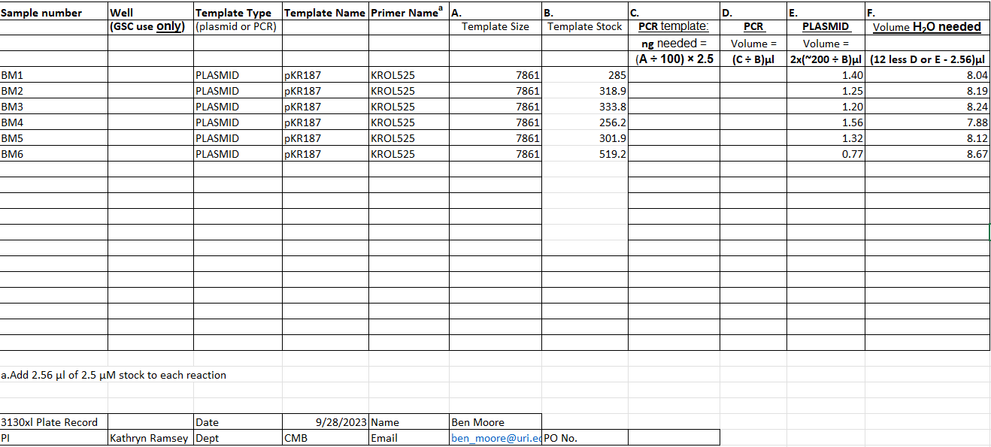

Figure. Sequencing submission form for pKR187 samples.

I prepared 500 mL of MHB and BHI media and will supplement them tomorrow morning before conducting the growth curve experiment. I also made more CHA mix.

I patched LVS (from Hannah’s glycerol stocks), LVS DrpsU2 (KRLVS9), and LVS pF (KRLVS120) onto CHAH plates and put the plates in the 37C incubator.

CHA Mix
Combine the following components, making sure to break up any clumps prior to adding to the container:
- 75 g Beef Heart Infusion
- 75 g Protease Peptone
- 75 g Glucose
- 7.5 g L-Cystine
- 112.5 g Agar
- 37.5 g NaCl
Put in recycled BD container, shake well to mix, and update tape with date made.

Thursday, September 28, 2023

To Do:
- Sequence pKR187
- Supplement MHB and BHI media
- Make LVS and LVS DrpsU2 electrocompetent
- Make iron pyrophosphate
- Patch LVS and LVS DrpsU2
Results and Data:

Supplemented Brain Heart Infusion Broth with Cysteine (sBHIc)
For 500 mL:
- Combine in a 1 L bottle:
  - 18.5 g BHI
  - .5 g L-cysteine hydrochloride
  - If preparing sBHIc with 5% KCl, add 25 g KCl (and be sure to label the bottle!)
- Add 480 mL type I ddiH₂0, shake to mix
- Autoclave 30’, let cool
- Store media in the dark for up to 1 month prior to adding supplements

I walked through how to measure growth curves with George but didn’t run them today, because I need to make iron pyrophosphate and supplement the MHB media I made yesterday.

I made 2.5% Iron pyrophosphate (1.25g iron pyrophosphate in 50mL of ddiH₂O (type 1), dissolved overnight, fresh solution every 2 weeks (filter-sterilized).

I prepared electrocompetent cells from the plates of LVS and LVS DrpsU2 that I patched yesterday.

Preparing Electrocompetent LVS
From Allelic exchange protocol; Edited by Hannah Trautmann
- Scrape up entire plate of cells into 400 uL of sterile 10% sucrose and resuspend (alternately, cells can be grown to mid-log in MHB)
- Add 1.1 mL of 10% sucrose to a final volume of 1.5 mL
- Spin for 3 minutes at 10,000 rpm
- remove supernatant, throw out, and resuspend in fresh 1 mL 10% sucrose
- Repeat 3x-5x in 10% sucrose (I repeated this a total of three times.)
- After final spin, remove all supernatant.
- Resuspend cells in 10% sucrose at high density (corresponding to ~1x10¹¹ cells /mL); by slowly adding 110 uL at a time. It should be about equal amounts of cells as sucrose. (I added 110 uL twice, so there should be four electroporations.)
- For any extra EC cells, aliquot ~110 μL / sterile tube (enough for 2 electroporations) and freeze at -80°C.
I patched LVS (from Hannah’s glycerol stocks), LVS DrpsU2 (KRLVS9), and LVS pF (KRLVS120) onto CHAH plates and put the plates in the 37C incubator.

Friday, September 29, 2023

To Do:
- Supplement MHB
- Measure LVS growth curves in MHB and BHI (every 1.5 hours)
- Electroporate LVS DrpsU2 with pKR187
- GFP assay
Results and Data:
I supplemented 500 mL MHB with 10 mL IsoVitalex, 5 mL 2.5% iron pyrophosphate, and 5 mL 10% glucose.

Reviewed sequencing results for pKR187. Samples 1, 2, and 5 had good sequences, so they were combined into one tube which was labeled as pKR187 and stored in the plasmids box in the -20C freezer. Samples 3, 4, and 6 did not have clean sequences, so they were discarded.

GFP reporter assay
By: Hannah Trautmann

- Have prepared 3 patches 2 patches on CHAH of biological replicates for each reporter strain, and one patch of LVS as a control
- Scrape up cells into MHB, resuspend, measure OD, and dilute to 0.08-0.10 in 6 mL of MHB with appropriate antibiotic (6 uL Kanamycin added to all tubes except LVS). I added 100 uL of each sample to a cuvette with 900 uL MHB and took the OD600 measurement, then multiplied the measurement value by ten to get the actual OD600. I used the equation C1V1=C2V2 to calculate the desired volume of cell culture to inoculate each culture tube with. C1 was the actual OD600, V1 was the desired volume we were trying to find, C2 was 0.09 OD600, and V2 was 6,000 uL. The calculated desired volumes are listed in the table below.

Table. Samples, initial OD600 values, and desired volumes to inoculate culture tubes.
Sample | OD (diluted) | OD (actual) | Desired Volume
BM_tul4 | 0.755 | 7.55 | 71.5
BM_tul4D2 | 0.567 | 5.67 | 95.2
BM_0215 | 0.542 | 5.42 | 99.6
BM_0215D2 | 0.457 | 4.57 | 118.2
LVS | 0.68 | 6.8 | 79.4
JG_tul4 | 0.687 | 6.87 | 78.6
JG_tul4D2 | 0.555 | 5.55 | 97.3
JG_0215 | 0.686 | 6.86 | 78.7
JG_0215D2 | 0.719 | 7.19 | 75.1

- Grow shaking at 37C until cells reach mid-log (0.3-0.4 OD). Generally takes 4-5 hours.
  - I put the culture tubes in the incubator around 2:35 PM.
  - I removed the tubes and took the first OD reading at 6:48 PM by adding 500 uL of culture along with 500 uL of MHB to a cuvette and then multiplying the resulting OD by two. The LVS culture was within the desired OD range of 0.3-0.4, so I removed this culture and put the others back in the incubator.
  - I removed the tubes and took the second OD reading at 7:30 PM by adding 250 uL of culture along with 750 uL of MHB to a cuvette and then multiplying the resulting OD by four, then put them back in the incubator.
  - I removed the tubes and took the third OD reading at 8:30 PM by adding 250 uL of culture along with 750 uL of MHB to a cuvette and then multiplying the resulting OD by four. At this point, I was able to confirm that the cultures were not growing, so I stopped the experiment and will try again next week. Perhaps the plates the cells were scraped from were too old or maybe the volume of antibiotic we added was too high.

Table. OD600 readings for GFP assay cultures at several time points.
1st OD | 6:48 PM |  | 2nd OD | 7:30 PM |  | 3rd OD | 8:30 PM
OD (diluted) | OD (actual) |  | OD (diluted) | OD (actual) |  | OD (diluted) | OD (actual)
0.072 | 0.144 |  | 0.041 | 0.164 |  | 0.04 | 0.16
0.088 | 0.176 |  | 0.035 | 0.14 |  | 0.05 | 0.2
0.089 | 0.178 |  | 0.039 | 0.156 |  | 0.07 | 0.28
0.1 | 0.2 |  | 0.048 | 0.192 |  | 0.059 | 0.236
0.204 | 0.408
0.065 | 0.13 |  | 0.031 | 0.124 |  | 0.031 | 0.124
0.102 | 0.204 |  | 0.05 | 0.2 |  | 0.053 | 0.212
0.101 | 0.202 |  | 0.046 | 0.184 |  | 0.054 | 0.216
0.087 | 0.174 |  | 0.044 | 0.176 |  | 0.041 | 0.164

I streaked out fresh plates (2 per strain) of tul4 control +/- bS21-2 (KRLVS180 and 182) and 0215 UTR +/- bS21-2 (KRLVS190 and 191) onto CHAH-Kan plates and put them in the 37C incubator for a second GFP assay attempt next week.

Electroporation of LVS ∆rpsU2 with pKR187
Electroporate plasmid into EC cells*
-For each electroporation, aliquot 4 mL MHB into glass test tubes for recovery, warm in shaker at 37°C
-For each electroporation, in a 2 mm sterile electroporation cuvette, combine:
5 μL of pEX-based allelic exchange construct or Tn7 plasmids (mini-prep concentration, at least 100 ng/μL)
*for pF-based plasmids, can use 3 ul
50 μL electrocompetent cells
-Have recovery media ready
-Electroporate using the following settings: 2.5 kV, 25 μF, and 600 Ω
-Immediately after individual electroporations, use 1 mL warm recovery media from test tube to wash cells out of cuvette and transfer cells to recovery test tube
-Recover cells for 4-8 hours, shaking at 37°C
*For pF-based plasmids, only recover 2-3 hours (recovered after 2 hours, 53 minutes)
-For pEX plasmids: pellet cells by centrifugation in sterile 2 mL tubes, 1’ at 10,000 x g. Plate on CHAH-Kan plates, using 1 plate for each 2 mL tube (2 plates per electroporation)
*For pF-plasmids: plate 10 ul and 100 ul on CHAH-kan plates (plated 50 uL, 500 uL, and remaining culture)
*For Tn7 plasmids: plate 100 ul and remaining on CHAH-kan plates
-Incubate plates at 37°C for 3 days (or until single colonies appear)

*Always include a control electroporation with no plasmid. Eventually single break-through colonies may start appearing; at that point, single colonies on the experimental plates are also likely to just be break-through growth.

Saturday, September 30, 2023

To Do:
- Electroporate LVS with pKR187
Results and Data:

Electroporation of LVS with pKR187
Electroporate plasmid into EC cells*
-For each electroporation, aliquot 4 mL MHB into glass test tubes for recovery, warm in shaker at 37°C
-For each electroporation, in a 2 mm sterile electroporation cuvette, combine:
5 μL of pEX-based allelic exchange construct or Tn7 plasmids (mini-prep concentration, at least 100 ng/μL)
*for pF-based plasmids, can use 3 ul
50 μL electrocompetent cells
-Have recovery media ready
-Electroporate using the following settings: 2.5 kV, 25 μF, and 600 Ω
-Immediately after individual electroporations, use 1 mL warm recovery media from test tube to wash cells out of cuvette and transfer cells to recovery test tube
-Recover cells for 4-8 hours, shaking at 37°C
*For pF-based plasmids, only recover 2-3 hours (recovered for 3 hours)
-For pEX plasmids: pellet cells by centrifugation in sterile 2 mL tubes, 1’ at 10,000 x g. Plate on CHAH-Kan plates, using 1 plate for each 2 mL tube (2 plates per electroporation)
*For pF-plasmids: plate 10 ul and 100 ul on CHAH-kan plates (plated 50 uL, 500 uL and remaining culture)
*For Tn7 plasmids: plate 100 ul and remaining on CHAH-kan plates
-Incubate plates at 37°C for 3 days (or until single colonies appear)

*Always include a control electroporation with no plasmid. Eventually single break-through colonies may start appearing; at that point, single colonies on the experimental plates are also likely to just be break-through growth.

Monday, October 2, 2023

To Do:
- Make CHAH plates
- Make hemoglobin
- Rerun GFP assay
- Check LVS plates
Results and Data:
Electroporation

Tuesday, October 3, 2023

To Do:
- GFP assay?
- Check LVS plates
Results and Data:
Electroporation

Wednesday, October 4, 2023

To Do:
- GFP assay?
- Check LVS plates
Results and Data:
Electroporation

Thursday, October 5, 2023

To Do:
- Make CHAH plates
- Rerun GFP assay
- Check LVS plates
Results and Data:
Electroporation

Friday, October 6, 2023

To Do:
- Make CHAH plates
- Rerun GFP assay
- Check LVS plates
Results and Data:
Electroporation

Bibliography
Ramsey, K. M. and Dove, S. L. (2016) ‘A response regulator promotes Francisella tularensis intramacrophage growth by repressing an anti-virulence factor’, Molecular Microbiology. doi: 10.1111/mmi.13418.

