Correspondence with NEB Regarding PURExpress Assay

My initial request for information submitted by an NEB phone representative:

Using the delta ribosome pure express kit (E3313) with a construct to express nano-luciferase they have done a ribosome titration from the recommended 60pmol down to 1.25 pmol of ribosomes added into the reaction. They have observed that they have the highest translation efficiency with 2.5pmol. They are measuring this by following the standard NEB reaction with the addition of nano glow reagent from Promega and then measuring luminescence. They would like to know if this has been observed before and if we have an explanation since this seems a very low ribosome input.

Their response on Aug 2, 2024:

Dear Benjamin,

Thank you for contacting NEB Technical Support
This is interesting. We know with PURExpress reactions that more is not necessarily better, but you're right in that this seems like a particularly low ribosome input. Would you mind sharing the volumes and diluents used to prepare the reactions? How do the other titrated concentrations compare?

Some other questions that may help me "troubleshoot" are: what amount of nano-luciferase template was used in the reaction? What temperature was used and how long did the reaction go until you detected expression through luminescence? Was expression checked through SDS PAGE?

If you have any further questions, please reply to this email.

Best wishes,
Emily
NEB Technical Support
My response on Aug 5, 2024:

Dear Emily,

Thank you for your response to my inquiry! I’ve attached some notes regarding the protocol and template in hopes that they will answer your questions. We have yet to check expression through SDS PAGE. Thank you for your feedback, and please let me know if there is any more information I can provide!

Thank you,
Ben

Attached notes:

PureExpress ∆ Ribosome Kit Protocol
Solution A and Factor Mix from the PureExpress ∆ Ribosome Kit were thawed on ice. Seven PCR reaction tubes were prepared. Tube 1 received 6 µL of kit ribosomes at 13.333 pmol/µL and 24 µL of H¹⁰M¹⁰A⁵⁰ buffer (10 mM HEPES KOH pH 7.6, 10 mM MgCl₂, and 50 mM NH₄Cl) to reach a total of 40 pmol ribosomes. Tubes 2-6 received 15 µL of H¹⁰M¹⁰A⁵⁰ buffer. 15 µL was pipetted from tube 1 to tube 2. Tube 2 was gently mixed by pipetting, and then 15 µL was pipetted from tube 2 to tube 3. This process was repeated for the remaining tubes, and 15 µL was removed from tube 6 after the final transfer, setting up a serial dilution of 40, 20, 10, 5, 2.5, and 1.25 pmol ribosomes. Tube 7 was the negative control and received 15 µL H¹⁰M¹⁰A⁵⁰ buffer. Plasmid template DNA (see construct below) was purified by phenol-chloroform extraction, and then diluted in 0.1x Buffer EB (Qiagen) to a concentration of 125 ng/µL. A Master Mix was created by combining Solution A, Factor Mix, and the plasmid template in a single tube and pipetting to mix. 15 µL of the Master Mix was pipetted into each reaction to reach a total of 10 µL Solution A, 3 µL Factor Mix, 2 µL template DNA (250 ng), and 15 µL ribosomes/buffer per reaction. After mixing gently and spinning briefly in a microfuge, the reactions were incubated at 37°C for 2 h in a thermocycler. The reactions were stopped by placing the tubes on ice, and the samples were frozen at –20°C for later use.
Nano-Glo® Luciferase Assay
Nano-Glo® Luciferase Assay Buffer and Nano-Glo® Luciferase Assay Substrate were thawed on ice and mixed by pipetting. An appropriate volume of reconstituted reagent was prepared by combining one volume of substrate with 50 volumes of buffer and mixed by pipetting. In vitro assay reactions were thawed on ice. Next, 30 µL of reconstituted reagent was added to the reactions, and the reactions were pipetted into a 96-well plate in technical triplicate. After a 3 min incubation period, the plate was read on the appropriate settings.

Figure. nLuc luminescence with translation of tul4 5’ UTR–nLuc reporter (pKR214) by NEB E. coli ribosomes.
Luminescence (RLU) values were highest for reactions with 1.25-2.5 pmol NEB E. coli ribosomes.

Figure. nLuc luminescence/pmol ribosomes with translation of tul4 5’ UTR–nLuc reporter (pKR214) by E. coli and Francisella tularensis ribosomes.
Fewer ribosomes per in vitro reaction corresponds to higher luminescence/pmol values for NEB E. coli and Francisella tularensis ribosomes.

Nano-Luciferase Plasmid Template
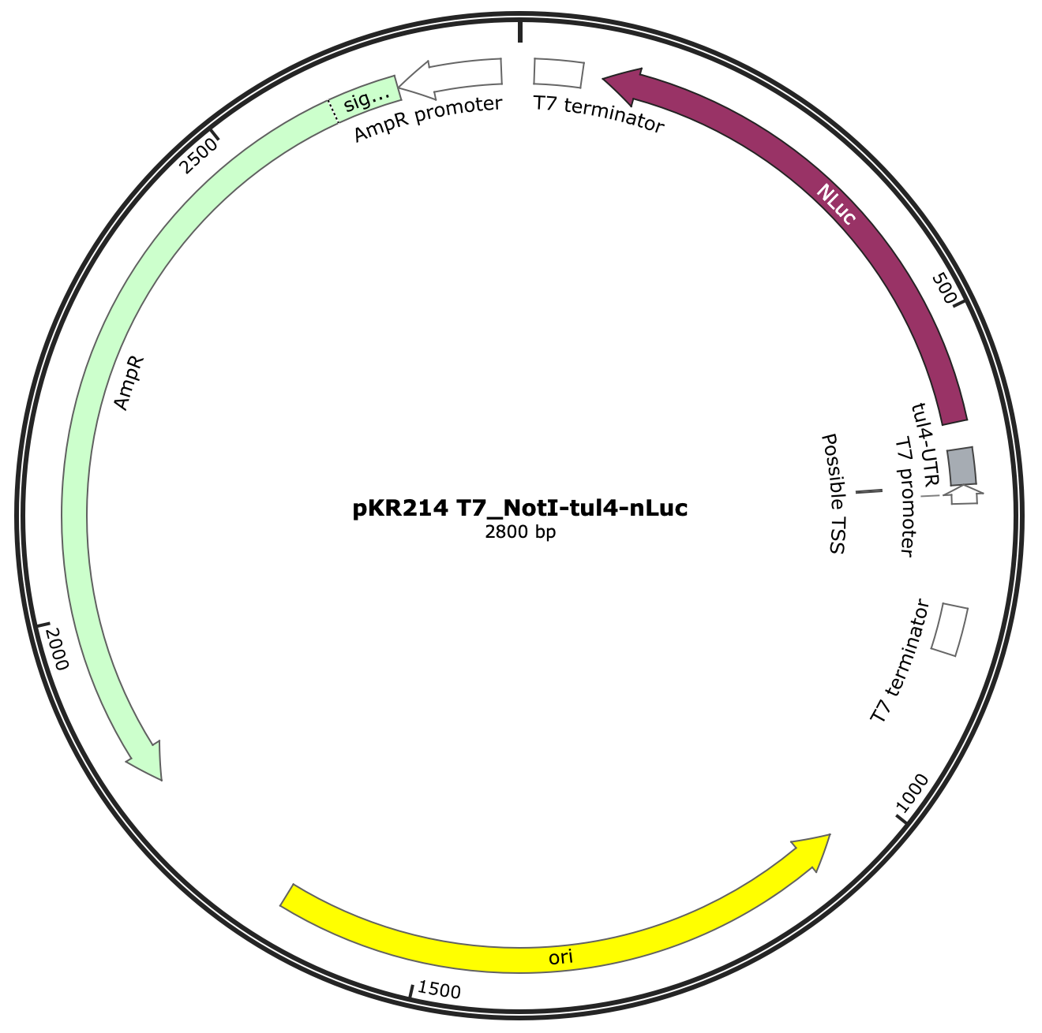

Figure. Nano-luciferase (nLuc) plasmid template (pKR214).
In vitro translation assays were performed using the pKR214 reporter template, which specifies a tul4 5’ UTR – nLuc reporter fusion.

Figure. Closeup of open reading frame for Nano-luciferase, showing T7 promoter, tul4 5’ UTR, and nLuc gene.
Their response on Aug 6, 2024:

Dear Benjamin,

Thank you for contacting NEB Technical Support
Thank you for the attached information, it was very helpful.

I think what you are seeing is a consequence of the buffer you are using to dilute the ribosomes and the volume that is added to the reactions. The concentration of magnesium is critical to both transcription and translation in PURExpress. So by adding 15 uL of the ribosome/buffer per reaction, which is a larger volume than recommended, you are changing the magnesium concentration of the reaction as well as diluting other reaction conditions. However, if you wish to proceed with these reaction conditions, I would just be aware of and consistent with the buffer components/concentrations. You might try a control reaction using standard volumes (10 uL Solution A, 3 uL Factor Mix, 4.5 uL ribosomes) to see how that compares.

If you have any further questions, please reply to this email.

Best wishes,
Emily
NEB Technical Support
Kathryn’s response on Aug 7, 2024:

Dear Emily,

We appreciate your insight into these findings!

But could you please offer some insight / clarification into how the "standard" reaction conditions compare to the reaction conditions outlined in the protocol (total volume of 25 uL +/- 20%)?

In particular, are there additional limits to what buffer or solute is expected to be in the final 7.5 uL?

And can you tell us what the final concentration of magnesium should be for optimal results?

Thank you for your help!
All the very best,
Kathryn
Their response on Aug 7, 2024:

Dear Benjamin,

Thank you for contacting NEB Technical Support
When the PURExpress kit was developed, it was optimized based on the fact that the final reaction would have certain concentrations of the various components. By adding the extra volume, the concentrations of those components have changed. This is not to say that different conditions will not be better, but just that it is outside of our testing conditions. And as the final concentrations of the many components of the kit have changed, it is difficult to comment on why lower concentrations of ribosomes are more effective in your reactions. I suggested a standard reaction thinking you could run the reaction to see if it could provide insight into whether it was the dilution factor or the buffer being used that influences your results. By this I mean if you were to dilute the ribosomes to have 2.5 or 1.25 pmol (as in your experiments) in your buffer in 4.5 uL and see how that compares to your diluted reaction with the same amount of ribosomes.

In our manual, we recommend that "samples should be free of potential inhibitors, including NaCl (> 50 mM), glycerol (> 1%), EDTA (> 1 mM) and magnesium or potassium salts (> 12 mM)." Additional potassium is more tolerated than additional magnesium. The concentration of magnesium does vary slightly lot to lot and we see that generally it only tolerates an additional 1 or 2 mM.

If you have any further questions, please reply to this email.

Best wishes,
Emily
NEB Technical Support

