Table of Contents
Introduction 2
Figure 1 2
Thoughts or questions. 2
Protocol 1 2
Reagents 3
File Formatting Protocol 3
September 2018 4
Bibliography 5

January 2024

Thursday, January 18, 2024
To Do:
- Start RNA isolation procedure by streaking out strain
- Plan RNA isolation with Dr. Ramsey
- Meeting at 3pm Dr. Ramsey
Notes:
Started RNA isolation procedure and made plan with Dr. Ramsey
Two main goals/projects
1. replicate figure 1 of ch2 of Sierra’s thesis with qPCR. Will include three strains done in duplicate.
LVS pF (empty vector) = KRLVS 120
LVSΔ2 = LVS Δ rpsU2 pF = KRPLVS 121 (slow growing)
LVSΔrpsU2 pF – rpsU2-V = KRLVS 123
2. RNA extraction and isolation and then qRT-PCR experiment at different time points stability test figure 5 ch2 of sierra’s thesis. Goal is to see if what was done can be replicated and if its what we’re actually seeing.

Protocol – Plan for RNA Isolation

Day 1 (today Jan18th) – streak out colonies (in this case Δ2 which is slow growing) onto CHA-kan plates in duplicate. Streaked out for isolation from glycerol stocks (plates made on 1/10/23). Plates stored at 37C.
Day 3 – streak out to single colonies LVSpF and LVSΔrpsUpF-rpsU2-V also on CHA-kan plates in duplicate.
Day 4 – Patches from single colonies for Δ2 on CHA-kan plates. Do 3 patches (lawns) in separate areas from 3 separate colonies. One colony per lawn.
Day 5 – Patches on LVSpF and LVSΔrpsUpF-rpsU2-V isolated colonies onto CHA-kan plates)
Day 6 – RNA isolation and grow cultures. Takes a few hours. Cultures in sHMB broth about 8mL each. sHMB = supplemented muller hinton broth.

Friday, January 19, 2024
To Do:
- Streak out KRLVS 120 and KRLVS 123 for isolation

Notes
- Looked at plates from yesterday with KRLVS 121 streaked out. Noted growth and no contamination seen
Sunday, January 21, 2024
To Do:
- Patch 6 colonies of LVS ΔrpsU2 pF

Monday, January 22, 2024
To Do:
- Patch 6 colonies of LVS pF
- Patch 6 colonies of LVSΔrpsU2 pF – rpsU2-V

Tuesday, January 23, 2024
To Do:
- Begin RNA isolation by doing culture growth for RNA Isolation protocol
- Begin RNAsnap protocol steps 1-9

Protocol – Culture growth for RNA isolation
- Put 8mL of supplemented MHB into sterile glass tubes and warm at 37C in incubator
- For each bacterial sample, scape up one patch of cells and resuspend in ~300uL of supplemented MHB in sterile 1.5mL microcentrifuge tube
- Add 700uL more supplemented MHB, make sure cells are well-resuspended
- Check OD600
  - Dilute resuspended cells 1:10 in MHB (100 uL cells, 900 uL MHB)
  - Check OD600 using 1 mL MHB as blank
  - Calculate actual OD600 (measured OD600 multiplied by dilution factor [10])*
  - Calculate what volume of cells you need to obtain an OD600 of 0.08 in 8 mL*
  - Make an excel sheet to help with this
- For each sample, inoculate one glass culture tube so that the final OD600 is 0.08
  - Example:
  - OD600 of resuspended cells: 4.0
  - (8 mL )(0.08 OD600) / (4.0 OD600) = 0.18 mL resuspended cells (180 uL)
  - Add 8 mL MHB per tube, remove 180 uL, and add back 180 uL resuspended cells
- Swirl tube to distribute cells
- Remove 1mL and use to measure OD600, record results in excel sheet
- Put tubes at 37C shaking
- Check OD600 after ~ 2 hours to be sure cells have come close to doubling (document OD600!*)
- When OD600 reaches between 0.3 – 0.4 (4-6 hours, document OD600!*):
  - Transfer 1.8 mL into 2 mL tube.
  - Go to RNAsnap protocol step 2

Protocol – RNAsnap protocol
Adapted from: Stead et al. (2012) Nucleic Acids Research
Updated 10/26/22
Note: All reagents should be RNAse free; use good RNA-technique by cleaning work area, gloves, and instruments with RNAse-away.
Wear safety goggles when handling formamide and dispose of as hazardous waste.
RNAsnap
- Grow strains to mid-log
- Centrifuge 1 to 10 mL of bacterial culture at max speed for 3 (1 MIN) mins. Discard supernatant. REPEAT ADDED 1.8ML TO TUBE ONCE, CENTRIFUGED, DISCARDED SUPERNATANT, THEN ADDED ANOTHER 1.8ML TO TUBE AND REPEATED PROCESS. (REMAINING STEPS WILL BE IN HOOD. BRING IN HEAT BLOCK, VORTEX, AND CENTRIFUGE INTO HOOD. SUPER STERILE)
- Resuspend cell pellet in 100 µL of fresh RES (see recipe below) by vortexing vigorously. If using 10 mL of culture, use 300 µL of RES.
- Incubate sample at 95°C for 7 minutes.
- Pellet cell debris by centrifuging at max speed for 5 mins at room temperature. Carefully move the supernatant to a fresh tube without disturbing the gelatinous pellet. WE DID TWICE BECAUSE COULDN’T SEE PELLET FIRST TIME. WE DID THIS OUTSIDE OF HOOD BECAUSE NO ROOM IN HOOD.
Sodium acetate/ethanol precipitation
- BACK TO HOOD. Dilute RNA sample to 300 µL with water. WE HAD 60UL OF RNA SAMPLE, POSSIBLY SOME GELATINOUS MATERIAL WITH IT. ADDED 240UL OF WATER
- Add 1/10 volume of 3 M sodium acetate, pH 5.2 (30 µL).
- Add 2 µL GlycoBlue Coprecipitant (ThermoFisher)
- Add three volumes of 100% ethanol (900 µL). Mix by vortexing then incubate for at least 60 mins (or overnight) at -80°C. STOPPED HERE 1/23/24
- Centrifuge at max speed for 30 mins at 4°C. Carefully remove supernatant. Set up centrifuge to correct temp prior.
- Wash cell pellet with 250 µL of freshly-diluted 75% ethanol. Make fresh each time.
- Centrifuge at max speed for 5 mins at 4°C. Carefully remove supernatant.
- Briefly centrifuge again to allow removal of all remaining ethanol, then air dry the pellet.
- Resuspend the pellet in 80 µL water. Centrifuge at max speed for 1 minute to pellet any remaining water insoluble proteins. Transfer the RNA-containing supernatant to a fresh tube.
- Check concentration by Nanodrop (RNA setting).
DNAse Treatment (Promega)
- Add 10 µL RNase-free DNase buffer and 10 µL RNase-free DNase (Promega, RQ1)
- Incubate at 37°C for 1 hour.
- Repeat sodium acetate/ethanol precipitation as above (steps 6-15). Resuspend in 50uL this time, NOT 80 (step 14).

Buffers and Reagents:
For all reagents (except 2-mercaptoethanol), use specific stocks for RNA work.
RNA Extraction Solution (RES)
Component | Stock Solution | Final Concentration | Volume (µL)
Water |  |  | 2.65
Formamide | 100% | 95% | 950.0
EDTA | 0.5 M | 18 mM | 36.0
SDS | 20% | 0.025% | 1.25
BME | 99% | 1% | 10.1
 |  | Final volume: | 1000.0

Results and Data:

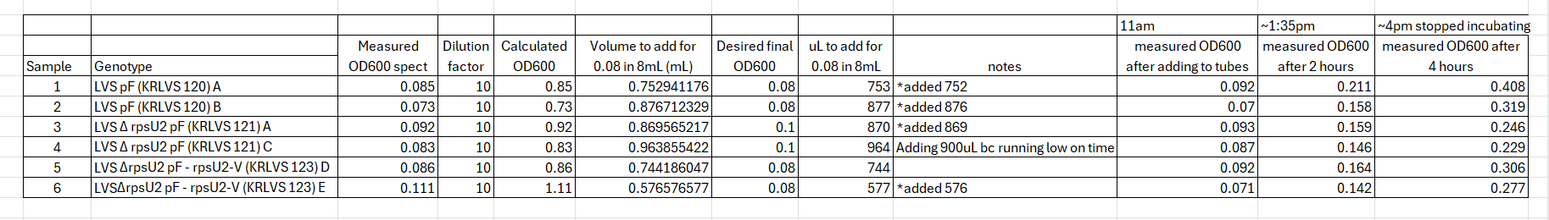

Figure 1: OD600 of samples 1-6 and set up of samples. Table from excel
It took a lot longer to get to the desired OD600 than originally expected when beginning cultures. I realized I have to take a lot more bacteria onto the loop than I originally thought.

Wednesday, January 24, 2024
To Do:
- Day 2 of RNAsnap protocol (steps 10-9)

Results and Data:
When doing step 14 saw pellets were white, however they moved readily and were not adhering to side of tube. Some pellet did make it into the new tubes.

Protocol – RNAsnap
Adapted from: Stead et al. (2012) Nucleic Acids Research
Updated 10/26/22
Note: All reagents should be RNAse free; use good RNA-technique by cleaning work area, gloves, and instruments with RNAse-away.
Wear safety goggles when handling formamide and dispose of as hazardous waste.
RNAsnap
- Grow strains to mid-log
- Centrifuge 1 to 10 mL of bacterial culture at max speed for 3 (1 MIN) mins. Discard supernatant. Repeat added 1.8ml to tube once, centrifuged, discarded supernatant, then added another 1.8ml to tube and repeated process. (remaining steps will be in hood. Bring in heat block, vortex, and centrifuge into hood. Super sterile)
- Resuspend cell pellet in 100 µL of fresh RES (see recipe below) by vortexing vigorously. If using 10 mL of culture, use 300 µL of RES.
- Incubate sample at 95°C for 7 minutes.
- Pellet cell debris by centrifuging at max speed for 5 mins at room temperature. Carefully move the supernatant to a fresh tube without disturbing the gelatinous pellet. We did twice because couldn’t see pellet first time. We did this outside of hood because no room in hood.
Sodium acetate/ethanol precipitation
- BACK TO HOOD. Dilute RNA sample to 300 µL with water. We had 60ul of rna sample, possibly some gelatinous material with it. Added 240ul of water
- Add 1/10 volume of 3 M sodium acetate, pH 5.2 (30 µL).
- Add 2 µL GlycoBlue Coprecipitant (ThermoFisher)
- Add three volumes of 100% ethanol (900 µL). Mix by vortexing then incubate for at least 60 mins (or overnight) at -80°C. STOPPED HERE 1/23/24 and 1/24/24 at end of day.
- Centrifuge at max speed for 30 mins at 4°C. Carefully remove supernatant. Set up centrifuge to correct temp prior. Started here 1/24/24
- Wash cell pellet with 250 µL of freshly-diluted 75% ethanol. Make fresh each time.
- Centrifuge at max speed for 5 mins at 4°C. Carefully remove supernatant.
- Briefly centrifuge again to allow removal of all remaining ethanol, then air dry the pellet.
- Resuspend the pellet in 80 µL water. Centrifuge at max speed for 1 minute to pellet any remaining water insoluble proteins. Transfer the RNA-containing supernatant to a fresh tube.
- Check concentration by Nanodrop (RNA setting).
DNAse Treatment (Promega)
- Add 10 µL RNase-free DNase buffer and 10 µL RNase-free DNase (Promega, RQ1)
- Incubate at 37°C for 1 hour. Can be right in incubator doesn’t need heat block.
- Repeat sodium acetate/ethanol precipitation as above (steps 6-15). Resuspend in 50uL this time, NOT 80 (step 14).

Table 1: Nanodrop results after first day (total nucleic acids)
# | Sample ID | Nucleic Acid | Unit | 260/280 | 260/230
1 | LVS pF A | 862.4 | ng/µl | 1.91 | 1.08
2 | LVS pF B | 742.1 | ng/µl | 1.79 | 0.86
3 | LVS Δ rpsU2 pF A | 423.6 | ng/µl | 1.49 | 0.81
4 | LVS Δ rpsU2 pF C | 543.7 | ng/µl | 1.74 | 0.74
5 | LVS ΔrpsU2 pF - rpsU2-V D | 850.5 | ng/µl | 1.71 | 0.74
6 | LVS ΔrpsU2 pF - rpsU2-V E | 777.8 | ng/µl | 1.71 | 0.72

Thursday, January 25, 2024
To Do:
- Day 3 of RNAsnap protocol steps 10- end
- Set up agarose gel to check RNA purity/ extraction results

Results and Data:
In seeing how the RNA purity levels were from yesterday’s nanodrop (only one of the A260/280 were at the 1.8 threshold and the 260/230 were all low) going to set up plan to do new RNA isolation next week. In doing the planning, the first streaks should be done tomorrow (Friday) so day 6 can be on Wednesday where I have large chunks of time to be in the lab. Goal is to be better at the gelatinous pellet step as we were unsure that the pellet wasn’t touched the first time as well as get better values purity-wise with both RNA/protein contaminants and salt from nanodrop.
After seeing the end of today’s Nanodrop results, it is good that the 260/280 value is around 2 for all of them! That is what we are looking for. The 260/230 looks a bit low, however the value is comparable to the values Hannah was getting, which I would assume is good because the lab has gone forward with those values in the past.

Protocol – RNAsnap
Adapted from: Stead et al. (2012) Nucleic Acids Research
Updated 10/26/22
Note: All reagents should be RNAse free; use good RNA-technique by cleaning work area, gloves, and instruments with RNAse-away.
Wear safety goggles when handling formamide and dispose of as hazardous waste.
RNAsnap
- Grow strains to mid-log
- Centrifuge 1 to 10 mL of bacterial culture at max speed for 3 (1 MIN) mins. Discard supernatant. Repeat added 1.8ml to tube once, centrifuged, discarded supernatant, then added another 1.8ml to tube and repeated process. (remaining steps will be in hood. Bring in heat block, vortex, and centrifuge into hood. Super sterile)
- Resuspend cell pellet in 100 µL of fresh RES (see recipe below) by vortexing vigorously. If using 10 mL of culture, use 300 µL of RES.
- Incubate sample at 95°C for 7 minutes.
- Pellet cell debris by centrifuging at max speed for 5 mins at room temperature. Carefully move the supernatant to a fresh tube without disturbing the gelatinous pellet. We did twice because couldn’t see pellet first time. We did this outside of hood because no room in hood.
Sodium acetate/ethanol precipitation
- BACK TO HOOD. Dilute RNA sample to 300 µL with water. We had 60ul of rna sample, possibly some gelatinous material with it. Added 240ul of water
- Add 1/10 volume of 3 M sodium acetate, pH 5.2 (30 µL).
- Add 2 µL GlycoBlue Coprecipitant (ThermoFisher)
- Add three volumes of 100% ethanol (900 µL). Mix by vortexing then incubate for at least 60 mins (or overnight) at -80°C. STOPPED HERE 1/23/24 and 1/24/24 at end of day.
- Centrifuge at max speed for 30 mins at 4°C. Carefully remove supernatant. Set up centrifuge to correct temp prior. Started here 1/24/24
- Wash cell pellet with 250 µL of freshly-diluted 75% ethanol. Make fresh each time.
- Centrifuge at max speed for 5 mins at 4°C. Carefully remove supernatant.
- Briefly centrifuge again to allow removal of all remaining ethanol, then air dry the pellet.
- Resuspend the pellet in 80 µL water. Centrifuge at max speed for 1 minute to pellet any remaining water insoluble proteins. Transfer the RNA-containing supernatant to a fresh tube.
- Check concentration by Nanodrop (RNA setting).
DNAse Treatment (Promega)
- Add 10 µL RNase-free DNase buffer and 10 µL RNase-free DNase (Promega, RQ1)
- Incubate at 37°C for 1 hour. Can be right in incubator doesn’t need heat block.
- Repeat sodium acetate/ethanol precipitation as above (steps 6-15). Resuspend in 50uL this time, NOT 80 (step 14).

Table 2: Nanodrop results final (RNA)

# | Sample ID | Nucleic Acid | Unit | 260/280 | 260/230
1 | LVS pF A | 527.5 | ng/µl | 1.98 | 1.59
2 | LVS pF B | 480.4 | ng/µl | 1.98 | 1.54
3 | LVS Δ rpsU2 pF A | 350.4 | ng/µl | 1.93 | 1.41
4 | LVS Δ rpsU2 pF C | 294.3 | ng/µl | 1.99 | 1.51
5 | LVS ΔrpsU2 pF - rpsU2-V D | 417.2 | ng/µl | 2 | 1.62
6 | LVS ΔrpsU2 pF - rpsU2-V E | 354.5 | ng/µl | 2.01 | 1.66

Table 3: Dilution of RNA for gel

Sample | RNA to add (uL) | water to add to 10uL | 6x Loading Dye to add (uL) | Total (uL)
1 | 3.8 | 6.2 | 2 | 12
2 | 4.2 | 5.8 | 2 | 12
3 | 5.7 | 4.3 | 2 | 12
4 | 6.8 | 3.2 | 2 | 12
5 | 4.8 | 5.2 | 2 | 12
6 | 5.6 | 4.4 | 2 | 12

This table was for running an agarose gel. Diluted the RNA so there was about 2000ng in each well. Diluted with RNAse free water.
Loaded 10uL in each well. 1% agarose gel ran at 110 V for 55min.
Lane 3 – sample 1
Lane 4 – sample 2
Lan3 5 – sample 3
Lane 6 – sample 4
Lane 7 – sample 5
Lane 8 – sample 6

Figure 2: Gel Image of RNA
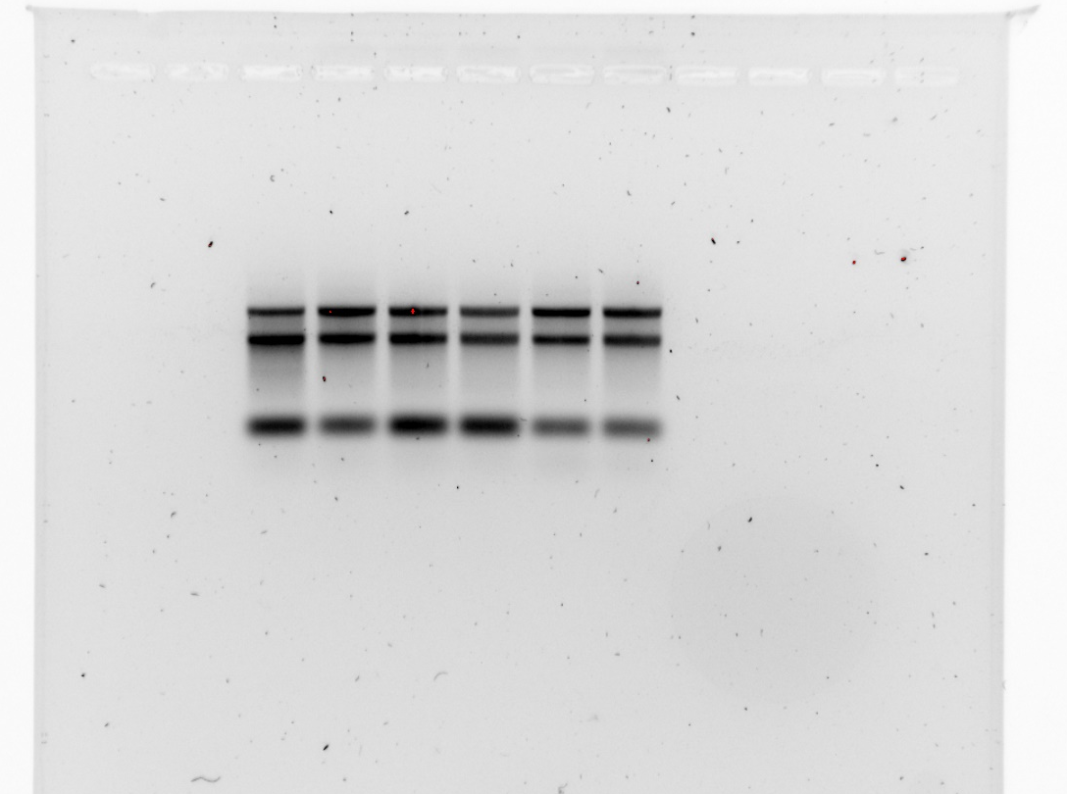

Friday, January 26, 2024
To Do:
- Streak out KRLVS 121 for RNA isolation repeats
Sunday, January 28, 2024
To Do:
- Streak out KRLVS 120 and 123 for RNA isolation repeats
Monday, January 29, 2024
To Do:
- Patch KRLVS 121 for RNA isolation repeats
- cDNA generation (part 1)
Results and Data:
Patched out KRLVS 121 to continue RNA isolation repeats.
For the RNA isolation done last week (started Jan 23, 2024) started cDNA generation.

Protocol: Generate cDNA (half protocol)*
*REACTION SIZE CUT IN HALF from Lory lab microarray protocol

- Combine the first components for primer annealing:
Component | Volume or Amount | Final Concentration
RNA | 3 ug | - - 333 ng/ ul
(NS)₅ Primer (250 ng/ul) | 1.5 ul | - g/ul
RNase-free water | up to 15 ul

- To normalize all the cDNA samples to the same DNA mass, dilute with RNase-free water in PCR strip tubes.

Table 4: cDNA volumes to add to each tube
Isolated 1.223.24 |  |  | cDNA
Sample | Patch | Template type | RNA conc | RNA (uL) | H2O | Total RNA
1 | A | LVS pF | 527.5 | 5.7 | 7.8 | 3000
2 | B | LVS pF | 480.4 | 6.2 | 7.3 | 3000
3 | A | LVS ΔrpsU2 pF | 350.4 | 8.6 | 4.9 | 3000
4 | C | LVS ΔrpsU2 pF | 294.3 | 10.2 | 3.3 | 3000
5 | D | LVS ΔrpsU2 pF - rpsU2 V | 417.2 | 7.2 | 6.3 | 3000
6 | E | LVS ΔrpsU2 pF - rpsU2 V | 354.5 | 8.5 | 5.0 | 3000

Note the total volume of cDNA and water is 13.5 uL.
- Add the 1.5 uL (NS)₅ oligo (stored in small aliquots at -80°C; take your own aliquot to use and move it to your own stock box; minimize freeze/thaw cycles) to the tubes.

- Incubate using program JSScDNA1 in the thermocycler:
  - Step Temp Time
  - 1 70°C 10'
  - 2 25°C 10'
  - 3 4°C hold

- While waiting, prepare the cDNA synthesis reaction in master mix format. The number of reactions you have plus 1.5 should be the factor you multiply by.

 | Master mix for cDNA synthesis reaction
Component | Final Conc | Volume (uL) | x9
5x 1st strand buffer | 1x | 6 | 54
Rnase-free water |  | 2.87 | 25.83
100mM DTT | 10mM | 3 | 27
10mM dNTPs | 0.5mM | 1.5 | 13.5
Superscript III (200U/uL) | 10.8U/uL | 1.63 | 14.67
 | total | 15 | 135
*Buffer, DTT, and dNTPs should be from the cDNA reagents box (they are RNase free!)
Note: When I did this on 1/29/24 I had 6 reactions. I multiplied by 9 because I multiplied 1.5 * 6 not 7.5 reactions. The ratios are the same, so I saved the extra Master Mix at -80C in the RNA box.
- Aliquot 15 ul of master mix per reaction into each PCR tube from the first reaction (total volume now 30ul)

- Incubate using program JSScDNA2
  - Step Temp Time
  - 1 25°C 10'
  - 2 37°C 60'
  - 4 42°C 60'
  - 5 70°C 10'
  - 6 4°C hold

*potential stopping point- samples can be stored at -80°C if necessary Stopped here 1/29/2024, saved in -80C box.

- Remove RNA from sample by degrading with sodium hydroxide:

- Add 10 ul of 1N NaOH
- Incubate 65°C for 30'
- Neutralize with 10 ul of 1N HCl
- Final volume is 50 ul
- Purify cDNA using Qiagen PCR clean-up column (be very sure there is no ethanol carry-over!) THIS IS THE PCR PURIFICATION PROTOCOL
- Elute in 60 ul of 0.1x EB

- Check concentration by Nanodrop

- Store cDNA at -80°C

Tuesday, January 30, 2024
To Do:
- cDNA generation part 2
- checked cDNA on nanodrop
- Patched KRLVS 120 and 123
Results and Data:
When looking at the isolated colonies from 1.28.324 they were really really small, they barely looked like colonies. Therefore I put them back in the incubator and will let them grow longer so I can hopefully isolate them by the end of the day for patches. If not, the plan is to let them grow longer tomorrow reisolate them so on Sunday I can have individual colonies for patches. I’ll patch them out on Saturday or Sunday so I can do the isolation on Monday.
Update: by the end of the day the colonies were still really tiny, however I saw isolated ones so I patched them out around 6pm.

Table 6: Nanodrop results from cDNA generation
# | Sample ID | Nucleic Acid | Unit | 260/280 | 260/230 | Sample Type
1 |  | 7.4 | ng/µl | 2.17 | 0.43 | DNA
2 |  | 10 | ng/µl | 1.78 | 0.72 | DNA
3 |  | 6.9 | ng/µl | 1.93 | 0.32 | DNA
4 |  | 15.9 | ng/µl | 1.68 | 0.52 | DNA
5 |  | 11.9 | ng/µl | 1.87 | 0.74 | DNA
6 |  | 22.9 | ng/µl | 1.54 | 0.81 | DNA

The 260/230 values don’t look good. When looking at Hannah’s notebook to compare I saw she ran the nanodrop setting on ssDNA. I ran this one on DNA. After talking to Dr. Ramsey, the cDNA that was made is just a single long strand, as there were no cycles or normal PCR steps in the incubation. Therefore, future nanodrops should be run on the ssDNA setting. This does not, however, account for the 260230 values being so poor. Therefore, left tubes open on bench, on ice, for about five hours to let the ethanol evaporate from sample. After letting the ethanol evaporate, reran the samples on the nanodrop under the ssDNA setting. Results are in table 7. Not much changed. Another possible source of error is the blue dye that is used in the RNAsnap protocol, as this can absorb at the same wavelength. Next time the RNAsnap protocol is done, I won’t use the blue dye glycerol and will instead use a clear one. Currently, I’m not going to repeat the cDNA generation as I’ll still have the same problem with the blue glycerol. Therefore when the next RNA isolation happens, I will do the cDNA generation from that.

Table 7: Nanodrop values on generated cDNA after ethanol evaporation, ssDNA setting
# | Sample ID | Date and Time | Nucleic Acid | Unit | 260/280 | 260/230 | Sample Type
1 | KRLVS 120 A | 1/30/2024 5:40:00 PM | 6.8 | ng/µl | 2.28 | 0.48 | ssDNA
2 | KRLVS 120 B | 1/30/2024 5:40:44 PM | 9.5 | ng/µl | 2.13 | 0.74 | ssDNA
3 | KRLVS 121 A | 1/30/2024 5:41:33 PM | 12.5 | ng/µl | 1.87 | 0.51 | ssDNA
4 | KRLVS 121 C | 1/30/2024 5:42:07 PM | 7.7 | ng/µl | 2.12 | 0.58 | ssDNA
5 | KRLVS 123 D | 1/30/2024 5:42:50 PM | 9.3 | ng/µl | 2.02 | 0.73 | ssDNA
6 | KRLVS 123 E | 1/30/2024 5:43:27 PM | 13.5 | ng/µl | 1.93 | 0.84 | ssDNA

Wednesday, January 31, 2024
To Do:
- Streaked for isolated KRLVS 121
- Refilled 85% ethanol bottle
- Lab chores (autoclave dry materials)
- Made a lawn of KRLVS121 for glycerol stock
Results and Data:
Unfortunately, when I came in this morning none of the patches I did yesterday grew. I’m assuming because there was only fourteen hours between them. This is unfortunate. So, I restreaked for isolation KRLVS 121, to repeat the whole process. That makes today day 1, which will make Monday day 6, or the day I do the isolation. This is good, as that is the first day I will be working with a new undergraduate student, so they will have things to watch which is nice. As I didn’t get a lot of growth before, I have decided I will streak for isolation KRLVS 120 and 123 tomorrow (instead of day 3) so they will have more time to grow. Over the weekend I will do the patching. That way I’ll know for sure I’ll have patches on Monday.
Thursday, February 1, 2024
To Do:
- Streaked for isolated KRLVS 120 and 123
Results and Data
Talked to Dr. Ramsey about running another gel on the RNA to see if we have the 16s and 17s RNA in the extraction. To do this we can set up a 1.6% agarose gel and run it for a long time. Set up the gel the same way as before (table 3). Will probably be able to do it Monday morning? Possibly Tuesday?
Friday, February 2, 2024
To Do:
- Make glycerol stocks of KRLVS121 from lawn made earlier in week
Results and Data:
Looked at growth of other plates. Seemed good. Will be back in tomorrow to work on patches.
Saturday, February 3, 2024
To Do:
- Patch out KRLVS 121
- Make lawns of KRLVS 120 and 123 from previous patches to make glycerol stocks
Sunday, February 4, 2024
To Do:
- Patch out KRLVS 120 and 123
Monday, February 5, 2024
To Do:
- Start RNA isolation day 1 (grow cultures and begin isolation)
- Make glycerol stocks of KRLVS120 and 123
- If time: agarose gel on RNA for long time to find 16s and 17s

Protocol – Culture growth for RNA isolation
- Put 8mL of supplemented MHB into sterile glass tubes and warm at 37C in incubator
- For each bacterial sample, scape up one patch of cells and resuspend in ~300uL of supplemented MHB in sterile 1.5mL microcentrifuge tube
- Add 700uL more supplemented MHB, make sure cells are well-resuspended
- Check OD600
  - Dilute resuspended cells 1:10 in MHB (100 uL cells, 900 uL MHB)
  - Check OD600 using 1 mL MHB as blank
  - Calculate actual OD600 (measured OD600 multiplied by dilution factor [10])*
  - Calculate what volume of cells you need to obtain an OD600 of 0.08 in 8 mL*
  - Make an excel sheet to help with this
- For each sample, inoculate one glass culture tube so that the final OD600 is 0.08
  - Example:
  - OD600 of resuspended cells: 4.0
  - (8 mL )(0.08 OD600) / (4.0 OD600) = 0.18 mL resuspended cells (180 uL)
  - Add 8 mL MHB per tube, remove 180 uL, and add back 180 uL resuspended cells
- Swirl tube to distribute cells
- Remove 1mL and use to measure OD600, record results in excel sheet
- Put tubes at 37C shaking
- Check OD600 after ~ 2 hours to be sure cells have come close to doubling (document OD600!*)
- When OD600 reaches between 0.3 – 0.4 (4-6 hours, document OD600!*):
  - Transfer 1.8 mL into 2 mL tube.
  - Go to RNAsnap protocol step 2

Table 8: OD600 Values after four hours
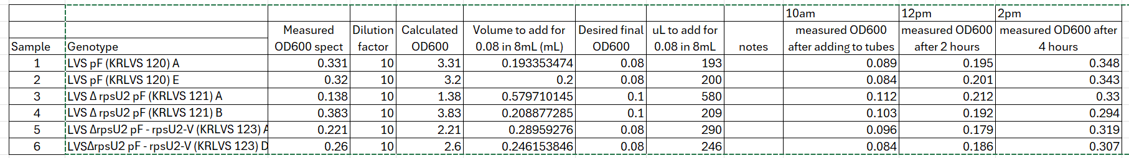

Protocol – RNAsnap protocol
Adapted from: Stead et al. (2012) Nucleic Acids Research
Updated 10/26/22
Note: All reagents should be RNAse free; use good RNA-technique by cleaning work area, gloves, and instruments with RNAse-away.
Wear safety goggles when handling formamide and dispose of as hazardous waste.
RNAsnap
- Grow strains to mid-log
- Centrifuge 1 to 10 mL of bacterial culture at max speed for 3 (1 MIN) mins. Discard supernatant. REPEAT ADDED 1.8ML TO TUBE ONCE, CENTRIFUGED, DISCARDED SUPERNATANT, THEN ADDED ANOTHER 1.8ML TO TUBE AND REPEATED PROCESS. (REMAINING STEPS WILL BE IN HOOD. BRING IN HEAT BLOCK, VORTEX, AND CENTRIFUGE INTO HOOD. SUPER STERILE)
- Resuspend cell pellet in 100 µL of fresh RES (see recipe below) by vortexing vigorously. If using 10 mL of culture, use 300 µL of RES.
- Incubate sample at 95°C for 7 minutes.
- Pellet cell debris by centrifuging at max speed for 5 mins at room temperature. Carefully move the supernatant to a fresh tube without disturbing the gelatinous pellet. We did twice because couldn’t see pellet first time. We did this outside of hood because no room in hood. Sample 5 may have had some gelatinous material with it.
Sodium acetate/ethanol precipitation
- BACK TO HOOD. Dilute RNA sample to 300 µL with water. WE HAD 60UL OF RNA SAMPLE, POSSIBLY SOME GELATINOUS MATERIAL WITH IT. ADDED 240UL OF WATER
- Add 1/10 volume of 3 M sodium acetate, pH 5.2 (30 µL).
- Add 2 µL GlycoBlue Coprecipitant (ThermoFisher). Used new glycogen to test if glycoblue interfered with nanodrop reading.
- Add three volumes of 100% ethanol (900 µL). Mix by vortexing then incubate for at least 60 mins (or overnight) at -80°C. STOPPED HERE 2/5/24
- Centrifuge at max speed for 30 mins at 4°C. Carefully remove supernatant. Set up centrifuge to correct temp prior.
- Wash cell pellet with 250 µL of freshly-diluted 75% ethanol. Make fresh each time.
- Centrifuge at max speed for 5 mins at 4°C. Carefully remove supernatant.
- Briefly centrifuge again to allow removal of all remaining ethanol, then air dry the pellet.
- Resuspend the pellet in 80 µL water. Centrifuge at max speed for 1 minute to pellet any remaining water insoluble proteins. Transfer the RNA-containing supernatant to a fresh tube.
- Check concentration by Nanodrop (RNA setting).
DNAse Treatment (Promega)
- Add 10 µL RNase-free DNase buffer and 10 µL RNase-free DNase (Promega, RQ1)
- Incubate at 37°C for 1 hour.
- Repeat sodium acetate/ethanol precipitation as above (steps 6-15). Resuspend in 50uL this time, NOT 80 (step 14).

Buffers and Reagents:
For all reagents (except 2-mercaptoethanol), use specific stocks for RNA work.
RNA Extraction Solution (RES)
Component | Stock Solution | Final Concentration | Volume (µL)
Water |  |  | 2.65
Formamide | 100% | 95% | 950.0
EDTA | 0.5 M | 18 mM | 36.0
SDS | 20% | 0.025% | 1.25
BME | 99% | 1% | 10.1
 |  | Final volume: | 1000.0

Tuesday, February 6, 2024
To Do:
- Start RNA isolation day 2 (grow cultures and begin isolation)

Protocol – RNAsnap protocol
Adapted from: Stead et al. (2012) Nucleic Acids Research
Updated 10/26/22
Note: All reagents should be RNAse free; use good RNA-technique by cleaning work area, gloves, and instruments with RNAse-away.
Wear safety goggles when handling formamide and dispose of as hazardous waste.
RNAsnap
- Grow strains to mid-log
- Centrifuge 1 to 10 mL of bacterial culture at max speed for 3 (1 MIN) mins. Discard supernatant. REPEAT ADDED 1.8ML TO TUBE ONCE, CENTRIFUGED, DISCARDED SUPERNATANT, THEN ADDED ANOTHER 1.8ML TO TUBE AND REPEATED PROCESS. (REMAINING STEPS WILL BE IN HOOD. BRING IN HEAT BLOCK, VORTEX, AND CENTRIFUGE INTO HOOD. SUPER STERILE)
- Resuspend cell pellet in 100 µL of fresh RES (see recipe below) by vortexing vigorously. If using 10 mL of culture, use 300 µL of RES.
- Incubate sample at 95°C for 7 minutes.
- Pellet cell debris by centrifuging at max speed for 5 mins at room temperature. Carefully move the supernatant to a fresh tube without disturbing the gelatinous pellet. We did twice because couldn’t see pellet first time. We did this outside of hood because no room in hood. Sample 5 may have had some gelatinous material with it.
Sodium acetate/ethanol precipitation
- BACK TO HOOD. Dilute RNA sample to 300 µL with water. WE HAD 60UL OF RNA SAMPLE, POSSIBLY SOME GELATINOUS MATERIAL WITH IT. ADDED 240UL OF WATER
- Add 1/10 volume of 3 M sodium acetate, pH 5.2 (30 µL).
- Add 2 µL GlycoBlue Coprecipitant (ThermoFisher). Used new glycogen to test if glycoblue interfered with nanodrop reading.
- Add three volumes of 100% ethanol (900 µL). Mix by vortexing then incubate for at least 60 mins (or overnight) at -80°C. STOPPED HERE 2/6/24
- Centrifuge at max speed for 30 mins at 4°C. Carefully remove supernatant. Set up centrifuge to correct temp prior.
- Wash cell pellet with 250 µL of freshly-diluted 75% ethanol. Make fresh each time.
- Centrifuge at max speed for 5 mins at 4°C. Carefully remove supernatant.
- Briefly centrifuge again to allow removal of all remaining ethanol, then air dry the pellet.
- Resuspend the pellet in 80 µL water. Centrifuge at max speed for 1 minute to pellet any remaining water insoluble proteins. Transfer the RNA-containing supernatant to a fresh tube.
- Check concentration by Nanodrop (RNA setting).
DNAse Treatment (Promega)
- Add 10 µL RNase-free DNase buffer and 10 µL RNase-free DNase (Promega, RQ1)
- Incubate at 37°C for 1 hour.
- Repeat sodium acetate/ethanol precipitation as above (steps 6-15). Resuspend in 50uL this time, NOT 80 (step 14).

Buffers and Reagents:
For all reagents (except 2-mercaptoethanol), use specific stocks for RNA work.

Table 9: Nanodrop values after day 2 (total RNA)
# | Sample ID | Nucleic Acid | Unit | A260 (Abs) | A280 (Abs) | 260/280 | 260/230
1 | LVS pF (KRLVS 120) A | 543.2 | ng/µl | 13.579 | 7.169 | 1.89 | 1
2 | LVS pF (KRLVS 120) E | 525.7 | ng/µl | 13.142 | 6.872 | 1.91 | 1.07
3 | LVS ΔrpsU2 pF (KRLVS 121) A | 549.3 | ng/µl | 13.734 | 7.287 | 1.88 | 0.98
4 | LVS ΔrpsU2 pF (KRLVS 121) B | 526.4 | ng/µl | 13.16 | 7.03 | 1.87 | 0.99
5 | LVS ΔrpsU2 pF - rpsU2 - V (KRLVS 123) A | 476.3 | ng/µl | 11.908 | 6.452 | 1.85 | 0.91
6 | LVS ΔrpsU2 pF - rpsU2 - V (KRLVS 123) D | 425.9 | ng/µl | 10.647 | 5.631 | 1.89 | 0.98

Wednesday, February 7, 2024
To Do:
- Start RNA isolation day 3 (grow cultures and begin isolation)
- Make glycerol stocks of KRLVS120 and 123
- If time: agarose gel on RNA for long time to find 16s and 17s
- Make TSBHK media for P. ging
- Put new strains and media into anaerobic chamber

Protocol – RNAsnap protocol
Adapted from: Stead et al. (2012) Nucleic Acids Research
Updated 10/26/22
Note: All reagents should be RNAse free; use good RNA-technique by cleaning work area, gloves, and instruments with RNAse-away.
Wear safety goggles when handling formamide and dispose of as hazardous waste.
RNAsnap
- Grow strains to mid-log
- Centrifuge 1 to 10 mL of bacterial culture at max speed for 3 (1 MIN) mins. Discard supernatant. REPEAT ADDED 1.8ML TO TUBE ONCE, CENTRIFUGED, DISCARDED SUPERNATANT, THEN ADDED ANOTHER 1.8ML TO TUBE AND REPEATED PROCESS. (REMAINING STEPS WILL BE IN HOOD. BRING IN HEAT BLOCK, VORTEX, AND CENTRIFUGE INTO HOOD. SUPER STERILE)
- Resuspend cell pellet in 100 µL of fresh RES (see recipe below) by vortexing vigorously. If using 10 mL of culture, use 300 µL of RES.
- Incubate sample at 95°C for 7 minutes.
- Pellet cell debris by centrifuging at max speed for 5 mins at room temperature. Carefully move the supernatant to a fresh tube without disturbing the gelatinous pellet. We did twice because couldn’t see pellet first time. We did this outside of hood because no room in hood. Sample 5 may have had some gelatinous material with it.
Sodium acetate/ethanol precipitation
- BACK TO HOOD. Dilute RNA sample to 300 µL with water. WE HAD 60UL OF RNA SAMPLE, POSSIBLY SOME GELATINOUS MATERIAL WITH IT. ADDED 240UL OF WATER
- Add 1/10 volume of 3 M sodium acetate, pH 5.2 (30 µL).
- Add 2 µL GlycoBlue Coprecipitant (ThermoFisher). Used new glycogen to test if glycoblue interfered with nanodrop reading.
- Add three volumes of 100% ethanol (900 µL). Mix by vortexing then incubate for at least 60 mins (or overnight) at -80°C. STOPPED HERE 2/6/24. Started step 10 2/7/24
- Centrifuge at max speed for 30 mins at 4°C. Carefully remove supernatant. Set up centrifuge to correct temp prior.
- Wash cell pellet with 250 µL of freshly-diluted 75% ethanol. Make fresh each time.
- Centrifuge at max speed for 5 mins at 4°C. Carefully remove supernatant.
- Briefly centrifuge again to allow removal of all remaining ethanol, then air dry the pellet.
- Resuspend the pellet in 80 µL water. Centrifuge at max speed for 1 minute to pellet any remaining water insoluble proteins. Transfer the RNA-containing supernatant to a fresh tube.
- Check concentration by Nanodrop (RNA setting).
DNAse Treatment (Promega)
- Add 10 µL RNase-free DNase buffer and 10 µL RNase-free DNase (Promega, RQ1)
- Incubate at 37°C for 1 hour.
- Repeat sodium acetate/ethanol precipitation as above (steps 6-15). Resuspend in 50uL this time, NOT 80 (step 14).

Buffers and Reagents:
For all reagents (except 2-mercaptoethanol), use specific stocks for RNA work.

Table 10: Nanodrop values after RNA isolation
# | Sample ID | Nucleic Acid | Unit | A260 (Abs) | A280 (Abs) | 260/280 | 260/230
1 | LVS pF (KRLVS 120) A | 365.7 | ng/µl | 9.144 | 4.452 | 2.05 | 1.67
2 | LVS pF (KRLVS 120) E | 374.8 | ng/µl | 9.37 | 4.576 | 2.05 | 1.74
3 | LVS ΔrpsU2 pF (KRLVS 121) A | 405.6 | ng/µl | 10.139 | 4.996 | 2.03 | 1.61
4 | LVS ΔrpsU2 pF (KRLVS 121) B | 358.9 | ng/µl | 8.972 | 4.408 | 2.04 | 1.62
5 | LVS ΔrpsU2 pF - rpsU2 - V (KRLVS 123) A | 294.9 | ng/µl | 7.371 | 3.65 | 2.02 | 1.56
6 | LVS ΔrpsU2 pF - rpsU2 - V (KRLVS 123) D | 263.5 | ng/µl | 6.588 | 3.268 | 2.02 | 1.54

Sterile loops to bring to M. Ramsey anaerobic chamber
800ul of TSBHK and 200ul of DMSO into cryovials into chamber.
Made TSBHK

Protocol: TSB supplemented with Hemin and Vitamin K (TSBHK)
Reference: Duncan et al 1993, Infect. Immun. 61: 2260-2265
- Final volume 500mL 1000mL
- TSB 15g 30g
- Hemin (1 mg/mL) 2.5mL 5mL (final = 5 μg/mL)
- dH2O 500mL 1000mL
- Menadione* (stock = 1 mg/mL, final = 1 μg/mL)
- Antibiotics*
- added sterilely after autoclaving
- Dissolve TSB and hemin in water and autoclave (121°C for at least 30min) then allow the media to cool. Add menadione (vitamin K) and antibiotics (if necessary) just prior to use.

Protocol: Hemin stock solution (1 mg/mL)
- Potassium hydroxide 1.12g
- dH2O 100mL
- 95% Ethanol 100mL
- Hemin 0.2g
- Dissolve potassium hydroxide in the water. Once dissolved, add the ethanol. To that add the hemin. It takes a while to dissolve hemin into the solution. Filter sterilize hemin solution. Store the solution at 4°C in a light sensitive container. Add 5 mL/L of media, such as in BAPHK.

Protocol: Menadione stock solution (1 mg/mL)
- Menadione 0.05g
- 95% Ethanol 50mL
- Dissolve menadione in the ethanol. Filter sterilize the solution. Store the solution at -20°C. Add 1 mL/L of media, such as in BAPHK.

Thursday, February 8, 2024
To Do:
- Run isolated RNA on 1.6% agarose gel
- Make new 1x TAE
- Make glycerol stocks of KRLVS120 and 123
- If time: agarose gel on RNA for long time to find 16s and 17s
Data and results:
2% agarose gel was made (2g agarose, 100mL 1xTAE, 10uL sybr safe). RNA samples from this week and last week were run on it to see if we could separate the 16s from the 17s RNA. Gel was run for approximately 4 hours with the first hour being on 110V and the remaining being on 90V. Gel was stopped for a little bit in the middle as the timer was on the gel box and I didn’t realize it until (an estimated) half an hour after it was stopped.

Table 11: Amount of RNA loaded into each well.
Each well had approx. 2000ng of RNA. This is for the new samples from Feb 7th, 2024. The amounts of RNA and chart followed for the samples from Jan 25th are on Jan 25th.
Sample | RNA to add (uL) | Water (uL) | 6x Loading dye | total
1 | 5.5 | 4.5 | 2 | 12
2 | 5.3 | 4.7 | 2 | 12
3 | 4.9 | 5.1 | 2 | 12
4 | 5.6 | 4.4 | 2 | 12
5 | 6.8 | 3.2 | 2 | 12
6 | 7.6 | 2.4 | 2 | 12

Lane 1: LVS pF (KRLVS 120) A (from Feb 7, 2024)
Lane 2: LVS pF (KRLVS 120) E from feb 7th, 2024
Lane 3: LVS ΔrpsU2 pF (KRLVS 121) A from feb 7th, 2024
Lane 4: LVS ΔrpsU2 pF (KRLVS 121) B from feb 7th, 2024

Lane 5: LVS ΔrpsU2 pF - rpsU2 - V (KRLVS 123) A from feb 7th, 2024

Lane 6: LVS ΔrpsU2 pF - rpsU2 - V (KRLVS 123) D from feb 7th, 2024
Lane 7: LVS pF A from Jan 25th
Lane 8: LVS pF B from Jan 25th
Lane 9: LVS Δ rpsU2 pF A from Jan 25th
Lane 10: LVS Δ rpsU2 pF C from Jan 25th
Lane 11: LVS ΔrpsU2 pF - rpsU2-V D from Jan 25th
Lane 12: LVS ΔrpsU2 pF - rpsU2-V E from Jan 25th
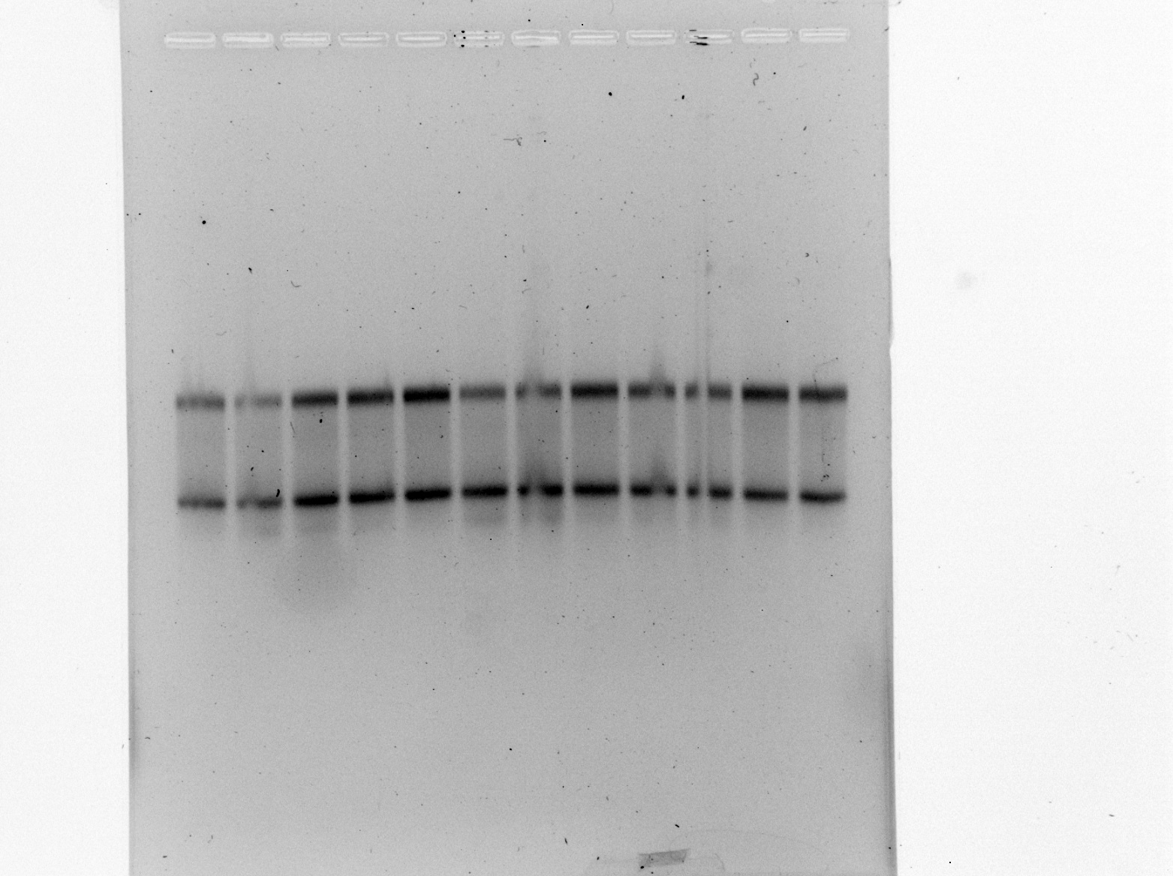

Figure 3: Gel image of RNA samples.
From the image, it looks like there is the 30s and 16s RNA. I do not see the 5s however that could’ve ran off the gel as it did run for 4 hours at a decently large voltage. I’m not worried, specifically because the last 6 lanes are samples that were previously run on gel where we saw the 5S RNA and the samples do not look like they have degraded over the past two weeks. It does not look like we can differentiate between the 16s and 17s rna.
Friday, February 9, 2024
To Do:
- Make stocks with p. ging
Results and Data:
Stocks were comprised of 800uL of TSBHK media and 200uL of DMSO. TSBHK media was brought into anaerobic chamber the day before so any remaining oxygen could dissipate. DMSO was brought in the morning of so it didn’t evaporate in the chamber.

Monday, February 12, 2024
To Do:
- Generate cDNA of RNA isolation from last week

Protocol: Generate cDNA (half protocol)*
*REACTION SIZE CUT IN HALF from Lory lab microarray protocol

- Combine the first components for primer annealing:
Component | Volume or Amount | Final Concentration
RNA | 3 ug | - - 333 ng/ ul
(NS)₅ Primer (250 ng/ul) | 1.5 ul | - g/ul
RNase-free water | up to 15 ul

- To normalize all the cDNA samples to the same DNA mass, dilute with RNase-free water in PCR strip tubes.

Table : cDNA volumes to add to each tube
Sample | Patch | Template type | Date Isolated | RNA conc | RNA | H2O | Total RNA
1 | A | LVS pF | 2/7/2024 | 365.7 | 8.2 | 5.3 | 3000
2 | E | LVS pF | 2/7/2024 | 374.8 | 8.0 | 5.5 | 3000
3 | A | LVS ΔrpsU2 pF | 2/7/2024 | 405.6 | 7.4 | 6.1 | 3000
4 | B | LVS ΔrpsU2 pF | 2/7/2024 | 358.9 | 8.4 | 5.1 | 3000
5 | A | LVS ΔrpsU2 pF - rpsU2 V | 2/7/2024 | 294.9 | 10.2 | 3.3 | 3000
6 | D | LVS ΔrpsU2 pF - rpsU2 V | 2/7/2024 | 263.5 | 11.4 | 2.1 | 3000

Note the total volume of cDNA and water is 13.5 uL.
- Add the 1.5 uL (NS)₅ oligo (stored in small aliquots at -80°C; take your own aliquot to use and move it to your own stock box; minimize freeze/thaw cycles) to the tubes.

- Incubate using program JSScDNA1 in the thermocycler:
  - Step Temp Time
  - 1 70°C 10'
  - 2 25°C 10'
  - 3 4°C hold

- While waiting, prepare the cDNA synthesis reaction in master mix format. The number of reactions you have plus 1.5 should be the factor you multiply by.

 | Master mix for cDNA synthesis reaction |  | # Reactions
Component | Final Conc | Volume (uL) | 9.5
5x 1st strand buffer | 1x | 6 | 57
Rnase-free water |  | 2.87 | 27.265
100mM DTT | 10mM | 3 | 28.5
10mM dNTPs | 0.5mM | 1.5 | 14.25
Superscript III (200U/uL) | 10.8U/uL | 1.63 | 15.485
 | total | 15 | 142.5

*Buffer, DTT, and dNTPs should be from the cDNA reagents box (they are RNase free!)

- Aliquot 15 ul of master mix per reaction into each PCR tube from the first reaction (total volume now 30ul)

- Incubate using program JSScDNA2
  - Step Temp Time
  - 1 25°C 10'
  - 2 37°C 60'
  - 4 42°C 60'
  - 5 70°C 10'
  - 6 4°C hold

*potential stopping point- samples can be stored at -80°C if necessary Stopped here 2/12/2024, saved in -80C box.

- Remove RNA from sample by degrading with sodium hydroxide:

- Add 10 ul of 1N NaOH
- Incubate 65°C for 30'
- Neutralize with 10 ul of 1N HCl
- Final volume is 50 ul
- Purify cDNA using Qiagen PCR clean-up column (be very sure there is no ethanol carry-over!) THIS IS THE PCR PURIFICATION PROTOCOL
- Elute in 60 ul of 0.1x EB

- Check concentration by Nanodrop

- Store cDNA at -80°C

Wednesday, February 14, 2024
To Do:
- Finish generate cDNA of RNA isolation from last week
Continuation of Protocol from yesterday. Started at step 8 (here its stated as step 1)
- Remove RNA from sample by degrading with sodium hydroxide:

- Add 10 ul of 1N NaOH
- Incubate 65°C for 30'
- Neutralize with 10 ul of 1N HCl
- Final volume is 50 ul
- Purify cDNA using Qiagen PCR clean-up column (be very sure there is no ethanol carry-over!) THIS IS THE PCR PURIFICATION PROTOCOL
- Elute in 60 ul of 0.1x EB
- Check concentration on nanodrop
- Store in -80C

Table: Nanodrop concentration of cDNA generation
The purity levels are really bad as well as the concentration of cDNA. A lot of RNA was used at the beginning of the process, so there should be a lot more cDNA generated now than there is. This has continually been a problem, so will do some troubleshooting to figure out what it is. The first step will be taking a known sample of RNA that has been successfully converted into cDNA before and convert that to see if its something with the RNA isolation process or something with the cDNA generation process.
Thursday, February 15, 2024
To Do:
- Generate cDNA of RNA isolation sample 2 and known RNA sample
- Inoculate broth tubes in anaerobic chamber of W83 and PG0121

Protocol: Generate cDNA (half protocol)*
*REACTION SIZE CUT IN HALF from Lory lab microarray protocol

- Combine the first components for primer annealing:

Component | Volume or Amount | Final Concentration
RNA | 3 ug | - - 333 ng/ ul
(NS)₅ Primer (250 ng/ul) | 1.5 ul | - g/ul
RNase-free water | up to 15 ul

- To normalize all the cDNA samples to the same DNA mass, dilute with RNase-free water in PCR strip tubes.

Table : cDNA volumes to add to each tube

Note the total volume of cDNA and water is 13.5 uL.
- Add the 1.5 uL (NS)₅ oligo (stored in small aliquots at -80°C; take your own aliquot to use and move it to your own stock box; minimize freeze/thaw cycles) to the tubes.

- Incubate using program JSScDNA1 in the thermocycler:
  - Step Temp Time
  - 1 70°C 10'
  - 2 25°C 10'
  - 3 4°C hold

- While waiting, prepare the cDNA synthesis reaction in master mix format. The number of reactions you have plus 1.5 should be the factor you multiply by.

*Buffer, DTT, and dNTPs should be from the cDNA reagents box (they are RNase free!)

- Aliquot 15 ul of master mix per reaction into each PCR tube from the first reaction (total volume now 30ul)

- Incubate using program JSScDNA2
  - Step Temp Time
  - 1 25°C 10'
  - 2 37°C 60'
  - 4 42°C 60'
  - 5 70°C 10'
  - 6 4°C hold

*potential stopping point- samples can be stored at -80°C if necessary Stopped here 2/15/2024, saved in -80C box.

- Remove RNA from sample by degrading with sodium hydroxide:

- Add 10 ul of 1N NaOH
- Incubate 65°C for 30'
- Neutralize with 10 ul of 1N HCl
- Final volume is 50 ul
- Purify cDNA using Qiagen PCR clean-up column (be very sure there is no ethanol carry-over!) THIS IS THE PCR PURIFICATION PROTOCOL
- Elute in 60 ul of 0.1x EB

- Check concentration by Nanodrop

- Store cDNA at -80°C

Friday, February 16, 2024
To Do:
- Finish cDNA generation
- Check dDNA generation on nanodrop

Table: cDNA nanodrop values with known working RNA sample
Notes:
I have no idea why I’m getting such poor cDNA values. The purification protocol is 7 steps and I feel confident in it, I don’t think it’s the protocol or anything I’m not doing in it, as I’m following it exactly. Some ideas I’m going to look into are:
      - Don’t do the potential stopping point after step 7. Keep going and finish it in one day.
      - New superscript III or other reagents? Maybe aliquot the larger reagents so they don’t thaw/freeze cycle. New tubes in general instead of the ones that looked like they were used by the last person
      - New reagents for the cDNA clean-up part. (PB buffer, PE buffer, new 0.1x EB). This will be last as I’m pretty confident these aren’t contaminated.
I’m confident in the RNA isolation, I don’t think that’s the problem because when using the known RNA sample that was isolated differently, I got the same result.
Tuesday, February 20, 2024
To Do:
- cDNA generation of known sample and new sample with troubleshooting
- Make BAPHK plates

After talking with Kathryn, going to troubleshoot by changing the reagents of the cDNA generation first. She doesn’t think the overnight step would do anything as at this point the RNA is cDNA and would be a lot more stable so the freeze/thaw isn’t as much of an issue. I replaced the buffer, DTT, dNTPS. I used the same superscript as I couldn’t find another. Followed protocol and froze after step 7, to not change too many things at once.

Protocol: Generate cDNA (half protocol)*
*REACTION SIZE CUT IN HALF from Lory lab microarray protocol

- Combine the first components for primer annealing:

Component | Volume or Amount | Final Concentration
RNA | 3 ug | - - 333 ng/ ul
(NS)₅ Primer (250 ng/ul) | 1.5 ul | - g/ul
RNase-free water | up to 15 ul

- To normalize all the cDNA samples to the same DNA mass, dilute with RNase-free water in PCR strip tubes.

Table : cDNA volumes to add to each tube

Note the total volume of cDNA and water is 13.5 uL.
- Add the 1.5 uL (NS)₅ oligo (stored in small aliquots at -80°C; take your own aliquot to use and move it to your own stock box; minimize freeze/thaw cycles) to the tubes.

- Incubate using program JSScDNA1 in the thermocycler:
  - Step Temp Time
  - 1 70°C 10'
  - 2 25°C 10'
  - 3 4°C hold

- While waiting, prepare the cDNA synthesis reaction in master mix format. The number of reactions you have plus 1.5 should be the factor you multiply by.

*Buffer, DTT, and dNTPs should be from the cDNA reagents box (they are RNase free!)

- Aliquot 15 ul of master mix per reaction into each PCR tube from the first reaction (total volume now 30ul)

- Incubate using program JSScDNA2
  - Step Temp Time
  - 1 25°C 10'
  - 2 37°C 60'
  - 4 42°C 60'
  - 5 70°C 10'
  - 6 4°C hold

*potential stopping point- samples can be stored at -80°C if necessary Stopped here 2/20/2024, saved in -80C box.

- Remove RNA from sample by degrading with sodium hydroxide:

- Add 10 ul of 1N NaOH
- Incubate 65°C for 30'
- Neutralize with 10 ul of 1N HCl
- Final volume is 50 ul
- Purify cDNA using Qiagen PCR clean-up column (be very sure there is no ethanol carry-over!) THIS IS THE PCR PURIFICATION PROTOCOL
- Elute in 60 ul of 0.1x EB

- Check concentration by Nanodrop

- Store cDNA at -80°C

Also, Dr. Ramsey and Kira noticed that the flasks we use for media prep and other things had a film in them, which led them to believe that the dishwasher isn’t working properly. Unsure if its our new dishwasher or the one on the third floor. Therefore, I handwashed some flasks and beakers so we would be able to use it. Will check today to see if I have to do a test or something to see if they’re actually clean.

Made Blood Agar Plates supplemented with Hemin and Vitamin K for the P. ging project. Made 500mL. No antibiotics added. Will dry on the benchtop overnight and then be used to isolate single colonies on them. The plan going forward with P. ging (then put on pause so the RNA stuff can be sorted out) is:
- Take the OD600 of the cultures today and tomorrow so we can see if they’re still growing and how long they take to grow (cultures started on Thursday night ~6pm)
- Make glycerol stock from the liquid cultures (800uL culture, 200uL DMSO)
- Using the glycerol stocks already made streak newly made plates for isolation. See how long it takes for them to grow

Table: OD600 of the liquid cultures P. ging (OD600 taken using a 1:4 dilution)
Sample | Measured OD600 | Calculated OD600
W83 | 0.311 | 1.244
PG0121 | 0.165 | 0.66

Protocol: BAPHK Plates (Blood Agar Plates supplemented with Hemin and Vitamin K)
Reference: Duncan et al 1993, Infect. Immun. 61: 2260-2265. Protocol sent to us by Davey Lab
Final volume 500mL 1000mL
Agar 7.5g 15g
TSB 15g 30g
Hemin (1 mg/mL) 2.5mL 5mL (final = 5 μg/mL)
dH2O 475mL 950mL
Menadione* (1 mg/mL) 0.5mL 1mL (final = 1 μg/mL)
Sheep blood* 25mL 50mL
Antibiotics (if necessary)*
* added sterilely after autoclaving
Dissolve agar, TSB, and hemin in water and autoclave (121°C for at least 30min). Cool the medium to 50°C (or hand-holdable) in a waterbath then move to stir plate. Gently stir in menadione (vitamin K), sheep blood, and antibiotics (if necessary) before pouring.
Wednesday, February 21, 2024
To Do:
- cDNA generation troubleshooting
- streak glycerol stock of p. ging for isolation on BAPHK plates
- Make glycerol stocks of liquid culture
- OD600 of liquid cultures
Finished the cDNA generation with the troubleshooting. Still got very low values (seen below). K. Ramsey is unsure why so we did a new cDNA generation together repeating the exact same thing from yesterday (including the stopping step). Tomorrow we will finish it to see if theres a difference. Dr Ramsey handled this one and we used a new tube of NS5 oligo. Everything else to my knowledge was the same. I will nanodrop these after they get out of the thermocycler using regular water as a blank to see if theres a ton of nucleic acid generated. Expecting the nanodrop results to look insanely messy.

Table: Nanodrop values after cDNA generation
# | Sample ID | Nucleic Acid | Unit | A260 (Abs) | A280 (Abs) | 260/280 | 260/230
1 | 1B | 3.6 | ng/µl | 0.11 | 0.037 | 2.94 | 0.68
2 | 3 | 4.4 | ng/µl | 0.134 | 0.079 | 1.71 | 0.61

I took the P.ging glycerol (not actually glycerol its DMSO) from the -80C and struck it to isolation on the benchtop. It was done quickly in the sense that in taking the stocks out of the freezer to having them in the anaerobic incubator was less than 5 minutes (probably closer to 2). The whole isolation streak was done on the benchtop and then moved to the chamber following M. Ramsey instruction. In the future, if good colonies don’t come, I can just streak the first quadrant on the benchtop and do the other 3 in the anaerobic chamber.
The glycerol stocks of the liquid culture happened by taking 200uL of DMSO and putting them in the cryovials on the benchtop, then moving it to the anaerobic chamber where 800uL of the liquid culture was aliquoted into the stock. Its important to note I didn’t spin down or concentrate the culture beforehand because there’s no centrifuge in the hood.

Table: OD600 of the liquid cultures P. ging (OD600 taken using a 1:4 dilution)
Sample | Measured OD600 | Calculated OD600
W83 | .287 | 1.148
PG0121 | .133 | .532

Interestingly, when taking the OD600 today (from the same liquid cultures as yesterday that was put back in the incubator overnight) the OD600s were lower. I think that is because the cells are dying. Although they would still be calculated on the spectrophotometer, maybe they’re sinking to the bottom of the tube. Looking at google, google says gram negative bacteria also swell before they lyse (when they die) which can also decrease OD. P. ging is gram negative.
https://www.researchgate.net/post/Why-does-the-OD-decrease-when-the-bacteria-enters-the-death-phase#:~:text=In%20the%20case%20of%20Gram,leads%20to%20decrease%20of%20OD.&text=OD600%20nm%20light%20is%20much,live%20cells%20readily%20absorb%20light.
Thursday, February 22, 2024
To Do:
- cDNA generation troubleshooting

Friday, February 23, 2024
To Do:
- Seminar talk
- Make plan with K Ramsey

Notes
Checked on the p.ging isolates. There is some growth in quadrant one, however nothing else. Will let it incubate over the weekend to see if things can still grow.
Talked with Dr. Ramsey about cDNA troubleshooting and she got mixed results when doing the troubleshooting on her end. She got some DNA from sample 3 but poor quality but no DNA and poor quality from sample 1B. Therefore, we are wondering if the DNA she was able to get was carry through from the RNA isolation. For instance, if the DNase didn’t get all the DNA out or if that gelatinous pellet is being an issue. Therefore, on Monday I’ll be setting up a PCR with

A: KROL526 and KROL527 - 351 bp
B: KROL59 and KROL60 - 158 bp

Samples:
RNA 1B - expect no products
RNA 3 - expect no products
cDNA 1B (from 2/22/24) - No DNA detected by nanodrop - - expect no products
cDNA 3 (from 2/22/24) - ~11 ng/ul ssDNA (maybe) - - ?
cDNA 1B (KMR old) - expect no product for A, product for B -KMR needs to find!
gDNA - expect products for A and B

2 ul of sample in a 20 ul rxn

Running it on the normal Francisella PCR protocol (in protocol folder) and conditions.
Monday, February 26, 2024
To Do:
- PCR to evaluate cDNA possible issues
- RNA seminar at Brown
P.ging colonies grew!
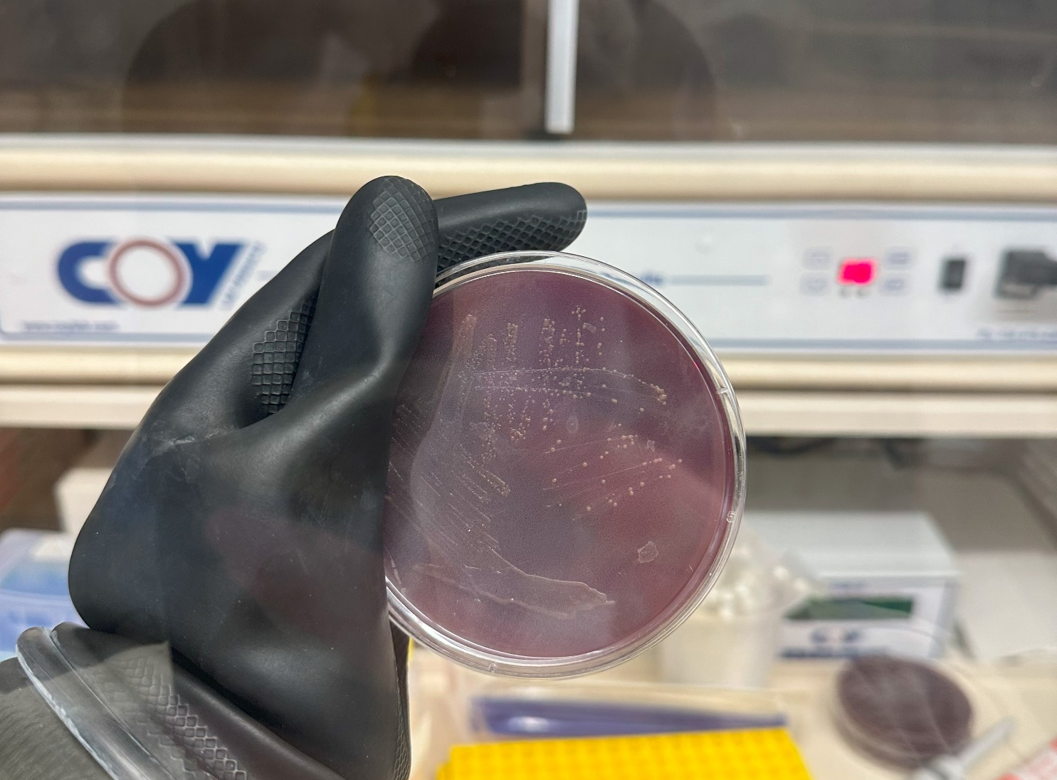

Figure: w83 isolated colonies of p. ging

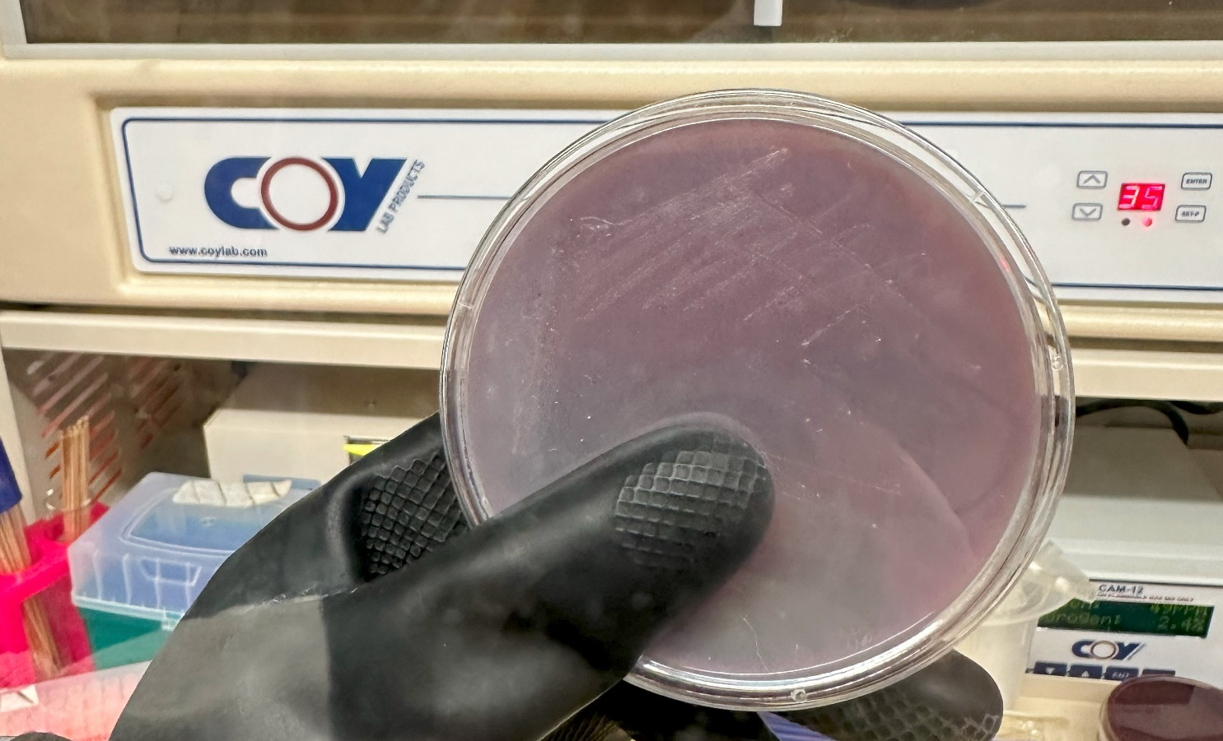

Figure: Isolated colonies PG0121 of p. ging

Tuesday, February 27, 2024
To Do:
- PCR to evaluate cDNA possible issues
- Reconstitute primers KROL 526 and 527
Notes:
Yesterday, I couldn’t find the cDNA needed as a control for the PCR. I found tubes labeled 149BR2 cDNA but couldn’t figure out what that was so I didn’t move forward with it. Today, I looked for the cDNA again and after checking every box I couldn’t find it. Kira suggested we text Sierra and when she did, we found out that the tube 149 BR-2 stands for KRLVS 149 biological replicate 2. So that’s how well find the right cDNA. Also, any LVS gDNA can be used as the control. At around 7pm I realized I couldn’t find the cDNA I needed with the correct date, so I will ask Kathryn in the beginning.
In other news, the primers are all ready for the PCR. I reconstituted KROL526 and 527 by following the below protocol and then made working stocks of 10uM for KROL526 and 527, as well as KROL59 and KROL 60.

Protocol: Receiving Primers
By: Hannah Trautmann
- Spin primers at maximum speed in tabletop centrifuge for 3 minutes so dessicated primers go to the bottom of the tube.
- Add 0.1x EB to a final concentration of 100 uM. Calculate this by multiplying the reported nm by 10 and adding that volume in ul (i.e. 12.7 nmoles = add 127 uL of 0.1xEB).
- Put on 42°C heat block for 5 minutes to help primers dissolve
- Vortex and brief spin.
- Label tubes with KROL numbers on the top and put in the appropriate 100 uM stock box in the -20°C freezer.
- Optional: Make dilution for intended purpose of primer.
  - If a PCR primer, make a 10 uM stock by diluting 20 uL of the 100 uM stock into 180 uL of 0.1xEB. Label with purple sticker and put in appropriate freezer box.
  - If a sequencing primer, make a 2.5 uM stock by diluting 5 uL of the 100 uM stock into 195 uL of 0.1x EB. Label with blue sticker and put in appropriate freezer box.
- Put Certificate of Analysis sheet in “Oligos Spec Sheet” binder and shipping sheet in Invoices box.

Important to note I did not put the certificate of analysis sheet in the binder as there were still more oligos in the batch that I was told not to reconstitute. Currently the stocks as well as the working stocks are in my cloning box as there wasn’t any room in the other primer boxes for them. I will be moving primers around to make some room probably next week when I have more time.
Wednesday, February 28, 2024
To Do:
- PCR to evaluate cDNA possible issues
- Gel on the PCR

Notes:
Set up PCR following standard SNT1 protocol, had extension time at 30sec.
PCR Set up (set up #s for each primer set):
Reaction numbers | Sample | Expected size
1 | 1B RNA | no
2 | 3 RNA | no
3 | 1B cDNA | no
4 | 3 cDNA | maybe B?
5 | LVS149 BR2 cDNA (from Sierra) | no A, yes B
6 | LVS gDNA from PCR box | yes A and B
7 | water | no

Made fresh 1% agarose gel, used fresh buffer. Ran at 108V for ~45min
Samples loaded in same order as reaction numbers above, with samples 1-7 of KROL 526 and 527 being loaded first, then the 1kb ladder, then samples 1-7 of KROL 59 and 60.
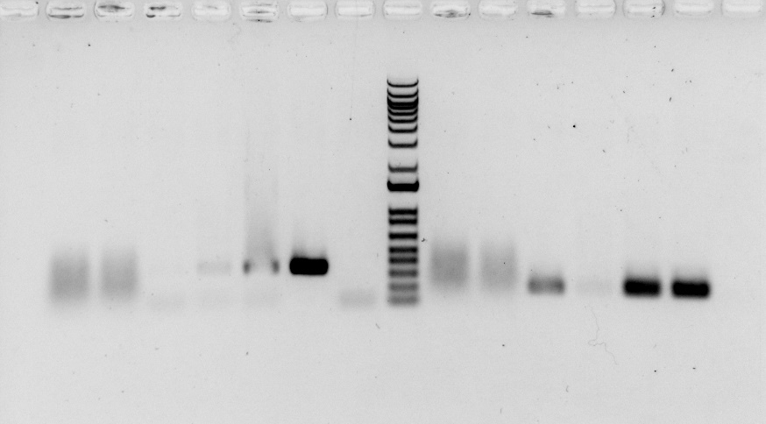
Image: 1% gel with KROL 526/527 aand KROL 59/60 on RNA and cDNA samples.
To move forward
- New sample sierra RNA and new RNA from me using new superscript that hasn’t been used before but has been in the freezer before and new NaOH and HCL
- - if superscript is same lot number then we grab brand new
Monday, March 4, 2024
To Do:
- cDNA generation with new superscript and new NaOH and HCl

Protocol: Generate cDNA (half protocol)*
*REACTION SIZE CUT IN HALF from Lory lab microarray protocol

- Combine the first components for primer annealing:
Component | Volume or Amount | Final Concentration
RNA | 3 ug | - - 333 ng/ ul
(NS)₅ Primer (250 ng/ul) | 1.5 ul | - g/ul
RNase-free water | up to 15 ul

- To normalize all the cDNA samples to the same DNA mass, dilute with RNase-free water in PCR strip tubes.

Table : cDNA volumes to add to each tube

Note the total volume of cDNA and water is 13.5 uL.
- Add the 1.5 uL (NS)₅ oligo (stored in small aliquots at -80°C; take your own aliquot to use and move it to your own stock box; minimize freeze/thaw cycles) to the tubes.

- Incubate using program JSScDNA1 in the thermocycler:
  - Step Temp Time
  - 1 70°C 10'
  - 2 25°C 10'
  - 3 4°C hold

- While waiting, prepare the cDNA synthesis reaction in master mix format. The number of reactions you have plus 1.5 should be the factor you multiply by.

*Buffer, DTT, and dNTPs should be from the cDNA reagents box (they are RNase free!)

- Aliquot 15 ul of master mix per reaction into each PCR tube from the first reaction (total volume now 30ul)

- Incubate using program JSScDNA2
  - Step Temp Time
  - 1 25°C 10'
  - 2 37°C 60'
  - 4 42°C 60'
  - 5 70°C 10'
  - 6 4°C hold

*potential stopping point- samples can be stored at -80°C if necessary

- Remove RNA from sample by degrading with sodium hydroxide:

- Add 10 ul of 1N NaOH
- Incubate 65°C for 30'
- Neutralize with 10 ul of 1N HCl
- Final volume is 50 ul
- Purify cDNA using Qiagen PCR clean-up column (be very sure there is no ethanol carry-over!) THIS IS THE PCR PURIFICATION PROTOCOL
- Elute in 60 ul of 0.1x EB

- Check concentration by Nanodrop

- Store cDNA at -80°C

Table: Nanodrop results after cDNA generation
Yay! Finally cDNA generation that works! Very happy. This time we had new superscript and new NaOH and HCl. We were thinking that the enzyme was bad and possibly I made something weird when I diluted the 5N HCl to make 1N HCl. Which is probably the case because water probably dissociates so theres more hydrogen in the solution then originally thought which probably threw off the neutralizing step. From now on we will use already ordered/made 1N HCl.
Tuesday, March 5, 2024
To Do:
- Reorganize working stocks of primers
Notes:
I saw the 10uM working conc of primers we use were very much out of order. Therefore I reordered them and left blank spaces for any extra primers that can be added. The 100uM concentrations will be done another day.
Wednesday, March 6, 2024
To Do:
- Run gel for Johanyx
- Figure out next steps
- Make journal club presentation
- Started program of study form
Notes:
Ran a gel for Johanyx and Kira. Kira set the gel. Gel ran at 108V for 45 mins. 10uL ladder loaded, then samples 1-5 in order. 20uL of each sample was loaded. Picture was taken and uploaded to Johanyx’s drive (no bands visible but ladder was visible)
Now that the cDNA generation protocol is back, I feel confident that I can move forward. With all the troubleshooting that was done, I am very low on RNA samples. I am thinking about growing more samples, doing another isolation, and then moving onto the cDNA generation and further steps from there. After the cDNA is generated, I’m not entirely sure what to do. I know I will eventually be doing qRTPCR, however I’m not sure which primers to use. I’m currently looking through Sierra’s old notebooks to find out.
On the p.ging route, tomorrow I will start new plates of isolated colonies, so I can grow them up and eventually make stocks from single colonies. I am also reading though the grant so I know the general direction of where I’m going with it.
I will talk to Kathryn about all of this when she comes back from her conference tomorrow. For now, I will get all the information from reading that I can.
Thursday, March 7, 2024
To Do:
- Struck out KRLVS 121 for isolation
- Make journal club presentation
- More program of study form
Notes:
Struck out KRLVS 121 for isolation to isolate more RNA.
Friday, March 8, 2024
To Do:
- Struck out KRLVS 120 and 123 for isolation
Sunday, March 10, 2024
To Do:
- Patched out single colonies of KRLVS 121
Monday, March 11, 2024
To Do:
- Patched out single colonies of KRLVS 120 and 123
- Autoclave trash
Tuesday, March 12, 2024
To Do:
- Culture growth for RNA Isolation
- Start RNA isolation protocol

Protocol – Culture growth for RNA isolation
- Put 8mL of supplemented MHB into sterile glass tubes and warm at 37C in incubator
- For each bacterial sample, scape up one patch of cells and resuspend in ~300uL of supplemented MHB in sterile 1.5mL microcentrifuge tube
- Add 700uL more supplemented MHB, make sure cells are well-resuspended
- Check OD600
  - Dilute resuspended cells 1:10 in MHB (100 uL cells, 900 uL MHB)
  - Check OD600 using 1 mL MHB as blank
  - Calculate actual OD600 (measured OD600 multiplied by dilution factor [10])*
  - Calculate what volume of cells you need to obtain an OD600 of 0.08 in 8 mL*
  - Make an excel sheet to help with this
  - Had to do a dilution factor of 40 this time, as the first reading of the OD600 cells were WAY to concentrated (0.9 for some of them)
- For each sample, inoculate one glass culture tube so that the final OD600 is 0.08
  - Example:
  - OD600 of resuspended cells: 4.0
  - (8 mL )(0.08 OD600) / (4.0 OD600) = 0.18 mL resuspended cells (180 uL)
  - Add 8 mL MHB per tube, remove 180 uL, and add back 180 uL resuspended cells
- Swirl tube to distribute cells
- Remove 1mL and use to measure OD600, record results in excel sheet
- Put tubes at 37C shaking
- Check OD600 after ~ 2 hours to be sure cells have come close to doubling (document OD600!*)
- When OD600 reaches between 0.3 – 0.4 (4-6 hours, document OD600!*):
  - Transfer 1.8 mL into 2 mL tube.
  - Go to RNAsnap protocol step 2

Table: OD600 Values going into RNAsnap Protocol

After 4 hours, saw that the OD600 values were not as high as I wanted, therefore I left them in the incubator for about half an hour longer to see if we could get them closer to the .3-.4 OD600 desired reading. Their starting OD600s were not as high as they should’ve been with the calculations, which was frustrating. I’m unsure how that could’ve happened. However, at that point there was nothing left to do but roll with it.

Protocol – RNAsnap protocol
Adapted from: Stead et al. (2012) Nucleic Acids Research
Updated 10/26/22
Note: All reagents should be RNAse free; use good RNA-technique by cleaning work area, gloves, and instruments with RNAse-away.
Wear safety goggles when handling formamide and dispose of as hazardous waste.
RNAsnap
- Grow strains to mid-log
- Centrifuge 1 to 10 mL of bacterial culture at max speed for 3 (1 MIN) mins. Discard supernatant. Repeat added 1.8ml to tube once, centrifuged, discarded supernatant, then added another 1.8ml to tube and repeated process. (remaining steps will be in hood. Bring in heat block, vortex, and centrifuge into hood. Super sterile)
- Resuspend cell pellet in 100 µL of fresh RES (see recipe below) by vortexing vigorously. If using 10 mL of culture, use 300 µL of RES.
- Incubate sample at 95°C for 7 minutes.
- Pellet cell debris by centrifuging at max speed for 5 mins at room temperature. Carefully move the supernatant to a fresh tube without disturbing the gelatinous pellet. We did twice because couldn’t see pellet first time. We did this outside of hood because no room in hood.
Sodium acetate/ethanol precipitation
- BACK TO HOOD 1st time. Dilute RNA sample to 300 µL with water. We had 60ul of rna sample. Added 240ul of water
- Add 1/10 volume of 3 M sodium acetate, pH 5.2 (30 µL).
- Add 2 µL GlycoBlue Coprecipitant (ThermoFisher)
- Add three volumes of 100% ethanol (900 µL). Mix by vortexing then incubate for at least 60 mins (or overnight) at -80°C. STOPPED HERE 3/12/24
- Centrifuge at max speed for 30 mins at 4°C. Carefully remove supernatant. Set up centrifuge to correct temp prior.
- Wash cell pellet with 250 µL of freshly-diluted 75% ethanol. Make fresh each time.
- Centrifuge at max speed for 5 mins at 4°C. Carefully remove supernatant.
- Briefly centrifuge again to allow removal of all remaining ethanol, then air dry the pellet.
- Resuspend the pellet in 80 µL water. Centrifuge at max speed for 1 minute to pellet any remaining water insoluble proteins. Transfer the RNA-containing supernatant to a fresh tube.
- Check concentration by Nanodrop (RNA setting).
DNAse Treatment (Promega)
- Add 10 µL RNase-free DNase buffer and 10 µL RNase-free DNase (Promega, RQ1)
- Incubate at 37°C for 1 hour.
- Repeat sodium acetate/ethanol precipitation as above (steps 6-15). Resuspend in 50uL 2nd time, NOT 80 (step 14).

Buffers and Reagents:
For all reagents (except 2-mercaptoethanol), use specific stocks for RNA work.
RNA Extraction Solution (RES)
Component | Stock Solution | Final Concentration | Volume (µL)
Water |  |  | 2.65
Formamide | 100% | 95% | 950.0
EDTA | 0.5 M | 18 mM | 36.0
SDS | 20% | 0.025% | 1.25
BME | 99% | 1% | 10.1
 |  | Final volume: | 1000.0

Wednesday, March 13, 2024
To Do:
- Day 2 of RNA isolation protocol

Protocol – RNAsnap protocol
Adapted from: Stead et al. (2012) Nucleic Acids Research
Updated 10/26/22
Note: All reagents should be RNAse free; use good RNA-technique by cleaning work area, gloves, and instruments with RNAse-away.
Wear safety goggles when handling formamide and dispose of as hazardous waste.
RNAsnap
- Grow strains to mid-log
- Centrifuge 1 to 10 mL of bacterial culture at max speed for 3 (1 MIN) mins. Discard supernatant. Repeat added 1.8ml to tube once, centrifuged, discarded supernatant, then added another 1.8ml to tube and repeated process. (remaining steps will be in hood. Bring in heat block, vortex, and centrifuge into hood. Super sterile)
- Resuspend cell pellet in 100 µL of fresh RES (see recipe below) by vortexing vigorously. If using 10 mL of culture, use 300 µL of RES.
- Incubate sample at 95°C for 7 minutes.
- Pellet cell debris by centrifuging at max speed for 5 mins at room temperature. Carefully move the supernatant to a fresh tube without disturbing the gelatinous pellet. We did twice because couldn’t see pellet first time. We did this outside of hood because no room in hood.
Sodium acetate/ethanol precipitation
- BACK TO HOOD 1st time. Dilute RNA sample to 300 µL with water. We had 60ul of rna sample. Added 240ul of water
- Add 1/10 volume of 3 M sodium acetate, pH 5.2 (30 µL).
- Add 2 µL GlycoBlue Coprecipitant (ThermoFisher)
- Add three volumes of 100% ethanol (900 µL). Mix by vortexing then incubate for at least 60 mins (or overnight) at -80°C. STOPPED HERE 3/13/24 (after starting here also on 3/13/24)
- Centrifuge at max speed for 30 mins at 4°C. Carefully remove supernatant. Set up centrifuge to correct temp prior.
- Wash cell pellet with 250 µL of freshly-diluted 75% ethanol. Make fresh each time.
- Centrifuge at max speed for 5 mins at 4°C. Carefully remove supernatant.
- Briefly centrifuge again to allow removal of all remaining ethanol, then air dry the pellet.
- Resuspend the pellet in 80 µL water. Centrifuge at max speed for 1 minute to pellet any remaining water insoluble proteins. Transfer the RNA-containing supernatant to a fresh tube.
- Check concentration by Nanodrop (RNA setting).
DNAse Treatment (Promega)
- Add 10 µL RNase-free DNase buffer and 10 µL RNase-free DNase (Promega, RQ1)
- Incubate at 37°C for 1 hour.
- Repeat sodium acetate/ethanol precipitation as above (steps 6-15). Resuspend in 50uL 2nd time, NOT 80 (step 14).

Figure: Nanodrop Values after 2nd day of isolation
Thursday, March 14, 2024
To Do:
- Day 3 of RNAsnap Protocol
Happy pi day!
Started at step 10 above, followed all the way through, eluting with 50uL instead of 80uL.

Figure: Nanodrop Values after 3rd day of isolation (Final RNA Values)
# | Sample ID | Nucleic Acid | Unit | 260/280 | 260/230
1 | LVS pF (KRLVS 120) B | 303.8 | ng/µl | 2.05 | 1.68
2 | LVS pF (KRLVS 120) A | 322.8 | ng/µl | 2.03 | 1.71
3 | LVS Δ rpsU2 pF (KRLVS 121) A | 208.9 | ng/µl | 2.02 | 1.6
4 | LVS Δ rpsU2 pF (KRLVS 121) E | 237.9 | ng/µl | 1.99 | 1.48
5 | LVS ΔrpsU2 pF - rpsU2-V (KRLVS 123) A | 289.8 | ng/µl | 2.05 | 1.79
6 | LVSΔrpsU2 pF - rpsU2-V (KRLVS 123) D | 221.4 | ng/µl | 2.04 | 1.71

Monday, March 18, 2024
To Do:
- cDNA generation on RNA samples from March 14th

Protocol: Generate cDNA (half protocol)*
*REACTION SIZE CUT IN HALF from Lory lab microarray protocol

- Combine the first components for primer annealing:
Component | Volume or Amount | Final Concentration
RNA | 3 ug | - - 333 ng/ ul
(NS)₅ Primer (250 ng/ul) | 1.5 ul | - g/ul
RNase-free water | up to 15 ul

- To normalize all the cDNA samples to the same DNA mass, dilute with RNase-free water in PCR strip tubes.

Table : cDNA volumes to add to each tube

*made total RNA 2820 this time instead of 3000 so all could be equal starting amount. If it was 3000, there wouldn’t be enough of sample 3.

Note the total volume of cDNA and water is 13.5 uL.
- Add the 1.5 uL (NS)₅ oligo (stored in small aliquots at -80°C; take your own aliquot to use and move it to your own stock box; minimize freeze/thaw cycles) to the tubes.

- Incubate using program JSScDNA1 in the thermocycler:
  - Step Temp Time
  - 1 70°C 10'
  - 2 25°C 10'
  - 3 4°C hold

- While waiting, prepare the cDNA synthesis reaction in master mix format. The number of reactions you have plus 1.5 should be the factor you multiply by.

*Buffer, DTT, and dNTPs should be from the cDNA reagents box (they are RNase free!)

- Aliquot 15 ul of master mix per reaction into each PCR tube from the first reaction (total volume now 30ul)

- Incubate using program JSScDNA2
  - Step Temp Time
  - 1 25°C 10'
  - 2 37°C 60'
  - 4 42°C 60'
  - 5 70°C 10'
  - 6 4°C hold

*potential stopping point- samples can be stored at -80°C if necessary

- Remove RNA from sample by degrading with sodium hydroxide:

- Add 10 ul of 1N NaOH
- Incubate 65°C for 30'
- Neutralize with 10 ul of 1N HCl
- Final volume is 50 ul
- Purify cDNA using Qiagen PCR clean-up column (be very sure there is no ethanol carry-over!) THIS IS THE PCR PURIFICATION PROTOCOL
- Elute in 60 ul of 0.1x EB

- Check concentration by Nanodrop

- Store cDNA at -80°C

Table: Nanodrop results after cDNA generation
# | Sample ID | Nucleic Acid | Unit | 260/280 | 260/230
1 | LVS pF (KRLVS 120) B | 26.2 | ng/µl | 1.69 | 1.05
2 | LVS pF (KRLVS 120) A | 21.1 | ng/µl | 1.83 | 1.17
3 | LVS Δ rpsU2 pF (KRLVS 121) A | 20.8 | ng/µl | 1.65 | 0.97
4 | LVS Δ rpsU2 pF (KRLVS 121) E | 13 | ng/µl | 1.8 | 0.93
5 | LVS ΔrpsU2 pF - rpsU2-V (KRLVS 123) A | 13.4 | ng/µl | 1.82 | 0.78
6 | LVSΔrpsU2 pF - rpsU2-V (KRLVS 123) D | 12.3 | ng/µl | 1.75 | 0.59

cDNA!!! I’m not sure why the purity values look like this but at this point I’m going to leave them on the bench top for a bit and see if ethanol evaporates and if not just run with it. I want to see what the next steps are.
After letting ethanol evaporate on benchtop for ~1.5 hours

Table: Nanodrop after longer ethanol evaporation

Questions for Kathryn on rt-pcr
Do I need a certain amount of DNA per sample (ex 200ng)
Confused with Sierra’s notebook because her master mixes have different amounts
Which primers to use?
Monday, March 25, 2024
To Do:
- Dilutions on cDNA from 3.18.24
- RT-qPCR on cDNA samples from 3.18.24

For RT-qPCR I need 1.5ng/uL of DNA per sample, so made dilutions for those.

Table: Dilutions of cDNA to get final conc of 1.5ng/uL
Then, set up qPCR

Real-Time PCR Protocol
Original protocol by Heather McManus, edited by Kathryn Ramsey

- Each ChIP experiment will need at least one test primer and one control primer for both the input and ChIP samples
  - Example: ChIP on 3 biological replicates = 6 DNA samples (3 Input and 3 ChIP)
      - Using two primer pairs = 12 different reactions

- Each different reaction type must be run in triplicate on the real-time plate
  - Example: 12 reactions = 36 wells

- Each Individual reaction = 20 µL
  - 10 µL PowerUp SYBR Green Master Mix
  - 1 µL 5uM combined forward and reverse primer
  - 1 µL ChIP DNA or 1µL of 1:10 dilution of Input DNA
  - 8 µL ddiH₂O

- The use of master mixes increases the consistency between samples; therefore follow the method below for setting up the plate

- For each reaction type (primer/DNA combination) set up a master mix equal to 3.5 reactions:
- Put 3.5µL of DNA type into strip tubes

- To determine the amount of each primer master mix to create, identify the number of reactions for each primer pair (i.e. #DNA samples x 3.5) and add 3.5 to this number to account for additional pipetting error
    - Example: 6 DNA samples per primer pair = 6 x 3.5 + 3.5 = 24.5

- Set up primer master mixes in separate 1.5 mL tubes (make one for each primer pair)
    - Example:
    - 10 µL PowerUp SYBR Green Master Mix x 24.5 = 245.0 µL
    - 1 µL 5µM combined F and R primer x 24.5 = 24.5 µL
    - 8 µL ddiH₂O x 24.5 = 196 µL
                - TOTAL = 465.5 µL
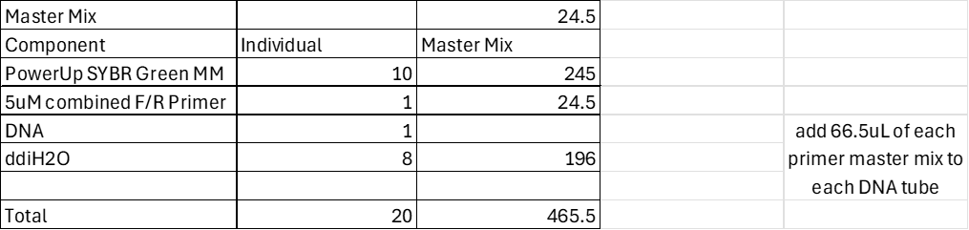
- Add primer master mix to tubes containing DNA.
  - 3.5 reactions x 20 µL volume = 70 µL. DNA tubes already have 3.5µL of DNA. Add 66.5 µL of primer master mix to each tube

- Pipette 20 µL of each reaction into 3 separate wells on the 96 well plate using dispense option on multichannel

- Spin plate down. There is plate centrifuge in INBRE

- Place in real-time machine and run using the same program used to determine that the primers are appropriately efficient.

Set up of master mix:
Master Mix | Primer Set | Why
1 | KROL 504/505 | rpsU
2 | KROL 63/54 | tul4 (control)

DNA for PCR set up

Plate set up for qRT-PCR

After, used the following protocol for the lightcycler. Roche480

Plate Spinner and Lightcycler for qrtPCR
Using plate spinner in INBRE Core Lab
- Ensure proper rotor is in place
- Place 96-well plate into plate holder and place into centrifuge
- Gently close lid and spin at 500xg for 2 minutes. On Janet’s bench
Using Roche LightCycler
- Turn on machine and wait for the left light on the front to turn green. Once it has, press and hold the  button on the front of the machine for a moment, to open the 96-well plate tray
- Place plate into tray, aligning the slanted edge correctly
- Open the LightCycler application and long in with the following credentials:
Username: K_Ramsey Lab
Password: Roche480
- Select New Experiment from template > Run template > ‘Kramsey_lab_old_stepone’ and press the check button
- Ensure the program matches the program specs listed in ‘Real-time PCR programs.docx’
- Select ‘Start Run,’ name and save the experiment to the KRamsey Lab > Experiments folder
- The program will take ~1.5 hours to complete
- To export:
  - Select Analysis, and click the ‘+’ button. The Analysis Type is ‘Absolute Quant/2nd Derivative Max’
    - Select appropriate subsets then hit the check
  - Select ‘Calculate’
  - Scroll to the right in the samples column, selecting ‘CP’ for Crossing Point then save the Analysis with the save icon
  - Select the Compass icon > ‘Results Batch Export’
  - Select the experiment you saved in the KRamsey Lab > Experiment folder, press the arrow to select the experiment then click ‘Next’
  - Browse Target and save to the flash drive
  - Select the same analysis type, select ‘Next,’ then select ‘Start’
  - Ensure it says 1 file exported, if file is not exported, likely you forgot to save on the analysis page.

Below is the protocol followed for the lightcycler.

Real-time PCR programs

GSC computer login:
K_Ramsey Lab
Password:
Roche480

Old StepOne Plus (2-step amplification)
- 95°C 10’
- 95°C 15”
- 60°C 60”
- Go to step 2, 39x (total 40 cycles)
- 95°C 10”
- 65°C 60”
- 97°C 60”
Melt curve (95°C 10”, 65°C 60”, 97°C 60” with continuous ramp)

Saved on the protocol under experiments as 20240325_ARF_PCR_Real

Tuesday, March 26, 2024
To Do:
- Analysis on qPCR
There is template in RNA-cDNA folder for analysis. I will be moving this to the qPCR folder.
Wednesday, March 27, 2024
To Do:
- Finish analysis on qPCR
Data from qPCR completed on 3.25.24 (cleaned up)

Figure: Abundance of rpsU2 in LVS, LVSΔrpsU2, and , LVSΔrpsU2-rpsU2-V
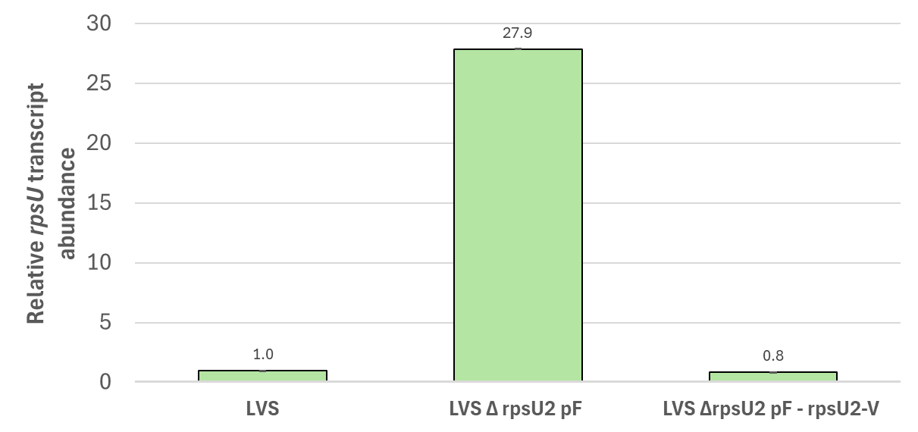
The above are the values that were plugged in to make the figure.
This figure makes sense because the rpsU primers that were used are not for rpsU exactly, but the rpsU operon. We can see in the RNA-seq data that there seems to be more transcript happening in the deletion, its just not being translated. This is supported in this qPCR data as well.
Next steps: do again in triplicate (9 samples this time not six, starting from isolation). Eventually, RNA stability assays will be done.
Also, start thinking about p.ging stuff
Friday, March 29, 2024
To Do:
- Streak out KRLVS 121 and put at 37
- Streak out KRLVS 120 and 123, leave on benchtop
For the upcoming RNA isolataion, cDNA, qPCR, and RNA stability experiments, I will be growing samples in triplicate. Therefore, today I struck out KRLVS 121 to single colonies and put in the incubator. As this weekend is Easter and I won’t be able to come in over the weekend, I also struck out KRLVS 120 and 123 to single colonies. They were left on the benchtop and Kira graciously agreed to put them in the 37C incubator when she comes in on Saturday. On Monday, I will be able to start day 4 of the protocol.
Monday, April 1, 2024
To Do:
- Patched out KRLVS121 and put at 37
- Autoclaved tip boxes and microcentrifuge tubes Grav30 (lab chores)
- Streaked out pg0121 and w83 of p ging to see if plates were still good

Tuesday, April 2, 2024
To Do:
- Patched out KRLVS120 and 123 and put at 37C
The patches were done before 8am today so they should be ready to go tomorrow
Wednesday, April 3, 2024
To Do:
- RNA isolation day 1
- Autoclave waste and take out

Protocol – Culture growth for RNA isolation
- Put 8mL of supplemented MHB into sterile glass tubes and warm at 37C in incubator
- For each bacterial sample, scape up one patch of cells and resuspend in ~300uL of supplemented MHB in sterile 1.5mL microcentrifuge tube
- Add 700uL more supplemented MHB, make sure cells are well-resuspended
- Check OD600
  - Dilute resuspended cells 1:10 in MHB (100 uL cells, 900 uL MHB)
  - Check OD600 using 1 mL MHB as blank
  - Calculate actual OD600 (measured OD600 multiplied by dilution factor [10])*
  - Calculate what volume of cells you need to obtain an OD600 of 0.08 in 8 mL*
  - Make an excel sheet to help with this
  - Had to do a dilution factor of 40 this time, as the first reading of the OD600 cells were WAY to concentrated (0.9 for some of them)
- For each sample, inoculate one glass culture tube so that the final OD600 is 0.08
  - Example:
  - OD600 of resuspended cells: 4.0
  - (8 mL )(0.08 OD600) / (4.0 OD600) = 0.18 mL resuspended cells (180 uL)
  - Add 8 mL MHB per tube, remove 180 uL, and add back 180 uL resuspended cells
- Swirl tube to distribute cells
- Remove 1mL and use to measure OD600, record results in excel sheet
- Put tubes at 37C shaking
- Check OD600 after ~ 2 hours to be sure cells have come close to doubling (document OD600!*)
- When OD600 reaches between 0.3 – 0.4 (4-6 hours, document OD600!*):
  - Transfer 1.8 mL into 2 mL tube.
  - Go to RNAsnap protocol step 2

Table: OD600 Values going into RNAsnap Protocol

.

Protocol – RNAsnap protocol
Adapted from: Stead et al. (2012) Nucleic Acids Research
Updated 10/26/22
Note: All reagents should be RNAse free; use good RNA-technique by cleaning work area, gloves, and instruments with RNAse-away.
Wear safety goggles when handling formamide and dispose of as hazardous waste.
RNAsnap
- Grow strains to mid-log
- Centrifuge 1 to 10 mL of bacterial culture at max speed for 3 (1 MIN) mins. Discard supernatant. Repeat added 1.8ml to tube once, centrifuged, discarded supernatant, then added another 1.8ml to tube and repeated process. (remaining steps will be in hood. Bring in heat block, vortex, and centrifuge into hood. Super sterile)
- Resuspend cell pellet in 100 µL of fresh RES (see recipe below) by vortexing vigorously. If using 10 mL of culture, use 300 µL of RES.
- Incubate sample at 95°C for 7 minutes.
- Pellet cell debris by centrifuging at max speed for 5 mins at room temperature. Carefully move the supernatant to a fresh tube without disturbing the gelatinous pellet. We did twice because couldn’t see pellet first time. We did this outside of hood because no room in hood.
Sodium acetate/ethanol precipitation
- BACK TO HOOD 1st time. Dilute RNA sample to 300 µL with water. We had 60ul of rna sample. Added 240ul of water
- Add 1/10 volume of 3 M sodium acetate, pH 5.2 (30 µL).
- Add 2 µL Glycogen Coprecipitant (ThermoFisher)
- Add three volumes of 100% ethanol (900 µL). Mix by vortexing then incubate for at least 60 mins (or overnight) at -80°C. STOPPED HERE 4/3/24
- Centrifuge at max speed for 30 mins at 4°C. Carefully remove supernatant. Set up centrifuge to correct temp prior.
- Wash cell pellet with 250 µL of freshly-diluted 75% ethanol. Make fresh each time.
- Centrifuge at max speed for 5 mins at 4°C. Carefully remove supernatant.
- Briefly centrifuge again to allow removal of all remaining ethanol, then air dry the pellet.
- Resuspend the pellet in 80 µL water. Centrifuge at max speed for 1 minute to pellet any remaining water insoluble proteins. Transfer the RNA-containing supernatant to a fresh tube.
- Check concentration by Nanodrop (RNA setting).
DNAse Treatment (Promega)
- Add 10 µL RNase-free DNase buffer and 10 µL RNase-free DNase (Promega, RQ1)
- Incubate at 37°C for 1 hour.
- Repeat sodium acetate/ethanol precipitation as above (steps 6-15). Resuspend in 50uL 2nd time, NOT 80 (step 14).

Buffers and Reagents:
For all reagents (except 2-mercaptoethanol), use specific stocks for RNA work.
RNA Extraction Solution (RES)
Component | Stock Solution | Final Concentration | Volume (µL)
Water |  |  | 2.65
Formamide | 100% | 95% | 950.0
EDTA | 0.5 M | 18 mM | 36.0
SDS | 20% | 0.025% | 1.25
BME | 99% | 1% | 10.1
 |  | Final volume: | 1000.0

Thursday, April 4, 2024
To Do:
- RNA isolation day 2

Protocol – RNAsnap protocol
Adapted from: Stead et al. (2012) Nucleic Acids Research
Updated 10/26/22
Note: All reagents should be RNAse free; use good RNA-technique by cleaning work area, gloves, and instruments with RNAse-away.
Wear safety goggles when handling formamide and dispose of as hazardous waste.
RNAsnap
- Grow strains to mid-log
- Centrifuge 1 to 10 mL of bacterial culture at max speed for 3 (1 MIN) mins. Discard supernatant. Repeat added 1.8ml to tube once, centrifuged, discarded supernatant, then added another 1.8ml to tube and repeated process. (remaining steps will be in hood. Bring in heat block, vortex, and centrifuge into hood. Super sterile)
- Resuspend cell pellet in 100 µL of fresh RES (see recipe below) by vortexing vigorously. If using 10 mL of culture, use 300 µL of RES.
- Incubate sample at 95°C for 7 minutes.
- Pellet cell debris by centrifuging at max speed for 5 mins at room temperature. Carefully move the supernatant to a fresh tube without disturbing the gelatinous pellet. We did twice because couldn’t see pellet first time. We did this outside of hood because no room in hood.
Sodium acetate/ethanol precipitation
- BACK TO HOOD 1st time. Dilute RNA sample to 300 µL with water. We had 60ul of rna sample. Added 240ul of water
- Add 1/10 volume of 3 M sodium acetate, pH 5.2 (30 µL).
- Add 2 µL Glycogen Coprecipitant (ThermoFisher)
- Add three volumes of 100% ethanol (900 µL). Mix by vortexing then incubate for at least 60 mins (or overnight) at -80°C. STOPPED (and started) HERE 4/4/24
- Centrifuge at max speed for 30 mins at 4°C. Carefully remove supernatant. Set up centrifuge to correct temp prior.
- Wash cell pellet with 250 µL of freshly-diluted 75% ethanol. Make fresh each time.
- Centrifuge at max speed for 5 mins at 4°C. Carefully remove supernatant.
- Briefly centrifuge again to allow removal of all remaining ethanol, then air dry the pellet.
- Resuspend the pellet in 80 µL water. Centrifuge at max speed for 1 minute to pellet any remaining water insoluble proteins. Transfer the RNA-containing supernatant to a fresh tube.
- Check concentration by Nanodrop (RNA setting).
DNAse Treatment (Promega)
- Add 10 µL RNase-free DNase buffer and 10 µL RNase-free DNase (Promega, RQ1)
- Incubate at 37°C for 1 hour.
- Repeat sodium acetate/ethanol precipitation as above (steps 6-15). Resuspend in 50uL 2nd time, NOT 80 (step 14).

Nanodrop after day 2 RNA isolation
Friday, April 5, 2024
To Do:
- RNA isolation day 3
- Autoclave waste and take out

Protocol – RNAsnap protocol
Adapted from: Stead et al. (2012) Nucleic Acids Research
Updated 10/26/22
Note: All reagents should be RNAse free; use good RNA-technique by cleaning work area, gloves, and instruments with RNAse-away.
Wear safety goggles when handling formamide and dispose of as hazardous waste.
RNAsnap
- Grow strains to mid-log
- Centrifuge 1 to 10 mL of bacterial culture at max speed for 3 (1 MIN) mins. Discard supernatant. Repeat added 1.8ml to tube once, centrifuged, discarded supernatant, then added another 1.8ml to tube and repeated process. (remaining steps will be in hood. Bring in heat block, vortex, and centrifuge into hood. Super sterile)
- Resuspend cell pellet in 100 µL of fresh RES (see recipe below) by vortexing vigorously. If using 10 mL of culture, use 300 µL of RES.
- Incubate sample at 95°C for 7 minutes.
- Pellet cell debris by centrifuging at max speed for 5 mins at room temperature. Carefully move the supernatant to a fresh tube without disturbing the gelatinous pellet. We did twice because couldn’t see pellet first time. We did this outside of hood because no room in hood.
Sodium acetate/ethanol precipitation
- BACK TO HOOD 1st time. Dilute RNA sample to 300 µL with water. We had 60ul of rna sample. Added 240ul of water
- Add 1/10 volume of 3 M sodium acetate, pH 5.2 (30 µL).
- Add 2 µL Glycogen Coprecipitant (ThermoFisher)
- Add three volumes of 100% ethanol (900 µL). Mix by vortexing then incubate for at least 60 mins (or overnight) at -80°C. Started HERE 4/5/24
- Centrifuge at max speed for 30 mins at 4°C. Carefully remove supernatant. Set up centrifuge to correct temp prior.
- Wash cell pellet with 250 µL of freshly-diluted 75% ethanol. Make fresh each time.
- Centrifuge at max speed for 5 mins at 4°C. Carefully remove supernatant.
- Briefly centrifuge again to allow removal of all remaining ethanol, then air dry the pellet.
- Resuspend the pellet in 80 µL water. Centrifuge at max speed for 1 minute to pellet any remaining water insoluble proteins. Transfer the RNA-containing supernatant to a fresh tube.
- Check concentration by Nanodrop (RNA setting).
DNAse Treatment (Promega)
- Add 10 µL RNase-free DNase buffer and 10 µL RNase-free DNase (Promega, RQ1)
- Incubate at 37°C for 1 hour.
- Repeat sodium acetate/ethanol precipitation as above (steps 6-15). Resuspend in 50uL 2nd time, NOT 80 (step 14).

- Stored in -80C

Final Nanodrop Readings of RNA conc (only RNA)

Bibliography

Ramsey, K. M. and Dove, S. L. (2016) ‘ A response regulator promotes Francisella tularensis intramacrophage growth by repressing an anti-virulence factor ’, Molecular Microbiology. doi: 10.1111/mmi.13418.

