Table of Contents
Introduction 2
Figure 1 2
Thoughts or questions. 2
Protocol 1 2
Reagents 3
File Formatting Protocol 3
September 2018 4
Bibliography 5

August 2024

Monday, August 5, 2024
To Do:
- Meeting with Kathryn
- Reorient myself
- Kentucky Stuff
Tuesday, August 6, 2024
To Do:
- Kentucky Stuff
- Orientation things
- Get excel sheet ready for sequencing
Results and Data:
Excel sheet saved under august 7th

Wednesday, August 7, 2024
To Do:
- Get samples ready for sequencing
- Drop sequencing things off at Janets
- Kentucky Stuff
Results and Data:

Table 1: Nanodrop values for plasmids for sequencing and sequencing set up
Sample ID | Nucleic Acid | Unit | 260/280 | 260/230
pKR226 1 | 186 | ng/µl | 1.86 | 2.18
pKR226 2 | 129.1 | ng/µl | 1.86 | 2.28
pKR226 3 | 128.3 | ng/µl | 1.88 | 2.31
pKR226 4 | 128.7 | ng/µl | 1.9 | 2.29
pKR227 1 | 161.1 | ng/µl | 1.87 | 2.32
pKR227 2 | 249 | ng/µl | 1.9 | 2.32
pKR227 3 | 286.2 | ng/µl | 1.9 | 2.28
pKR227 4 | 247.4 | ng/µl | 1.89 | 2.35
pKR228 1 | 275.5 | ng/µl | 1.89 | 2.34
pKR228 2 | 245.3 | ng/µl | 1.9 | 2.3
pKR228 3 | 290.4 | ng/µl | 1.88 | 2.28
pKR228 4 | 327.8 | ng/µl | 1.9 | 2.31
pKR229 1 | 213.5 | ng/µl | 1.88 | 2.35
pKR229 2 | 243.9 | ng/µl | 1.9 | 2.34
pKR229 3 | 239.8 | ng/µl | 1.89 | 2.29
pKR229 4 | 231 | ng/µl | 1.88 | 2.31

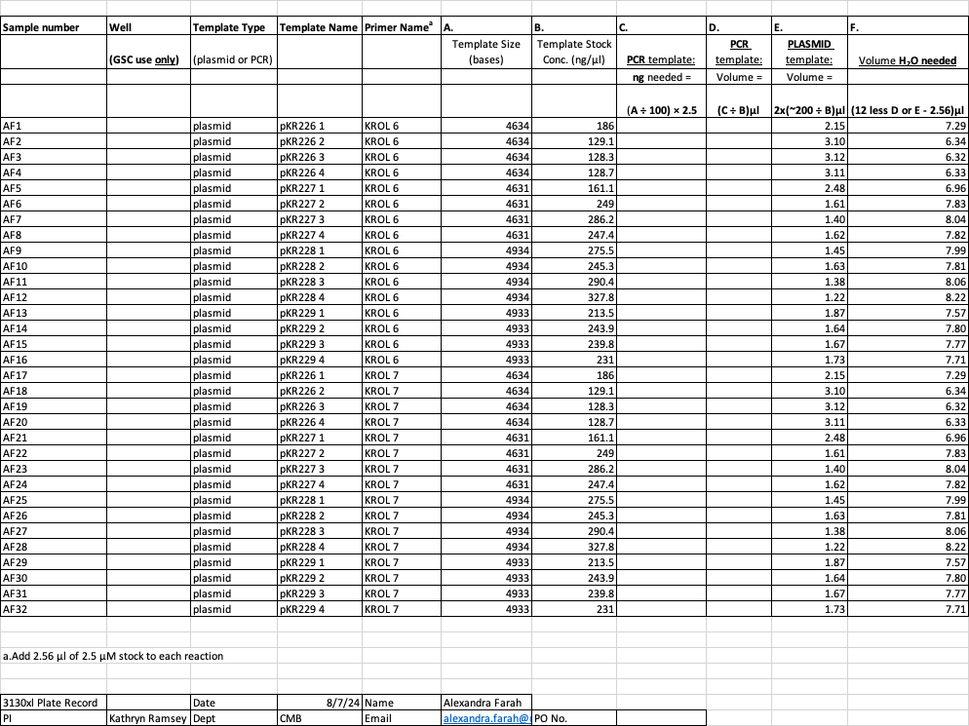

Thursday, August 8, 2024
To Do:
- Book Club 9am
- Lab Meeting 10am
- Kentucky Things

Friday, August 9, 2024
To Do:
- Analyze sequencing results
- Get ready for Boston
Results and Data:
Janet sent back sequencing results! When looking at the results it seems that all of the plasmids are correct and took up. Their designated insert EXCEPT FOR pKR228 1 which had a weird insert bp, pKR229 2 and pKR 229 3 which had huge gaps where the insert should be, so I guess their insert did not correctly get inserted and it was just the backbone. Below is what the snapgene looked like.
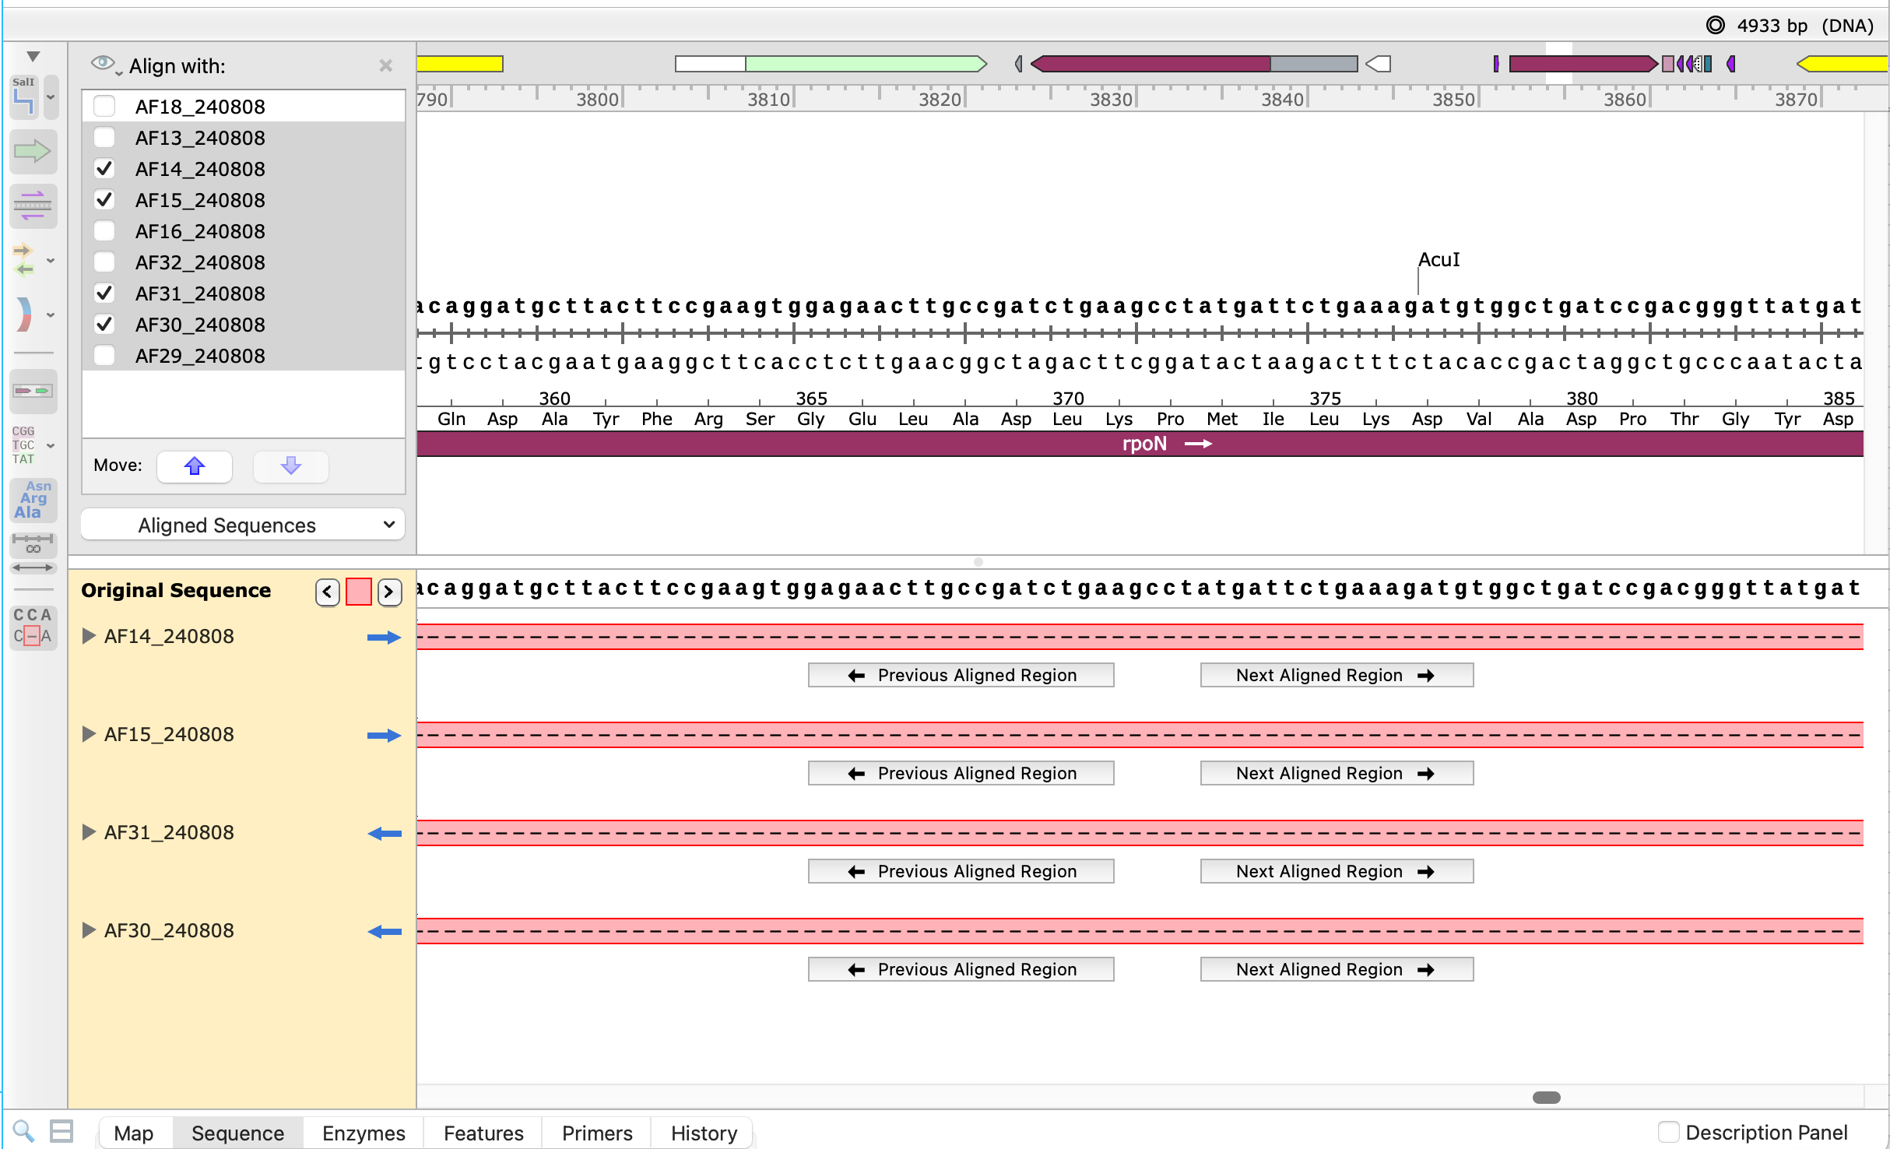

Therefore, to prepare the plasmids for Boston, I took 2ug of DNA for each plasmid (pKR226 – pKR229). Manda asked for a max of 10uL. I prepared them in microcentrifuge tubes. I prepared 2 of each just in case.
Plasmids taken:
Plasmid name | Starting conc | uL DNA needed | uL H20 needed
pKR 226 1 | 186 | 10 | 0
pKR 227 4 | 247.4 | 8.1 | 1.9
pKR 228 3 | 290.4 | 6.9 | 3.1
pKR 229 4 | 231 | 8.7 | 1.3

Monday, August 12, 2024
To Do:
- Get things from lab for boston
- Louisville orientation
- Boston training
Results and Data:
Pg has high ginigpan content which will degrade any proteins in like 15 minutes. High protease conetent. Need protease inhibitor if wanting to get any proteins. Need need need to work quickly and on ice to make sure the proteins don’t get degraded.
Liquid media good for about two weeks after adding vitamin K.
Plates good for about a month after adding vitamin K or the antibiotic. Only erythromycin and mad=ybe one other antibiotic works with Pg. Other antibiotics (like kanamycin) doesn’t work.
Tuesday, August 13, 2024
To Do:
- Boston training
- Louisville orientation day 2

Bibliography

Ramsey, K. M. and Dove, S. L. (2016) ‘ A response regulator promotes Francisella tularensis intramacrophage growth by repressing an anti-virulence factor ’, Molecular Microbiology. doi: 10.1111/mmi.13418.

