RI-INBRE SURF Program
Kingston, RI 02811

To whom it may concern:

My name is Matthew Ramsey and I am an Assistant Professor in the Department of Cell and Molecular Biology at the University of Rhode Island. I am writing to enthusiastically recommend Shannon Oliver to the RI-INBRE summer research (SURF) program. I have had the pleasure to work with Shannon last fall where she was an undergraduate research assistant in my laboratory.

During my time as a graduate student, postdoc and professor, I have mentored nearly twenty undergraduate and graduate students in hands on laboratory research and Shannon easily ranks as the best student I have mentored in that entire time. Shannon is very goal oriented and focused on a career in biological research. She contacted me during her freshman year to pursue research in my lab and clearly stated her intention to gain research experience towards obtaining a graduate degree. Shannon has been a wonderful assistant so far. Her meticulous attention to detail, punctuality and work ethic have been fantastic and she provides an ideal example for my other student workers. Shannon has impressed me with her ability to solve problems in the lab and ask insightful questions. I am confident she has the intellect to succeed as a researcher and will be a valuable asset to any research program that chooses her.

As you can see from her transcripts, Shannon is a great student and she has been able to think her way through all the problems I’ve given her as part of her training so far. In addition to her scholastic and research work, Shannon has been a joy to work with on a personal level. Her attitude and sociability is well suited for work within a group setting and she routinely works with other members of my lab to complete many tasks without issue. She’s been a bright spot in my group and I frequently brag about the quality of her work and temperament to my colleagues. In my opinion you would be lucky to have her join your program and I look forward to the training she would be able to receive. I hope that you consider her for the position.

It’s been my joy to recommend Shannon for this position. If you have any further questions, please do not hesitate to contact me.
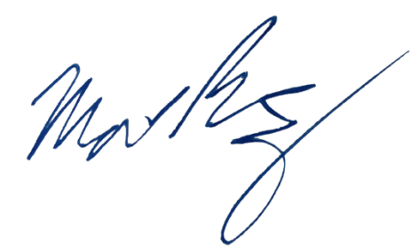
Sincerely,

Matthew Ramsey
University of Rhode Island
mramsey@uri.edu

