 Department of Oral Immunology and Infectious Diseases

Dear David,

I am pleased to agree to act as a consultant for your upcoming R01 application “Phytocannabinoid resistance mechanisms among oral pathobionts”.

As you know I have considerable experience in developing mutational strategies for understudied oral bacteria, including Corynebacterium and Haemophilus spp. and we have several published techniques and vectors in use for these organisms.

My laboratory's expertise in this area and all relevant strains and protocols will be made available to you. Your R01 identifying cannabinoid resistant oral bacteria and their potential resistance traits is both timely and important to our field.

I look forward to working with you as the project develops!

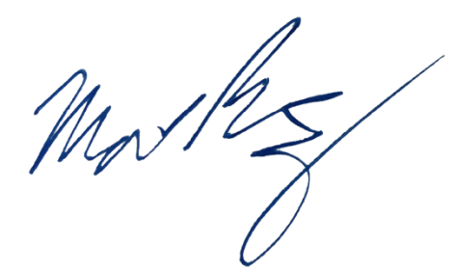
Sincerely,

Matthew Ramsey
Associate Professor, University of Louisville
Matthew.Ramsey@louisville.edu

