January 03, 2023

Dear Members of the Review Committee,

I am writing to express my support for Dr. Apollo Stacy’s MIRA proposal. I have known Dr. Stacy since 2011, when we briefly overlapped as PhD students in the laboratory of Dr. Marvin Whiteley. Since 2016, I have led a research group focused on the ecology of oral commensals in the Department of Cell and Molecular Biology at The University of Rhode Island. I received tenure in 2023. Over the years, I have kept up with Dr. Stacy at conferences and most recently as co-organizers of an ESI networking event.

One of the primary focuses of my laboratory is the prominent yet understudied oral commensal Haemophilus parainfluenzae. We have characterized how it metabolically interacts with other oral commensals, and have also made strides in developing genetic tools, including a dense transposon mutant pool for Tn-seq experiments. We plan to publish this important resource within the next year, and have already shared it with the Stacy Lab, specifically to support their proposed research on how H. parainfluenzae competes with other commensals for nitrate. I also have expertise in Enterococcus faecalis physiology and genetics, including Tn-seq, from my time as a postdoctoral fellow in the laboratory of Mike Gilmore, and therefore can support this aspect of Dr. Stacy’s proposed research as well, which will involve examining how nitrate-induced commensals inhibit pathobionts such as E. faecalis. Beyond this, I am happy to support these lines of research in any other way that I possibly can, such as the interpretation of Tn-seq results or the construction of defined mutants in H. parainfluenzae or E. faecalis.

Dr. Stacy’s MIRA proposal will undoubtedly advance our fundamental understanding of microbiota ecology. Please feel free to contact me if you have any further questions.

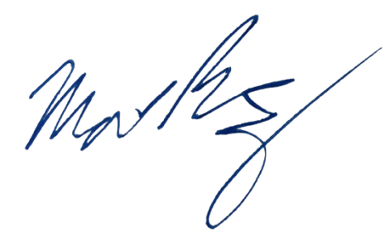
Sincerely,

Matthew Ramsey (he/him)
Associate Professor
University of Rhode Island
mramsey@uri.edu

