May 01, 2023

To whom it may concern:

My name is Matthew Ramsey and I am an assistant professor at the University of Rhode Island in the Department of Cell and Molecular Biology. I am writing to give my highest recommendation for Surendra Puri. I met Surendra a few years ago as part of an ongoing collaboration between my lab and his graduate advisors, Dr. Jiyeon Kim.

Surendra has primarily interacted with my graduate students as part of our collaboration, so I have not had a chance to mentor him directly in a laboratory setting. However, I can say that he has been excellent as a collaborator and is always consistent with sample preparation, organization, oral and verbal communication skills with myself and my group. Through publishing together, I have gotten to see Surendra’s writing and editing skills 1st hand and think they are quite good for a PhD student at his level, especially among students from backgrounds of English as a secondary language.

Surendra has performed a very difficult set of collaborative experiments with our group and by doing so has allowed us to significantly push forward single-cell metabolite resolution and kinetics between bacterial cells of multiple species. These advances are outstanding for what our group has tried to do and having worked in a similar collaboration with an SECM group like Surendra’s when I was a student, I know exactly how difficult the tasks he accomplished were. I am confident that he would be able to carry out very difficult collaborative projects in the future. I think that Surendra would be successful as a postdoctoral researcher in your program and can perform well despite any difficulty with his research that he may face. Please feel free to contact me if I can be of further assistance.

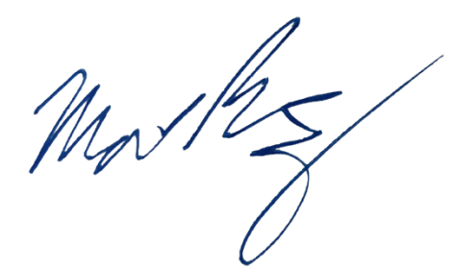
Sincerely,

Matthew Ramsey
University of Rhode Island
mramsey@uri.edu

