June 9, 2022
To the Admissions Committee:

My name is Matthew Ramsey and I am an Assistant Professor in the Department of Cell and Molecular Biology at the University of Rhode Island. I am writing to enthusiastically recommend Karishma Patel for pharmacy school. I met Karishma ~4 years ago as a sophomore at URI. Karishma heard from another professor that I did research on bacteria and contacted me that same day expressing her interest and asking if she could work in my lab to gain more experience in the field.

Karishma began work in my lab in the fall of 2019 helping us isolate and characterize bacterial and fungal isolates from the mouths of student volunteers for further study in my lab. During this time she assisted with routine culturing, isolation, DNA purification and molecular typing by 16S PCR as well as assisted in creating gene cloning constructs for some of the bacteria we study. In all of these areas, Karishma performed extremely well and took to the work without additional instruction or monitoring.

Overall, I would rank Karishma’s work ethic, professionalism, motivation and communication skills in the top 10% of undergraduates I have trained since 2016. Karishma exhibits a degree of maturity beyond that of her peers and takes the work seriously. Her intellect and analytical ability was evident in her work and while she performed exceptionally well there, her time in the lab was cut short when Covid struck. At that time, I had much more complex work planned for Karishma, on par with what I would expect for a 1st year graduate student. I am confident that Karishma would have excelled in carrying this out but we sadly never got the chance to finish. I would still rank her in the top 25% of all students I’ve trained in terms of intellect and I suspect it to be much higher than that but didn’t get the chance to assess it further.

Karishma is very resilient and motivated, when her initial work in the lab ran into problems she never slowed down and talked to myself and her graduate mentor and pressed on after identifying issues that had held her back. She is a very easygoing person and is a clear communicator and ready to share her thoughts. In lab social functions she was emotionally mature and had no issues interacting with her peers professionally or personally.

If Karishma had wished to work in my lab for graduate school I would have happily accepted her here. I fully and enthusiastically recommend Karishma for pharmacy school and I am certain that she will rise to the challenge and be successful. I hope that you would all share my enthusiasm for her and agree.
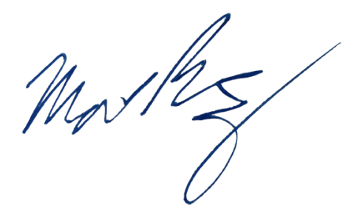
Sincerely,

Matthew Ramsey
University of Rhode Island
mramsey@uri.edu

