October 17, 2021

To whom it may concern:

My name is Matthew Ramsey and I am an Assistant Professor in the Department of Cell and Molecular Biology at the University of Rhode Island. It is my pleasure to recommend Tessa Bellavia for a URI² undergraduate research grant. My own laboratory is well funded by an NIH R01 grant in oral microbiology with 2.5 years of funding remaining. The research described within this proposal fit well under the umbrella of my research programs interests.

Tessa is a very new addition to my laboratory just starting 1 month ago. The first thing I noticed about Tessa is how proactive and goal oriented she is. Tessa approached me in the spring of 2021 expressing interest in my labs research in oral microbiology and then mentioned her interest in practicing dentistry / being involved in dental health research. Upon joining the lab Tessa immediately brought this grant mechanism to my attention and came up with deadlines for her to have the initial application drafts written. I have been highly impressed with her diligence and ability to stick to deadlines while turning in quality work.

Our initial meeting about the grant and her work in my laboratory laid out very broad strokes into what we wanted to accomplish this year. Using this general introduction, Tessa was able to create much of the experimental details that are in this proposal. Her initiative, critical thinking, attention to detail and drive up to this point are as good or better than any undergraduate that has worked in my laboratory. I am confident that her proposal will yield valuable data for our research and will leave Tess with a tremendous amount of training and experience relevant to her career goals both here at URI and beyond. I fully recommend Tess for this award without hesitation and look forward to supporting her research in my lab with or without external funding from URI².

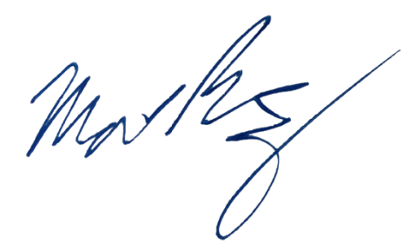
Sincerely,

Matthew Ramsey
University of Rhode Island
mramsey@uri.edu

