January 07, 2021

To Whom it May Concern:

My name is Matthew Ramsey and I am an Assistant Professor in the Department of Cell and Molecular Biology at the University of Rhode Island. Maria worked in my research lab for two consecutive summers (2018-2019) as an undergraduate research assistant.

During Maria’s 1st summer she had not yet taken microbiology which is usually a prerequisite for work in my group. I was immediately impressed at how quickly Maria picked up not only the day to day work but also an understanding of the “why” we were asking her to do what she did and what we were driving for in our research. Maria assisted my graduate students with microbiology research on multispecies bacterial interaction within the human oral cavity. During the time in my lab she learned nearly all basic microbiological techniques and helped with a good deal of molecular biology work as well. She did not simply spend her summer washing dishes for us! My graduate students and myself were all impressed with how quickly Maria picked up each technique and also by how diligent she was with her work and with her lab notebook and recordkeeping (something often lacking in my younger students). I would say her strengths are great retention of information and teaching, strong sense of professionalism, excellent work ethic and attitude and a natural curiosity. Of her few weaknesses I would state that she is also an independently motivated worker and might spend time chasing down things in the lab that could be less productive if no one stepped in to make sure she needed help or some redirection.

Maria was a joy to work with and I would place her research ability in the top 10% of any 1st year graduate student I have worked with. In addition to her professionalism in the lab she was also a great asset to the lab dynamic and is an excellent person to have in your group. She brings a bright and competent personality to the room and we all enjoyed spending time with her both in and out of the lab. I would not have hesitated to offer her a spot as a PhD student in my own group if she wanted it, but I am certain her talents will take her much higher than that. Overall, Maria is an excellent person and I am certain you would enjoy having her be part of your team at St. Jude’s.

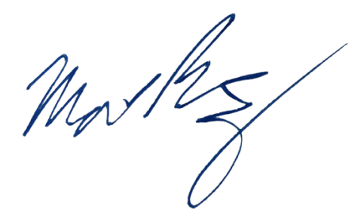
Sincerely,

Matthew Ramsey
University of Rhode Island
120 Flagg Rd. CBLS Rm. 387
Kingston, RI 02881
(401) 874-9505
mramsey@uri.edu

