April 01, 2021

To Dr. Batbileg Bor:

As you and I know each other well and you know my position at URI I will forego my usual personal introduction for a recommendation letter!

I am writing a letter of support for Chris Schuttert who is a graduating PhD student in the Nelson lab at URI. The Nelson lab shares space and is directly adjacent to my own laboratory and thus I got to enjoy a lot of overlap with Chris, especially during my 1st year setting up the lab (2016-17). Right away I was impressed with Chris’s maturity and composure vs his peers. Many graduate students, especially at URI, are fairly distant from the faculty and do not speak with or engage with them as often as what I was used to in my own graduate program. However, Chris had no such issues and is very eager to communicate and ask questions. It was immediately obvious that Chris had a very high level of scientific curiosity and enthusiasm and in this regard I would rank him in the top 10% of the graduate students I have worked with in all phases of my career.

Chris was an immediate help to my young lab. In addition to knowing where everything in the department was, he also could instruct myself and my early students on how it worked and has many times helped us troubleshoot older equipment. Chris has also helped my students in some molecular biology protocols and been a good source of information for my newer students in the lab. I did not interact with Chris in a way that would let me be a good judge of his day to day scientific performance and ability. However, I can say that Chris is a constant presence in the lab and in working many long hours I also saw Chris there actually working and not just being present and socializing. I would defer to Dr. Nelson’s assessment of his overall scientific and writing ability. Chris has given 3 graduate seminars since I have arrived and I would rank his among the top 2-3 of all our students (top 1-5%) that I have seen so far. Chris is a natural speaker and his practice and preparation in his seminars are evident.

In addition to Chris’s obvious work ethic and scientific curiosity I’ve gotten to be fairly friendly with Chris on a personal level and have had numerous conversations with him about not only his professional concerns and aspirations but also numerous non-scientific topics. Chris is an easygoing and humorous person and I think his personality in a group setting would mesh well with a wide variety of coworkers. On the points that I can evaluate him on I would not hesitate to choose Chris to join my group as a postdoctoral fellow and I give him the strongest recommendation that I can.

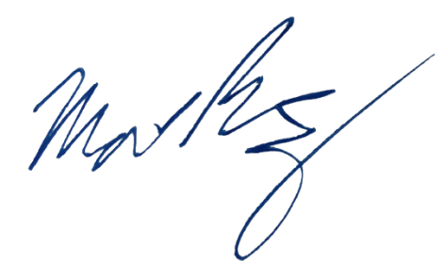
Sincerely,

Matthew Ramsey
University of Rhode Island
mramsey@uri.edu

