March 23, 2021

To Dr. Paul Thompson:

My name is Matthew Ramsey and I am an Assistant Professor in the Department of Cell and Molecular Biology at the University of Rhode Island. I am writing to recommend Nick Pagliusi for a Research Associate position with your group.

I met Nick in late 2019 when he approached me to join my lab as a summer undergraduate researcher through our University SURF program. I had also reached out to two colleagues in my department who had previously had Nick in their courses and both immediately remembered him and gave him a strong recommendation. Due to the onset of COVID-19, Nick had a delayed start in the lab and had to work under very restrictive / atypical circumstances. Nick ended up being one of only 2 undergrads who has worked in my lab alongside my graduate students over the past year. Given the distancing adhere to, Nick started out with the most minimal instruction and supervision compared to his earlier peers. Despite the handicaps of working in our current conditions, Nick did incredibly well!

I assigned Nick to help with 2 projects relating to developing a better transposon delivery system for Corynebacterium matruchotii, a commensal oral bacterium that we study in the lab. Nick was primarily tasked with testing transformation rates and quantifying transposition events into the chromosome and carried this out without issue or need for continued instruction. Later, Nick helped develop a luciferase-based promoter-reporter fusion construct for the same bacterium where Nick got a good deal of experience with molecular cloning and helped create a plasmid based reporter system and then helped test it under numerous growth conditions. Nick’s work should land him secondary authorship when the rest of our studies finish up later this year. Nick has worked constantly under some of the worst conditions in our lab and without a complaint or issue. He is a great colleague and well-liked by the graduate students. He is also a very easygoing and open communicator and is sure to bring up issues to a supervisors attention before they become a problem. In a recent lab meeting I actually had Nick share his slides to the lab afterwards because he provided an excellent introduction and summary of the data he had produced. It was so well done I wanted some of my junior graduate students to emulate his presentation style.

In summary, Nick has been a very hard working student with a lot of solid lab experience and has generated a lot of data in a difficult climate. I would not hesitate to call him one of the top 5% of undergraduate workers I have had and I would certainly hire him if I was in your position.
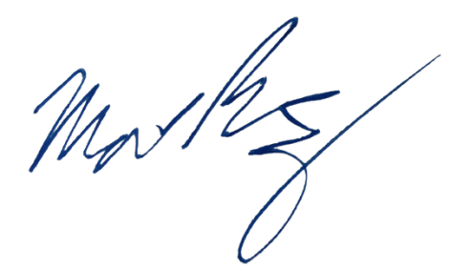
Sincerely,

Matthew Ramsey
University of Rhode Island
mramsey@uri.edu

