February 21, 2019
Coastal and Environmental Fellows Program
Kingston, RI 02881

To whom it may concern:

My name is Matthew Ramsey and I am an Assistant Professor in the Department of Cell and Molecular Biology at the University of Rhode Island. It is my pleasure to recommend Quintin Rocha to the URI Coastal and Environmental Fellows program.

Quintin first joined my lab in the summer of 2018 as a Science and Engineering Fellow. Quintin quickly picked up techniques in the lab and was able to accomplish a substantial amount of research during the summer session. Since that summer Quintin has been enrolled in research credits and continues to assist research projects in my lab today.

Quintin has been a very easy student to communicate with and is incredibly open and unreserved. During his time in the lab Quintin has matured and begun to develop his projects further. I would rate Quintin in the top 25% of all the undergraduate trainees I have worked with so far at URI. I believe that he will continue to develop into a better researcher as he becomes more involved with his project.

Quintin’s attitude and interpersonal skills are far better than most trainees in my lab and he will be a great colleague for whoever he works with. Thus, it is without reservation that I recommend Quintin to this program.

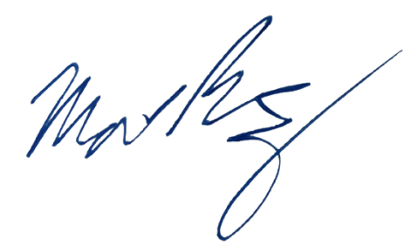
Sincerely,

Matthew Ramsey
University of Rhode Island
mramsey@uri.edu

