December 13, 2019
To Whom it May Concern:

My name is Matthew Ramsey and I am an Assistant Professor in the Department of Cell and Molecular Biology at the University of Rhode Island. I am confirming that Quintin Rocha worked in my laboratory from June 2018 until December 2019. During his time in my lab Quintin worked on several projects as part of the URI Science & Engineering Fellows and Coastal Fellows programs respectively.

In evaluating Quintin I would rank his verbal communication skills in the top 5% of all students (graduate or undergraduate) I have taught in 4 years at URI and 3 years in technical administrator positions. I would rank Quintin in the bottom 50% in general laboratory skills and in the bottom 5% in maturity and responsibility, i.e. keeping up with deadlines, assigned tasks, etc.

Quintin established a routine of talking about his work often, but not achieving practical results. Most of the time Quintin would turn things in at the last minute. During the past summer he informed me that he was leaving 1 week early from the Coastal Fellows program for a vacation from the airport as he left. When Quintin returned it was on a probationary status and ultimately, he let multiple deadlines lapse on projects necessary for his Coastal Fellows program and only informed a graduate student when the final assignment was due within 24 hours, asking them to help edit his final proposal. He never reached out to me during this entire period about his work while other fellows in the same program did so numerous times throughout the semester, well in advance of known deadlines. Quintin was terminated from the lab after this last failure.

My other employees impressions of Quintin are that he will perform a minimal amount of work in the maximum time available and that he is quite good at talking about the work, but not performing it. I share these impressions. Quintin personally is a fun and intelligent individual and a joy to socialize with and all of my employees like him. However, in a professional setting, he is a liability and I have concerns that his maturity is still non-existent. When informed of his termination his only replies were twice asking me if he could maintain access to the laboratory chat rooms where we share information and sometimes socialize. I find this again telling of an overall lack of maturity. I cannot recommend Quintin’s employment in a research position, but I would enthusiastically recommend him for more social or outward facing work that had no strict deadlines attached.
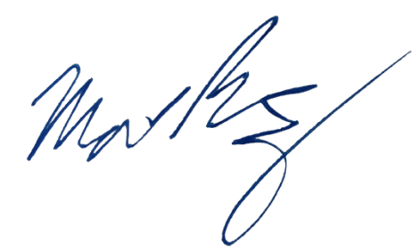
Sincerely,

Matthew Ramsey
University of Rhode Island
120 Flagg Rd. CBLS Rm. 387
Kingston, RI 02881
(401) 874-9505
mramsey@uri.edu

