May 02, 2019

To Whom it May Concern:

My name is Matthew Ramsey and I am an Assistant Professor in the Department of Cell and Molecular Biology at the University of Rhode Island. I am confirming an opportunity for Maria Iannotti to gain research experience in my lab this summer. Maria will serve as an Undergraduate Research Assistant where she will assist myself and graduate students in the lab in designing and carrying out experiments in oral microbiology which is the focus of my lab’s research.

This position will be an unpaid part-time position of ~30 hrs per week. Maria is currently scheduled to work from June 10 to August 16, 2019.

We are excited to have Maria work with our lab again this summer. If you have any questions or concerns please contact me directly and I will do my best to help.

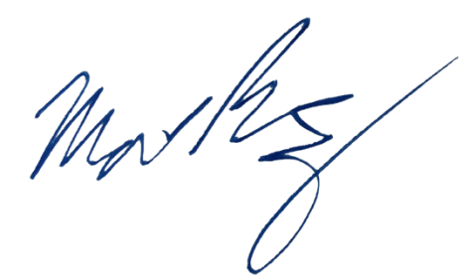
Sincerely,

Matthew Ramsey
University of Rhode Island
120 Flagg Rd. CBLS Rm. 387
Kingston, RI 02881
(401) 874-9505
mramsey@uri.edu

