February 18, 2019
S&E Fellows Program, URI
Kingston, RI 02881

To whom it may concern:

My name is Matthew Ramsey and I am an Assistant Professor in the Department of Cell and Molecular Biology at the University of Rhode Island. It is my pleasure to recommend Kaileigh Cloutier-LeBlanc for the summer Science and Engineering Fellows program here at URI.

I have had the pleasure of mentoring two S&E fellows students so far during my time at URI. I have also been fortunate to have Kaileigh serve as an undergraduate researcher in my laboratory this past year alongside my previous S&E fellow. I have absolute faith that Kaileigh would be an excellent addition to the program and would go above and beyond many other student researchers performance in this program. She has been a joy to have in our group and is rapidly turning into a valuable asset for our research work as well. She’s picked up many techniques in her training quickly, so even if she were to work in another lab she would already have many useful skills to help contribute.

Kaileigh has excellent verbal communication skills and a positive and eager attitude. I believe she would fit in well with nearly any group of researchers she might be asked to work with. I would not hesitate to have her work in my own group if there was room available for her. I believe that she would be an ideal student for the program and I recommend her without reservation. Please feel free to contact me for further comment or information if you like.

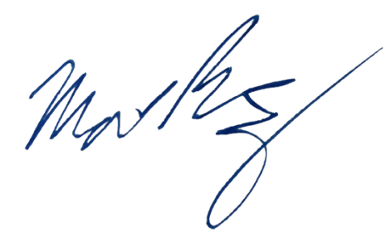
Sincerely,

Matthew Ramsey
University of Rhode Island
mramsey@uri.edu

