November 18, 2019

To whom it may concern:

My name is Matthew Ramsey and I am an Assistant Professor in the Department of Cell and Molecular Biology at the University of Rhode Island and am the primary instructor for CMB265G ‘Science and Pseudoscience’.

After discussion with Dina Elias with a scheduling conflict I am writing that I consent to the following resolution. Dina needs both my course and Dr. Greene’s Pathogenic Microbiology course next semester to graduate on time. However, my course officially ends at 3:15pm on T/TR and Dr. Greene’s course lab section begins at 3pm on T/TR. My course is in Chafee hall and Dr. Greene’s in CBLS. Thus no more than a 20 minute overlap would exist for Dina.

In CMB265G many of our lectures end a few minutes early as they are heavy on in-class discussion which sometimes concludes before a standard lecture might. Thus, Dina can leave these courses without missing any content. When necessary I am formally allowing Dina to leave my class no more than 20 minutes early to attend Dr. Greene’s laboratory section. If applicable I expect Dina to attend the full length of CMB265G lectures otherwise. Dina will not be penalized for leaving 20 minutes early to make this accommodation.

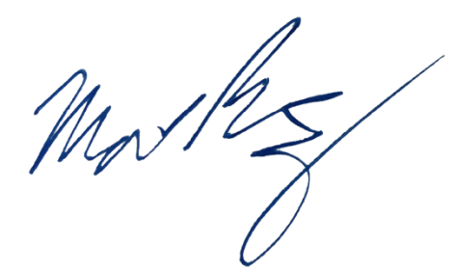
Sincerely,

Matthew Ramsey
University of Rhode Island
mramsey@uri.edu

