March 11, 2019

URI College of Pharmacy
PharmD Transfer Applications

To whom it may concern:

My name is Matthew Ramsey and I am an Assistant Professor in the Department of Cell and Molecular Biology at the University of Rhode Island. I am writing to recommend Rebecca “Bekk” Trojan to the PharmD program at the University of Rhode Island. I have had the pleasure of teaching Bekk this past semester as a student in my CMB201 Medical Microbiology lecture.

Bekk performed extremely well in my course receiving an A and was in the top 5% of her cohort of 35 other students. She also maintained a 100% average in the laboratory section of the course. In this course I instruct numerous Pharm Sci and PharmD students and I found Bekk’s attitude to be on par with many of her peers already in the PharmD program. Bekk attended every lecture and voluntary study section. I believe Bekk could be successful in the PharmD program based on other students I interact with there and on her own excellent efforts put forward in my course.

It is my belief that Bekk would be successful in this program and I am glad to offer my full support and recommendation.

If you have any further questions, please do not hesitate to contact me.

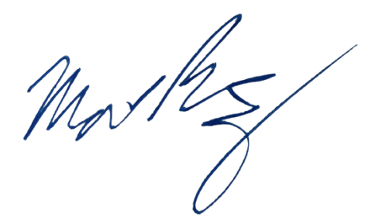
Sincerely,

Matthew Ramsey
University of Rhode Island
mramsey@uri.edu

