February 21, 2019

URI College of Pharmacy
PharmD Transfer Applications

To whom it may concern:

My name is Matthew Ramsey and I am an Assistant Professor in the Department of Cell and Molecular Biology at the University of Rhode Island. I am writing to recommend Allison Richard to the PharmD program at the University of Rhode Island. I have had the pleasure of teaching Allison this past semester as a student in my CMB201 Medical Microbiology lecture.

Allison performed well in my course receiving a B and was in the top 40% of her cohort of 35 other students. In this course I instruct numerous Pharm Sci and PharmD students and I found Allison’s attitude to be on par with many of her peers already in the PharmD program albeit a bit more reserved. Despite her quieter nature, Allison attended every lecture and voluntary study section. While her performance was not as good as a few of her peers, her effort and maturity did stand out. I believe Allison could be successful in the PharmD program based on other students I interact with there. I do not know what Allison’s other course grades are so far. If she was performing well outside of my course as well I believe she would be a strong candidate.

It is my belief that Allison would be successful in this program and I am glad to offer my support and recommendation.

If you have any further questions, please do not hesitate to contact me.

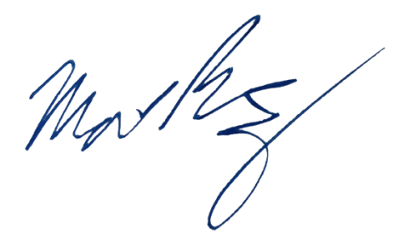
Sincerely,

Matthew Ramsey
University of Rhode Island
mramsey@uri.edu

