December 30, 2019

To Whom it May Concern:

My name is Matthew Ramsey and I am an Assistant Professor in the Department of Cell and Molecular Biology at the University of Rhode Island. I am writing to give my strongest possible recommendation to accept Alex Labossiere to the BES graduate program at URI.

I met Alex around a year ago when he approached me to ask questions about research and how the actual process of laboratory research was carried out. Since then I’ve had Alex as a student in a senior level microbiology course and have had conversations with him about the course and about biotech research on a near weekly basis. I am accepting Alex as an undergraduate researcher in my laboratory next semester and if accepted in the graduate program at URI I would also gladly accept Alex into my lab as a Masters student if that was what he desired to do. I would support Alex being a member of the program in other labs besides my own as well.

Alex displays an incredible curiosity and aptitude for independent learning that I would place as greater than 90% of his peers. He has always gone a little further in his efforts to understand a subject better compared to nearly any other student I’ve worked with. As you can see from his CV, Alex also has done some relevant research and media prep work and has a well-rounded exposure to other club sports and entities on campus. You will also notice that Alex has a substandard GPA which he and I have spoken about.

Alex comes from an impoverished background and will be the 1st member of his family to graduate from college. Alex had many issues with family and finances outside of academics that made his studies more difficult than most students. As those issues have passed, Alex’s GPA has improved. After witnessing Alex’s intellect and understanding in my own course, I feel confident that he has enough knowledge to be an excellent graduate student and I am honored to recommend him to this program.

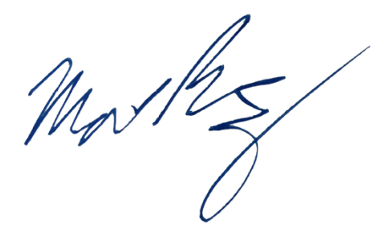
Sincerely,

Matthew Ramsey
University of Rhode Island
120 Flagg Rd. CBLS Rm. 387
Kingston, RI 02881
(401) 874-9505
mramsey@uri.edu

