January 02, 2018

To whom it may concern:

My name is Matthew Ramsey and I am an Assistant Professor in the Department of Cell and Molecular Biology at the University of Rhode Island. It is my pleasure to recommend Rachel Smilansky for a summer internship. Rachel was a student in my CMB201 – ‘Medical Microbiology’ course in the fall of 2017.

Rachel finished in the top 10% of my course (of 288 students) with an A grade. In a class this large, it’s somewhat difficult for me to get to know many of the students. Despite this, Rachel has established herself as a willing and eager participant in class, attending most lectures that I can recall as well as my voluntary exam review sessions. Rachel received an extremely high (98%) grade in the laboratory section of this course as well. In the labs Rachel has received training relevant to bench-work in your facilities including basic dilutions, microbial isolation, enumeration and culturing as well as aseptic techniques.

Rachel has maintained her grades alongside the time commitments of being a student-athlete at URI. Her dedication to this and ability to maintain high grades in her coursework speaks well of her work ethic and self-discipline.

In my discussions with Rachel I understand she would prefer to work at either your PA or MA locations due to proximity to family and her general interest in the work performed at these sites. I am confident that Rachel will be an eager trainee for you and that she will be quite successful in whatever path she chooses to pursue next. Whatever you decide, I am sure that Rachel will do quite well and I look forward to seeing her progress beyond her time at our University. I recommend Rachel without reservation and I hope you agree.

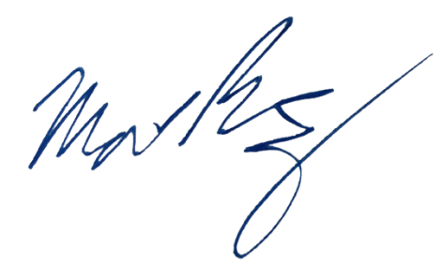
Sincerely,

Matthew Ramsey
University of Rhode Island
mramsey@uri.edu

