January 29, 2018

URI College of Pharmacy
PharmD Transfer Applications

To whom it may concern:

My name is Matthew Ramsey and I am an Assistant Professor in the Department of Cell and Molecular Biology at the University of Rhode Island. I am writing to recommend Julia Hodgins to the PharmD program at the University of Rhode Island. I have had the pleasure of teaching Julia this past semester as a student in my CMB201 Medical Microbiology lecture.

Julia performed well in my course receiving an B+ and was in the top 40% of the course of over 280 other students. Julia started out with a poor grade in the beginning of the semester and steadily improved her scores throughout the entire course. In this course I instruct numerous Pharm Sci and PharmD students and I found Julia’s attitude to be on par with many of her peers already in the PharmD program. From in-person conversation with Julia she felt that she wasn’t sure about which direction to take initially at URI and that her time in Pharm Sci and in my course have led her to be certain about a career in pharmacy and the decision to join the PharmD program.

It is my belief that she would be successful in this program and I am glad to offer my support and recommendation.
If you have any further questions, please do not hesitate to contact me.

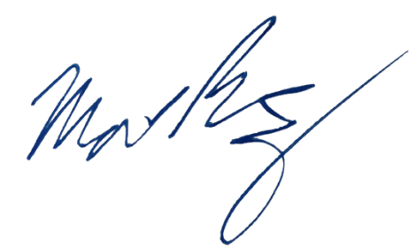
Sincerely,

Matthew Ramsey
University of Rhode Island
mramsey@uri.edu

