January 26, 2018

URI College of Pharmacy
PharmD Transfer Applications

To whom it may concern:

My name is Matthew Ramsey and I am an Assistant Professor in the Department of Cell and Molecular Biology at the University of Rhode Island. I am writing to enthusiastically recommend Emily Davison to the PharmD program at the University of Rhode Island. I have had the pleasure of teaching Emily this past semester as a student in my CMB201 Medical Microbiology lecture.

Emily performed quite well in my course receiving an A- and was in the top 25% of the course of over 280 other students. Emily was very proactive in contacting me throughout the semester to make sure she was staying on top of her grades and current with the material. In this course I instruct numerous Pharm Sci and PharmD students and I found Emily’s attitude and work ethic to be on par or better than many of her peers already in the PharmD program. In addition to Emily’s grades she is also committed heavily in community and activity involvement being part of the URI 101 program as a mentor, a member of the URI Lacrosse club and participating in the Rhody Ambassadors program. Despite these activities Emily has performed at a high level as a student and I anticipate she will have no difficulty doing so as part of your program.

It is my belief that she would be successful in this program and I am glad to offer my support and recommendation.
If you have any further questions, please do not hesitate to contact me.

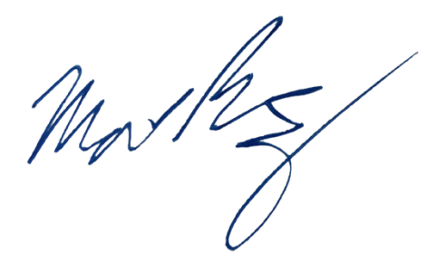
Sincerely,

Matthew Ramsey
University of Rhode Island
mramsey@uri.edu

