February 16, 2017
RI-INBRE SURF PROGRAM
Kingston, RI 02881

To whom it may concern:

My name is Matthew Ramsey and I am an Assistant Professor in the Department of Cell and Molecular Biology at the University of Rhode Island. It is my pleasure to recommend Terra Jouaneh to the RI-INBRE summer undergraduate research (SURF) program. Terra was a student in my CMB201 – ‘Medical Microbiology’ course in the fall of 2016.

Terra finished in the top 5 (of 267) students in my class with a >99% course average. Clearly Terra is an exceptional academic student and this is evident in her grades at URI outside of my course as well. Terra attended every class that I recall and all voluntary review sessions where she contributed frequently, asking very good questions that demonstrated a clear understanding of the material and a motivation to do well.

Terra spoke with me several times during the semester about the day to day activity in academic research and was very interested in how actual scientific investigation operates. She also asked many questions above and beyond what we covered in class and was interested to learn well beyond just what was necessary to pass a test or do well in the class. I believe her intellect and curiosity position her quite well to be a successful researcher for the SURF program.

Terra has excellent verbal communication skills and a positive and eager attitude. I believe she would fit in well with nearly any group of researchers she might be asked to work with. I would not hesitate to have her work in my own group if there was room available for her. I believe that she would be an ideal student for the SURF program and I recommend her without reservation. Please feel free to contact me for further comment or information if you like.

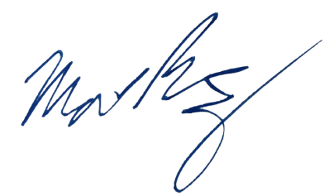
Sincerely,

Matthew Ramsey
University of Rhode Island
mramsey@uri.edu

