Matthew M. Ramsey PhD
120 Flagg Rd.
Kingston, RI 02882
January 14, 2017

URI College of Pharmacy
PharmD Transfer Applications

To whom it may concern:
My name is Matthew Ramsey and I am an Assistant Professor in the Department of Cell and Molecular Biology at the University of Rhode Island. I am writing to enthusiastically recommend Alex Balkum to the PharmD program at the University of Rhode Island. I have had the pleasure of teaching Alex this past semester as a student in my CMB201 Medical Microbiology lecture.
Alex performed well in my course. While he did not receive perfect scores, Alex contacted me early in the semester and was very proactive towards maintaining a good grade in CMB201. Despite being in a class of over 260 students, Alex distinguished himself with his attendance and his ability to ask good questions both in class and in my office hours. While I can only speak for the limited interactions I have had with Alex during this semester, I found his attitude to be very positive and he demonstrated a strong eagerness to learn and do well in his studies.
During this course I also interacted with numerous current PharmD students and I do not find Alex to be beneath them in aptitude or motivation. It is my belief that he would be successful in this program and I am glad to offer my support and recommendation.
If you have any further questions please do not hesitate to contact me.
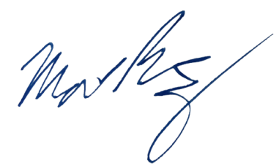
Sincerely,

Matthew Ramsey
University of Rhode Island
mramsey@uri.edu

