RI-INBRE SURF Program
Kingston, RI 02811

To whom it may concern:

My name is Matthew Ramsey and I am an Assistant Professor in the Department of Cell and Molecular Biology at the University of Rhode Island. It is my pleasure to recommend Adam Capwell to the RI-INBRE summer undergraduate research (SURF) program. Adam has been a student researcher in my lab since the Fall semester of 2016.

Currently, Adam is engaged in several research projects in my lab and he and another undergraduate (which I have also recommended for the SURF program) were instrumental in getting my lab research going when I started last semester at URI. Adam has been an exceptional student and has been incredibly easy to train. Adam has expressed an interest in a biological sciences research career and I am looking forward to seeing how far he can go. I would 100% want Adam to work in my lab and I think anyone else in the SURF program would be lucky to have him as part of their group.

Adam’s intellect and technical skills are one of the best I have seen from an undergraduate and his work ethic is second to none. Numerous times throughout the year I have seen Adam come in and instead of waiting for me to give him a task, he will start cleaning up the lab, making media, taking care of what needs to be done, etc. Adam is highly motivated and has a very easygoing disposition making him a natural fit in any research group he might participate in. I think he would be one of the better students you could admit to this program and I hope you consider him. Please feel free to contact me with any further questions.

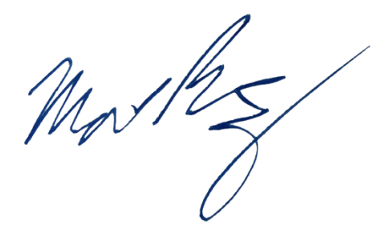
Sincerely,

Matthew Ramsey
University of Rhode Island
mramsey@uri.edu

