 Department of Oral Immunology and Infectious Diseases

To whom it may concern:

My name is Matthew Ramsey and I am an Associate Professor in the Department of Oral Immunology and Infectious Diseases at the University of Louisville School of Dentistry. I am writing to enthusiastically recommend Delainey Witt for the Evalee C. Schwarz Charitable Trust for Education. I have had the pleasure of teaching Delainey in my 400 level Microbiomes and Biofilms course when I was at the University of Rhode Island (2023). This course met twice per week and is focused on very small group level work (<20 total students) and is highly interactive, based on current journal articles in the field. This allows me to get to know students in this course much better than in my larger general microbiology course for example. During the semester I got to see firsthand Delainey’s interest and excitement for the field, particularly when we discussed how the microbiome may affect the host. Delainey’s drive and motivation were evident in her in-class interactions with myself and her peers and she frequently spoke about her desire to become a veterinarian.

Overall as a student I would rank Delainey in the top 10% among all I have taught. I believe she could be much higher than that but given that we only had one semester of interaction I can only judge on that duration, the lower ranking here is only due to being less familiar with her in other aspects compared to students I rank highest. I would not hesitate to have her work with my own research group if we could accommodate her and she would be an asset to our graduate program if she wished to continue in that direction. In my course I got to observe Delainey’s ability to read, comprehend and verbally communicate very difficult research papers that each student struggled to understand at the beginning of the semester. Over the semester Delainey began to grasp the content faster than most in the room and it was apparent that she was doing the work ahead of time. I believe that Delainey has what it takes to succeed at the next level and I have only good opinions of her integrity, work ethic and motivation. In the group setting Delainey was interactive and would lead her groups discussion to the rest of the class when she had a better grasp of the content that day vs her peers. I think as Delainey grows as a scientist and clinician she will have an easy time mentoring others in a group setting. At present she is a good asset as a trainee and would be easy to instruct and a reliable presence. While I cannot know everything that is expected as a Veterinarian, I am confident that Delainey is capable of performing difficult work under stressful situations while maintaining an excellent degree of professionalism, communication, composure and care for those around her. I think she would be a reliable colleague, willing and eager to accept instruction and able to direct the work of others with ease.

It is my belief that Delainey would be very successful in Veterinary Medicine and I give her my full and enthusiastic recommendation. I believe that she is deserving of support from your Trust and would be a reliable investment for funding and for your consideration.
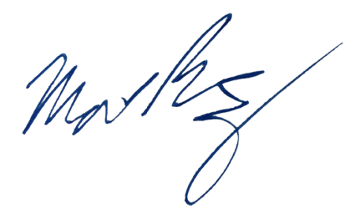
Sincerely,

Matthew Ramsey
Associate Professor, University of Louisville
Matthew.Ramsey@louisville.edu

