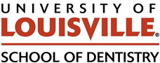 Department of Oral Immunology and Infectious Diseases

Referral Officer
Center for Scientific Review
National Institutes of Health
6701 Rockledge Drive, MSC 7768
Bethesda, MD 20892

December 8, 2024

Dear Referral Officer,

This letter regards the attached R01 application (PA-18-484) titled “Mechanisms underlying spatial interaction in the oral microbiota.” This is a resubmitted renewal application of R01 DE027958. We believe that this submission should also be considered under the NIDCR - Notice of Special Interest (NOSI): The Functional Oral Microbiome (NOT-DE-21-015).

We request that you assign this application to the following:

Institutes/Centers:
National Institute of Dental and Craniofacial Research – NIDCR

Scientific Review Group:
Oral, Dental and Craniofacial Sciences - ODCS

The reason for this request is that the primary focus of this grant is to identify species-species interactions within oral plaque microbiota and study biochemical mechanisms of interaction between them. Because these organisms are oral microbes and are involved in oral disease, we believe this research may be of interest to NIDCR. These assignments were approved for the initial reward. Also, as the lead PI, I am eligible for Continuous Submission as a standing member of the NIDCR-DSR study section, thus the timing of our submission.

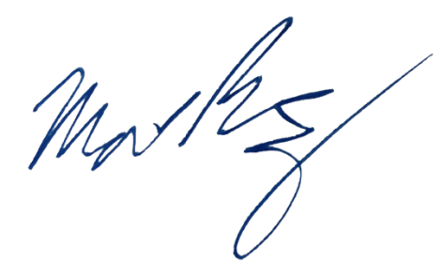
Sincerely,

Matthew Ramsey
Associate Professor, University of Louisville

