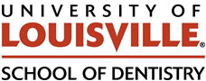 Department of Oral Immunology and Infectious Diseases

Date: 11/07/25

To: Margaret Hill, DMD
Dean, University of Louisville School of Dentistry

Subj: Meeting minutes – 11/07/2025
Meeting format/location: Virtual MS Teams meeting
ULSD Research committee
“Check-In” meeting with first year tenure-track faculty member Dr. Kim Jasmer
_________________________________________________________________________________
Dear Dean Hill:

On 11/07/25 the ULSD Research Committee met for a first year “check-in” meeting with Dr. Kim Jasmer. The purpose of these meetings are to assess if the faculty member is on track for promotion in regards to Research and Scholarship.

Committee members present:
Matthew Ramsey (Committee Chair)
Lisa Sandell (former Chair, attended in advisory capacity)
Gustavo Santaella
Hector Martinez

Dr. Kim Jasmer PhD. Assistant Professor, Department of Oral Immunology and Infectious Disease. Advisor and Chair – Dr. Richard Lamont. Dr. Jasmer is hired with an 80% Research Commitment.

This committee finds that Dr. Jasmer has done well is on track with their research efforts.

Successes: Dr. Jasmer is a COBRE funded junior investigator. They had one paper published in their 1st year with a collaborator from their previous institute. They have applied for an NIH R35 (5+ yr career award grant). Dr. Jasmer hosted two summer USLD student researchers, one of whom won an award at the UL Research Day for their poster presentation. Dr. Jasmer has hired one staff scientist late in their 1st year who has been productive and aiding with generating research data.

Challenges: Dr. Jasmer has had typical lab-startup challenges that are not unique or overly concerning. Primarily their difficulties were in expediting transfer of materials from their previous institution and significant delays in hiring of new staff due to the hiring freeze and the petition process.

Suggestions: The committee noted in our review (relayed separately to Dr. Jasmer) that Dr. Jasmer should largely continue as they have been, and to be proactive in meeting with their mentor team (Drs. Sandell, Diamond and Scott) beyond their 1st formal meeting earlier this year.

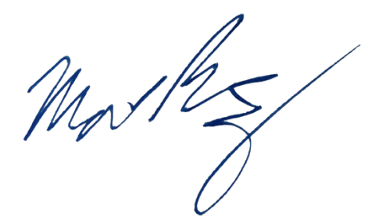
Sincerely,

Matthew Ramsey
Associate Professor, University of Louisville School of Dentistry
Chair, ULSD Research Committee

