Travel Expense Claim
35th Challenge in Infectious Diseases, Engelberg, 16-18 January 2026

Last and first Names: Matthew Ramsey
Institution: University of Louisville, School of Dentistry

Reason of payment: Invited speaker | Reimbursement by bank transfer up to $ 3’500
Travel (please enclose numbered receipts): | Currency & Amount | (will be completed by SAFE-ID)  $
Receipt 1……United Airlines…………….  Receipt 2………………………………………….  Receipt 3………………………………………….  Receipt 4………………………………………….  Receipt 5…………………………………………. | $1052.82 USD
TOTAL: | Currency & Amount | $

Bank information:
Account holder name: Matthew Ramsey
Account holder address: 609 West Saint Catherine Street, Louisville, KY, USA 40203
Name of bank: L&N Federal Credit Union
Bank address: 200 West Chestnut Street, Louisville, KY, USA, 40203
Subaccount / Comment: Checking
Account number: 120132000408570129
IBAN / routing Nr. / ABA Nr.: 283079227
SWIFT/BIC:

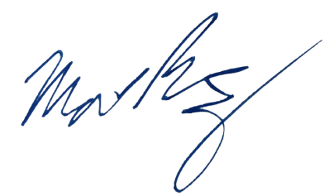
Date, City: January 29, 2026

Signature:

Please bring the completed and signed form with you to Engelberg. The payment will be done shortly after the meeting or email a scan to secretary@safe-id.ch

