 Department of Oral Immunology and Infectious Diseases

Fisher Scientific

December 17, 2024

I, Matthew Ramsey, on behalf of the University of Louisville School of Dentistry (the “Institution”) with Fisher Scientific Company L.L.C. (“Fisher Scientific”) business account number 092944038 acknowledge that access to the Fisher Scientific New Lab Start-Up Program, including the product promotions offered, is being provided to the Institution based on the representations and certifications provided in this letter. By signing this letter, the Institution certifies and agrees it will not seek reimbursement for product purchases made through this program from any government funded healthcare program. This letter serves as confirmation that this laboratory and its personnel are focused on primary research in oral microbiology, specifically the in vitro study of health-associated oral bacteria, and are removed from the provisions of health care services to patients which include but are not limited to clinical trials, patient care, patient treatment, and patient diagnosis and do not purchase, lease, recommend, use, arrange for purchase or lease thereof, or prescribe medical products. Furthermore, this letter serves to confirm that lab personnel (i) are not healthcare professionals such as, but not limited to, individuals licensed to practice medicine, and (ii) will not share or recommend product purchased through this program with healthcare professionals. Additionally, purchasing support for this laboratory and its research are entirely separate from any purchasing conducted for clinical or patient care purposes.
I, the undersign, represent and warrant to Fisher Scientific following due inquiry, at the time of signing this letter, the information set forth is complete and accurate, and I am duly authorized to execute this letter and have the authority to legally bind the Institution regarding the subject matter herein.

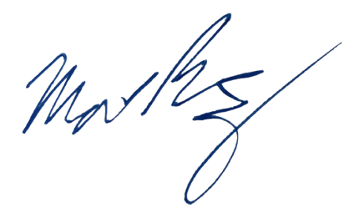
Sincerely,

Matthew Ramsey
Associate Professor, University of Louisville
December 12, 2024
Matthew.ramsey@louisville.edu

