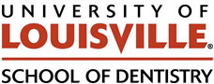 Department of Oral Immunology and Infectious Diseases

June 20, 2024

To whom it may concern:

This letter concerns the upcoming promotion and tenure decision for Dr. Fata Moradali, currently an Assistant Professor in the Department of Oral Immunology and Infectious Diseases (OIID) in the University of Louisville School of Dentistry (ULSD). OIID has formed an Internal Review Committee (hereafter “the committee”) composed of myself, Dr. Matthew Ramsey as chair, Drs. David Scott, and Gill Diamond. The committee’s review of Dr. Moradali is based on the performance criteria put forth in the “ULSD Faculty Personnel Document” which is an appendix to the ULSD Faculty Governance Document and Bylaws. It is the committee’s pleasure to enthusiastically and unanimously support Dr. Moradali for tenure and promotion to Associate Professor.

Dr. Moradali has been assigned a work plan consisting of Teaching (28%), Scholarship (70%), and Service (2%). Dr. Moradali has had a performance review 4 times in the years 2021-2024. Dr. Moradali’s performance is evaluated in comparison to the University of Louisville “Redbook” Minimum Guidelines. We note that in each category, Dr. Moradali has performed at standards ranked as “Satisfactory” or better in all criteria in each year of review.

Specifically, for Teaching, Dr. Moradali has ranked as “Excellent” in 2022 and 2024 and started as the lead instructor and organizer for the Oral Microbiology Course (OIID 604) in 2022 to present. During this time Dr. Moradali has substantially updated the course to modernize and foster more interaction between the Research and Dental Training arms of ULSD. They also have served as an instructor for MBIO 624 in 2022, and MBIO 622 in 2023-2024. Additionally, they have completed the Provost’s 6-month Seminar on Teaching for New Faculty (STNF) program in 2022-23 continue as the lead instructor for OIID 604 through the present. In addition to these classroom duties, Dr. Moradali has served as a direct mentor for several summer students, postdocs, and staff hires. For Service, Dr. Moradali has ranked “Satisfactory” for 2021-24 and serves on several committees at ULSD and has served in peer review for multiple high impact journals.

For Scholarship, Dr. Moradali has been ranked as “Excellent” in 2021-24, and has won multiple competitive peer-reviewed NIH awards to fund their lab. Much of Dr. Moradali’s initial focus on Scholarship has been oriented towards establishing a well-funded research lab, culminating in an NIH R03 awarded in 2022 and a more recent NIH R01 in 2024. Dr. Moradali’s Scholarship focus is now transitioned towards publication of data generated from these awards and they have published 3 peer-reviewed manuscripts as corresponding author during their time at ULSD, and 2 other manuscripts as primary or secondary author and 1 book chapter. Each manuscript has been published in well regarded journals at a high level in their respective fields with impact scores of 4.4 – 7.6. This work has established already Dr. Moradali’s place in the oral microbiology field at a very early career stage. The committee realizes that publication output for Dr. Moradali is thus far modest yet notes that Dr. Moradali began their lab at the height of the COVID-19 pandemic, slowing the start to staffing and supply critical for initial lab productivity. As a result, Dr. Moradali focused heavily on obtaining extramural funding which has been extremely successful and shows exceptional progress. Despite these initial limitations Dr. Moradali now has a well-funded and fully staffed laboratory and will be submitting two more publications during July / August of 2025.

The committee has also evaluated Dr. Moradali’s extramural reviewers, verifies that they are experts in their field with relevant expertise to adequately evaluate Dr. Moradali’s career progress, and are objective and unbiased reviewers. These reviewers gave a very strong recommendation to support the promotion and tenure of Dr. Moradali, one with which this committee agrees wholeheartedly.

It is this committee’s pleasure to recommend Dr. Moradali’s immediate promotion and tenure. We report our votes for Dr. Moradali’s promotion and tenure as: Dr. Ramsey (approve), Dr. Scott (approve), Dr. Diamond (approve).

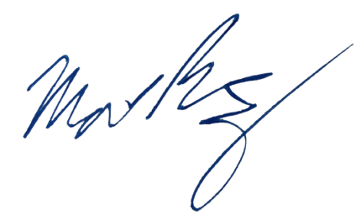
Sincerely,

Matthew Ramsey
Associate Professor, University of Louisville School of Dentistry
Department of Oral Immunology and Infectious Diseases
Internal Review Committee Chair

David Scott
Professor, University of Louisville School of Dentistry
Department of Oral Immunology and Infectious Diseases

Gill Diamond
Professor, University of Louisville School of Dentistry
Department of Oral Immunology and Infectious Diseases

