Standard Operating Procedure (SOP)
CARCINOGENS
CASRN: View specific chemical SDS
DANGER
View specific chemical SDS for complete hazard details.
Toxic if inhaled, swallowed or in contact with skin; may cause cancer;
suspected of causing genetic defects.
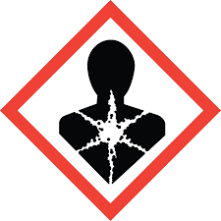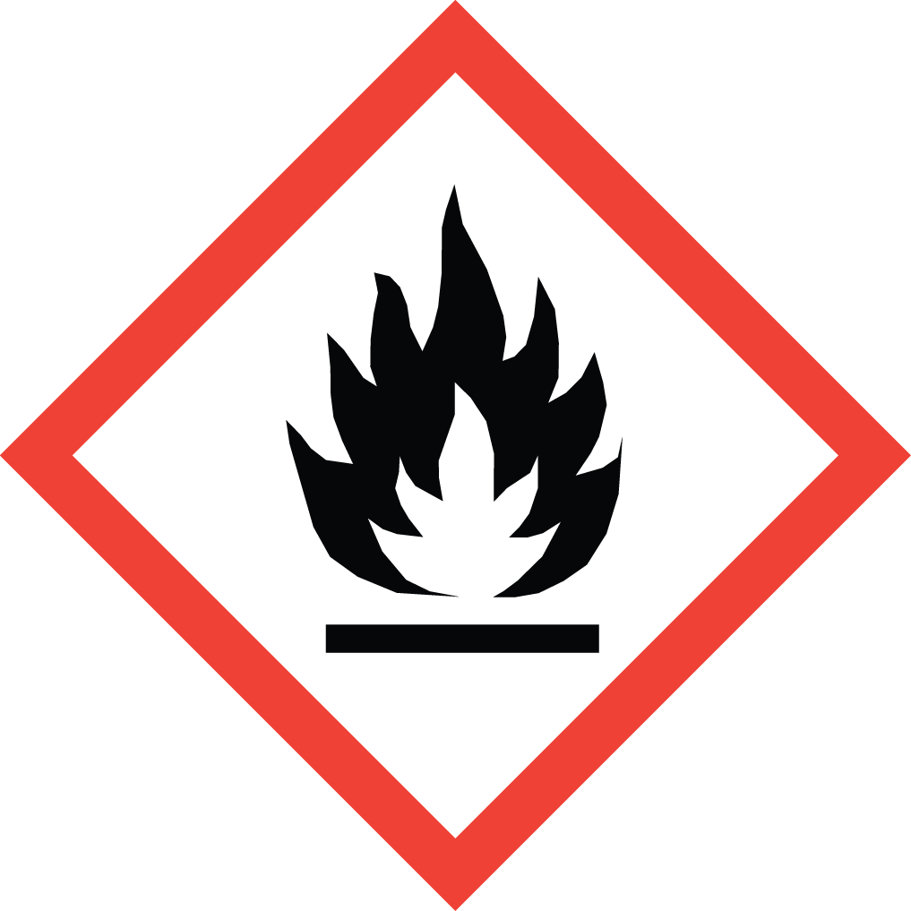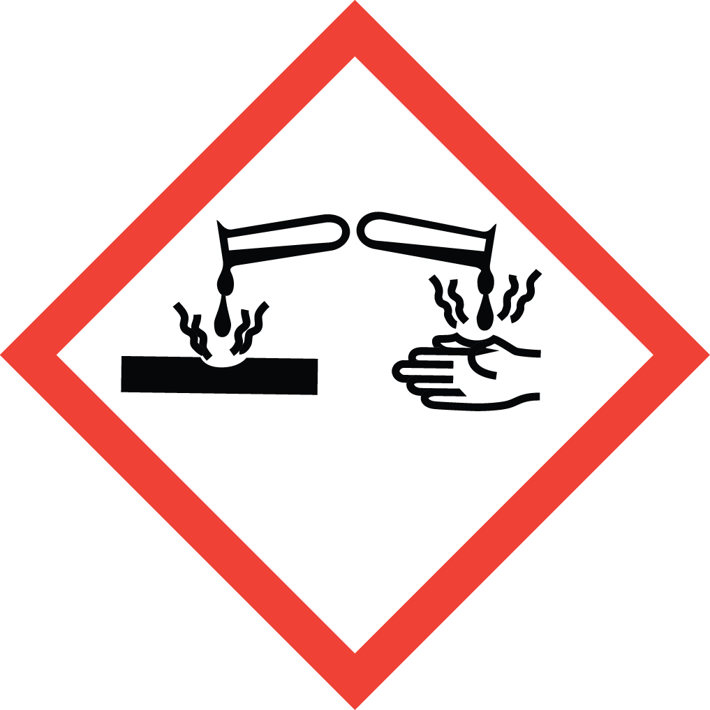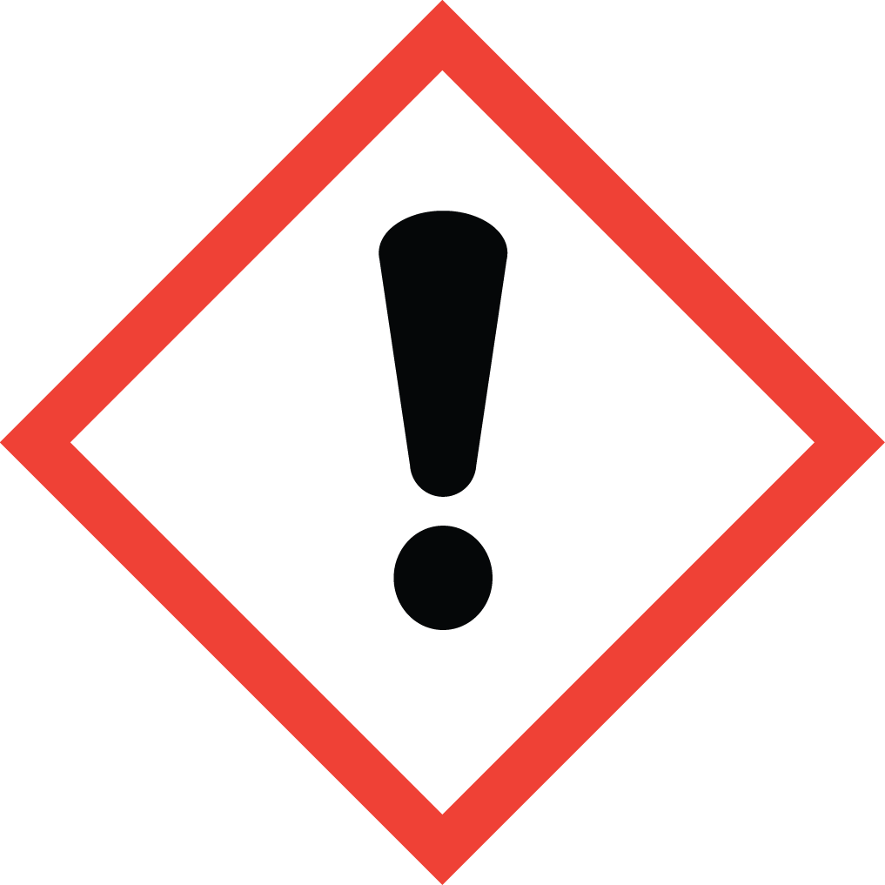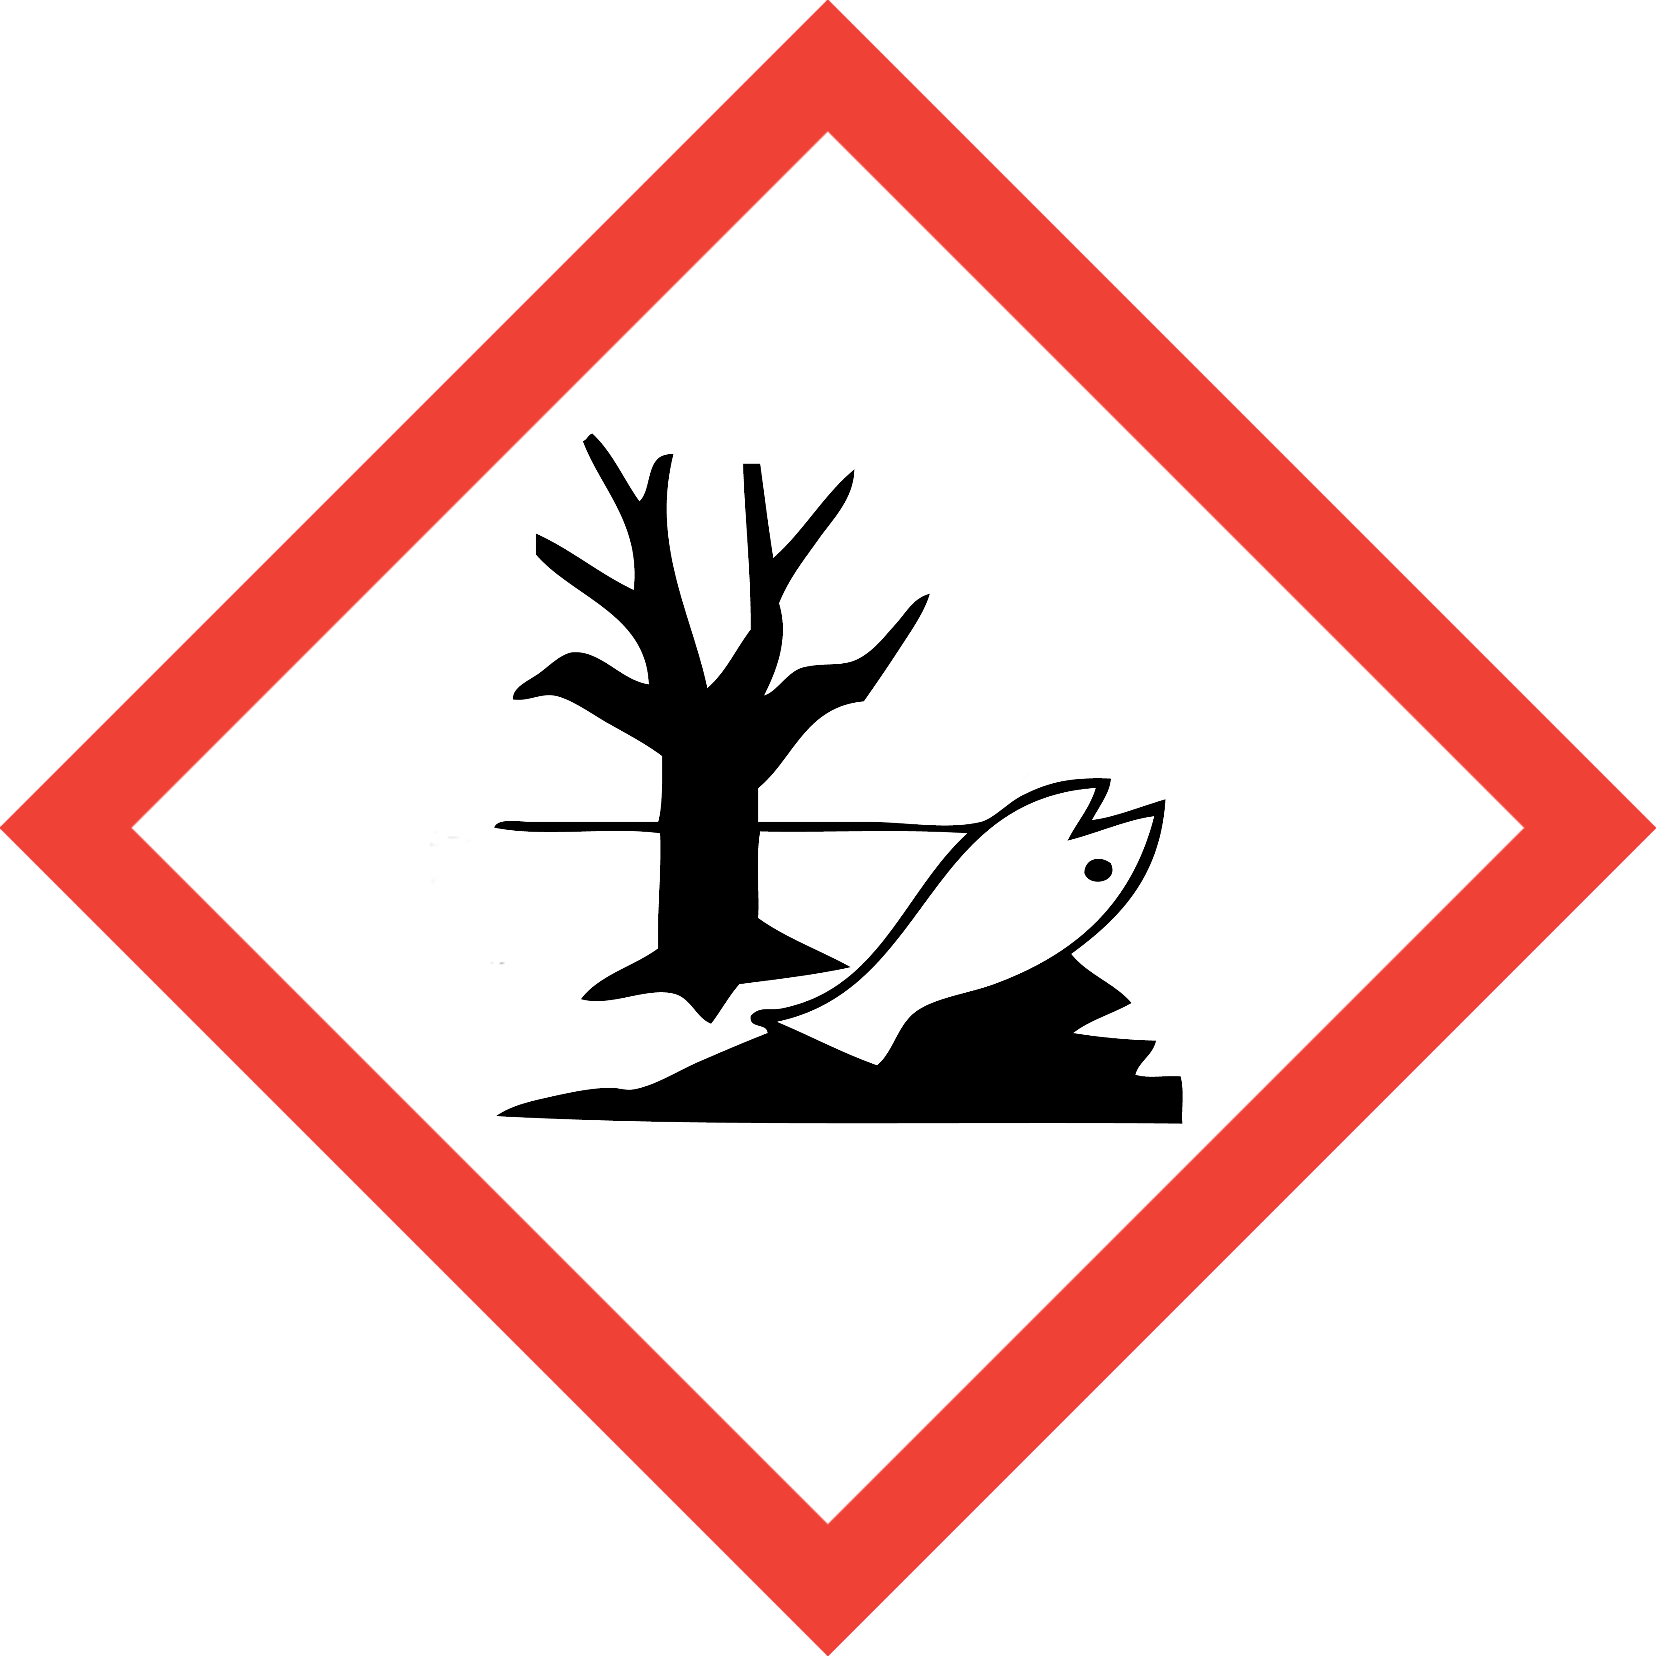
This is an SOP template and is not complete until:
1) Lab specific information is entered into Section 1
2) Lab specific protocol/procedure is added to Section 8 and,
3) Section 9, SOP has been signed and dated by the PI and relevant lab personnel.

Upload PI approved and signed SOP into SciShield PI Lab Web Page, Documents Section.
Print a copy and insert into your Laboratory Chemical Hygiene Plan.
Section 1 – Lab-Specific Information
Building/Room(s) covered by this SOP: | School of Dentistry, Rooms 341, 342, 343
Department | Oral Immunology and Infectious Diseases
Principal Investigator | Matthew M. Ramsey PhD
Principal Investigator Phone | 502.852.8304
Date SOP written, approved by PI | 6/12/2025
Lab Manager | Click or tap here to enter text.
Lab Phone
Emergency Contact & Phone Number | Kathryn Ramsey 603-557-2207

Lab Specific Carcinogen(s) covered by this SOP:
Lab personnel should purchase carcinogen chemical in smallest container size practical.
Chemical name | CAS Number | Target Organ(s) | Additional Specific hazard info and/or decontamination/clean up instructions
Chloramphenicol | 56-75-7 | Serious eye damage (Category 1), H318  Carcinogenicity (Category 2), H351  Reproductive toxicity (Category 2), H361 | Control Parameters: 0.5 mg/m3  Personal protective equipment  Skin protection  This recommendation applies only to the product stated in the safety data sheet,  supplied by us and for the designated use. When dissolving in or mixing with other  substances and under conditions deviating from those stated in EN 16523-1 please  contact the supplier of CE-approved gloves (e.g. KCL GmbH, D-36124 Eichenzell,  Internet: www.kcl.de).  Full contact  Material: Nitrile rubber  Minimum layer thickness: 0.11 mm  Break through time: 480 min
(PI/Authorized PI Lab Manager: add more rows as needed)
Section 2 – Potential Hazards/Toxicity
CARCINOGENS listed specific chemical(s) current manufacturer-specific Safety Data Sheet (SDS) must be available and reviewed by lab personnel prior to use.
CARCINOGEN compounds are chronic toxins with long latency periods that can cause damage after repeated or long duration exposures and often do not have immediate harmful effects. Users can be exposed to these compounds through inhalation, ingestion, and/or dermal absorption.
CARCINOGENS covered under this SOP are defined as solid and liquid materials, regulated by OSHA as a carcinogen, as follows:

- Listed under the category, “known to be carcinogens,” in the Annual Report on Carcinogens published by the National Toxicology Program (NPT) latest edition (check SDS Section 11).

- Listed under Group 1, “carcinogenic to humans” by the International Agency for Research on Cancer Monographs (IARC) latest edition (check SDS Section 11).

- Listed in either Group 2A or 2B by IARC or under the category, “reasonably anticipated to be carcinogens” by NTP (check SDS Section 11).

- GHS Carcinogencity Category 1, 1A, 1B, or 2 (check SDS Section 2.1)

- If you are still unsure if your chemical is classified as a CARCINOGEN contact DEHS at 852-6670 for assistance.
CARCINOGEN compressed gas cannot be included under this SOP. Contact DEHS at 852-6670 for separate required SOP assistance.
Section 3 – Engineering Controls and Personal Protective Equipment (PPE)
- Engineering Controls: Use of CARCINOGENS must be conducted in a properly functioning chemical fume hood. Chemical fume hoods must be approved and certified annually by DEHS and have a face velocity between 80 – 120 feet per minute (fpm).
- Hygiene Measures: Avoid contact with skin, eyes, and clothing. Wash hands before breaks and immediately after handling the product.
- Hand Protection: Nitrile gloves. Gloves must be inspected prior to each use. Use proper glove removal technique (without touching outer surface of the gloves) to avoid skin contact with CARCINOGENS on the contaminated gloves. Dispose of gloves after use into medical waste box labeled for incineration. Wash hands thoroughly with warm water and soap.
- Eye Protection: ANSI-approved properly fitting safety glasses or chemical splash goggles are required.
- Skin and Body Protection: A chemical resistant lab coat shall be worn at a minimum. The lab coat must be appropriately sized for the individual and securely closed to its full length. Personnel must also wear full length pants, or equivalent, socks, and close-toed and closed-heeled shoes.
- Respiratory Protection: CARCINOGENS should not be opened or administered outside of a chemical fume hood; therefore, respiratory protection should not be required. If work with CARCINOGEN cannot be conducted within a chemical fume hood, or other ventilated enclosure, contact DEHS at 852-6670 for a safety assessment.
Section 4 – First Aid Procedures
  - Personnel exposure should be reported to PI immediately. For assistance contact UofL Campus Health at 502-852-2402 or preferred physician for medical advice regarding possible long-term health effects and potential recommendation for medical monitoring. PI shall also report any exposure incident to DEHS at 502-852-6670.
If inhaled: Call 502-852-6111 if victim is unconscious or not breathing. Move to fresh air. If the person is not breathing, give artificial respiration. Avoid mouth to mouth contact.
In case of skin contact: Call 502-852-6111 or consult physician. Immediately (within seconds) flush affected area for at least 15 minutes. Remove contaminated clothing and shoes. Place clean blanket around victim.
In case of eye contact: Call 502-852-6111 or consult physician. First check the victim for contact lenses and remove if present. Flush eyes with water for 15 minutes then transport patient immediately to hospital.
If swallowed: Call 502-852-6111 or consult physician. Do not induce vomiting. Rinse mouth with water. Never give anything by mouth to unconscious person.
Section 5 – Special Handling and Storage Requirements
- CARCINOGENS and working solutions containing CARCINOGENS must be clearly labeled to describe contents and hazards.
- When in use, there shall be an established, designated area for CARCINOGENS (i.e. tape of area of bench where CARCINOGENS will be used, post signage, etc ).
- When not in use, CARCINOGENS and working solutions must be securely stored.
- Access and use of CARCINOGENS must be restricted to PI-authorized lab personnel who are current on DEHS Lab Safety and Hazardous Waste training and have read, understand, and been trained on this SOP as well as any other lab-specific procedure involving use of this chemical.
- A current copy of the CARCINOGENS Safety Data sheet (SDS) must be available at all times to personnel working in the laboratory.
- Do not work with CARCINOGENS alone. Lab buddy system is highly recommended.

Section 6 –Spill and Accident Procedures; Decontamination
  - Report any spills of CARCINOGENS to DEHS immediately. If there is an imminent threat to building occupants, pull the nearest fire alarm station to evacuate the building and call 502-852-6111. If personnel have become exposed and need medical assistance, call 502-852-6111.
Clean up all spills immediately. ensure others are aware of the release of CARCINOGENS outside of the chemical fume hood or other ventilated enclosure.
- Avoid breathing vapors and contact with skin and eyes. Wear protective clothing, rubber gloves and safety glasses.
- Wipe up and absorb small quantities with vermiculite or other absorbent material. Place spilled clean up materials in lab chemical solid waste container or plastic bag marked as “Hazardous waste CARCINOGENS – Carcinogen + any other known physical or health hazard “, securely close container and submit for DEHS chemical waste pick up.
  - Decontaminate any surfaces that may have contacted CARCINOGENS with detergent, such as Alconox or soap and water.
Section 7 – Waste Disposal Procedures
Label Waste

- Collect CARCINOGENS containing liquid waste in a container not to exceed 1 gal. Waste collection container must have a closeable lid (i.e. screw top cap) and marked as “Hazardous waste CARCINOGENS –Carcinogen + any other known physical or health hazard“ and submit for DEHS chemical waste pick up.
- CARCINOGENS contaminated sharps (syringe, needle, pipette tips, glass slides) shall be disposed in a puncture resistant sharps container and discarded into medical waste box to be destroyed by incineration (Stericycle Yellow QR code label) .
- CARCINOGENS contaminated PPE (gloves, paper towels) and contaminated labware (i.e. well-plates) shall be discarded into medical waste box to be destroyed by incineration (Stericycle Yellow QR code label) .
- Unwanted or expired containers of CARCINOGENS must be submitted for DEHS chemical waste pick up.

Store Waste
- Store properly labeled hazardous waste closed containers in a designated location within the lab.
- Best management practice (BMP) is to store hazardous waste containers in secondary containment (i.e. polyethylene tray, do not use styrofoam).
- Waste must be under control of the person generating the waste and stored at or near the process generating the waste (i.e. kept in the same lab or assigned pod).

Dispose of Waste
- CARCINOGENS is prohibited from sink disposal or discard into trash. Submit waste containers of CARCINOGENS for pick up by DEHS via online University hazardous waste management system Chematix https://louisville.chematix.com/Chematix/Login.
- If you have never used Chematix, contact DEHS at 852-6670 or chematix@louisville.edu for further assistance and training.
- For existing users of Chematix, Quick Reference Guides and Videos are available at https://louisville.edu/dehs/waste-disposal

Section 8 – Description of Lab-Specific Procedures
NOTE: Any deviation from this SOP requires approval from Principal Investigator.
Chemical Security:
Consult the above instructions. Note Eyewash stations near sink in Rms 341, 343. Verify access to eyewash is unobstructed before using chemicals. Verify presence of spill kit in Rm 341 before using chemicals.

Controlling Exposure:
Areas where Chloramphenicol is used will be marked with the following:
Danger
Chloramphenicol
Potential Cancer Hazard
Authorized Personnel Only

Experimental Procedure:
None detailed, standard PPE (barrier coat, eye protection and nitrile gloves) are adequate for handling this substance.

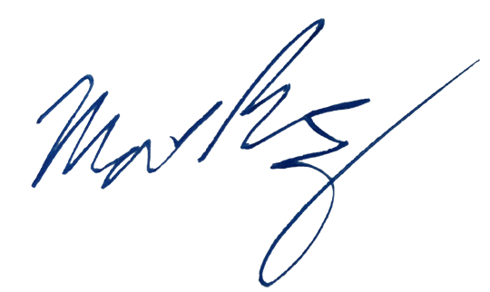
Section 9 – Documentation of Training (signature and training date of all users is required)
Principal Investigator SOP Approval
Print name ____Matthew Ramsey______________ Signature______________________________
Approval Date: __06/12/2025_________________
MM/DD/YYYY
Prior to conducting any work with CARCINOGENS listed in Section 1 of this SOP the Principal Investigator must ensure that all laboratory personnel receive training on the content of this SOP and have read and understand this SOP and are aware of chemical specific hazard(s) and how to minimize their risk of exposure to themselves and others.
I have read and understand the content of this SOP:
Name | Signature | Date
Alex Labossiere |  | 6/13/2025
Click or tap here to enter text.
Click here to enter text. |  | Click here to enter a date.
Click here to enter text. |  | Click here to enter a date.
Click here to enter text. |  | Click here to enter a date.
Click here to enter text. |  | Click here to enter a date.
Click here to enter text. |  | Click here to enter a date.
Click here to enter text. |  | Click here to enter a date.
Click here to enter text. |  | Click here to enter a date.
Click here to enter text. |  | Click here to enter a date.

