Recruiting volunteers for a study of the healthy oral microbiome!

The laboratory of Dr. Matthew Ramsey in the Department of Oral Immunology and Infectious Diseases in the School of Dentistry is seeking volunteers to help us with a research study investigating interactions between oral microbes associated with good health!

Our laboratory is developing an oral plaque bacterial cultivation model for research into ways to prevent or reverse oral infections. We are seeking volunteers to donate saliva and/or supragingival plaque samples.

Saliva sampling will take approximately 10-15 minutes. Plaque sampling will take approximately 5-10 minutes. Volunteers can provide either one or both types of samples at their discretion.

There are no reasonable risks or discomfort associated with either sampling. No compensation is given for volunteers to sample. No penalties of any kind exist for volunteers to remove themselves from the study. There are no expected benefits for participating this study. All sampling is non-invasive.

Healthy volunteers are requested between the ages of 18-65 years old. Volunteers must be in good oral health, not currently undergoing a known infection, and not have been on antibiotics in the previous 6 months.

Please contact Dr. Ramsey if you are interested / want more information!
Contact Information: Matthew Ramsey PhD
matthew.ramsey@louisville.edu
School of Dentistry, 501 S Preston St. Room 341
Phone: (502) 852-8304
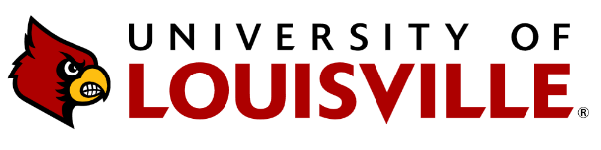
IRB #: 24.0794

