University of Louisville - School of Dentistry

Faculty (Research) Annual Work Plan

1. NAME (Last, First, Middle)  Ramsey, Matthew, Mark | 2. RANK  Associate | 3. CLASSIFICATION  Professor
4. DEPARTMENT  OIID | 5. PERIOD OF EVALUATION  FROM: 1/1/2026 | TO: 12/31/2026

1. Teaching | Projected % Effort : 15
A. List course titles and catalog number for which you will be Course or Co-Course Director:

None for director or codirector, I have been asked to and agreed to lecture at least once each for OIID604 and OIID??? (Gill’s Immunology course)

B. Estimate the number of hours of lectures that you will give per week:
Spring __0.25____
Summer ___0___
Fall __0.25____

C. List any student and postdoc advising, monitoring, or mentoring activities (estimate hours per week of direct contact):
Spring __10____
Summer __10____
Fall ___10___

D. List any other planned teaching activities (e.g. mentoring postdocs, junior faculty, summer research students or graduate students).

- I plan once weekly meetings with my incoming technician for 2h. I also have 30m-1h checkins a few times a week in the lab to review notebooks or to assist in experimental design, data interpretation or review of manuscript / dissertation preparation.

Chair recommendations:

2. Research, Scholarship and Creative Activity | Projected % Effort: 60
A. Describe any major changes (additions or subtractions) to your ongoing research, scholarship and teaching activities

- No major changes are planned. My PhD student graduated, but I am hiring one full time and one part-time technician (planned) and they will roughly occupy the same amount of hands-on time.

B. List grant submissions planned for upcoming year, target cycle, and role

NIDCR R21 – Cycle 1 or 2, sole PI
NIDCR R21/01 – Cycle 2 or 3, co-Investigator (K. Jasmer PI)
NIDCR R01 – Cycle 2 or 3, co-PI (if current (Oct 2025 submission) R01 proposal is not funded this will be the resubmission)

C. List any other new planned research, scholarship or creative activities, invitations to serve on review panels, invitations to speak at conferences, and invited editorships

Chair recommendations:

3. Service |  | Projected % Effort: 25
A. ULSD Service/Committee Assignments (indicate leadership roles and hours per month average)

-ULSD Research Committee – Chair – 3h/mo
-MS-Oral Biology Committee for Jacob Spencer – Member, Gill Diamond, Chair – 0.75h/mo
-PhD-Microbiology Committee for Sofia Douglas – Member, Gill Diamond, Chair – 0.75h/mo

B. University Committee Assignments (indicate leadership roles and hours per month average)

-Sequencing Technology Steering Committee – Member – 0.5h/mo

C. Regional/National/International Professional Organizations (indicate leadership roles and hours per month average)

-Journal of Oral Microbiology, Associate Editor. 8h per month.

D. Community Service /Engagement (teaching/advising/consulting outside of ULSD)
- Invited Lecturer, Harvard School of Dental Medicine. ORB601 – Oral Microbiology
1 lecture per year.

Chair recommendations:

4. Administration |  | Projected % Effort: 0
A. List all administrative commitments and hours per week needed to perform task(s). These are appointed by the Dean or Department Chair.

FACULTY | DEPARTMENT CHAIR
Matthew Ramsey 12/3/25  _________________________________________  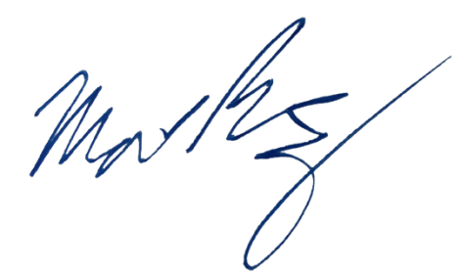  Signature of Faculty Date | _________________________________________  Signature of Department Chair Date
Name and Title of Department Chair

Richard J. Lamont
Professor

ADMINISTRATION
_____________________________________________
Signature of Dean Date

