University of Louisville - School of Dentistry

Faculty (Research) Annual Work Plan

1. NAME (Last, First, Middle)  Ramsey, Matthew, Mark | 2. RANK  Associate | 3. CLASSIFICATION  Professor
4. DEPARTMENT  OIID | 5. PERIOD OF EVALUATION  FROM: 1/1/2025 | TO: 12/31/2025

1. Teaching | Projected % Effort : 20
A. List course titles and catalog number for which you will be Course or Co-Course Director:

B. Estimate the number of hours of lectures that you will give per week:
Spring __0____
Summer ___0.25___
Fall __0.25____

C. List any student and postdoc advising, monitoring, or mentoring activities (estimate hours per week of direct contact):
Spring __5____
Summer __5____
Fall ___10___

D. List any other planned teaching activities (e.g. mentoring postdocs, junior faculty, summer research students or graduate students).

- I have once weekly meetings with my trainee (1 presently, at least 1 expected during the year to be added) for 2h. I also have 30m-1h checkins a few times a week in the lab to review notebooks or to assist in experimental design, data interpretation or review of manuscript / dissertation preparation.

Chair recommendations: May be assigned the occasional lecture this year

2. Research, Scholarship and Creative Activity | Projected % Effort: 60
A. Describe any major changes (additions or subtractions) to your ongoing research, scholarship and teaching activities

B. List grant submissions planned for upcoming year, target cycle, and role

I plan for an R21 in the Spring 25’ cycle (with Marcelo Freire on commensals impact on innate immune signaling) , if my Winter 24’ resubmission is not funded then another R01 submission in the Summer 25’ cycle (with Jessica Mark Welch on oral commensal polymicrobial interactions) and another R21 submission in the Winter 25’ cycle (on development of a commensal focused plaque in vitro model).

C. List any other new planned research, scholarship or creative activities, invitations to serve on review panels, invitations to speak at conferences, and invited editorships

Chair recommendations:

3. Service |  | Projected % Effort: 20
A. ULSD Service/Committee Assignments (indicate leadership roles and hours per month average)

B. University Committee Assignments (indicate leadership roles and hours per month average)

C. Regional/National/International Professional Organizations (indicate leadership roles and hours per month average)

- DSR Study section standing member, 3x meetings yearly (1 in person in Oct 25’) 8h per month.
- Journal of Oral Microbiology, Associate Editor. 6h per month.

D. Community Service /Engagement (teaching/advising/consulting outside of ULSD)

Chair recommendations: May be assigned a SoD committee this year

4. Administration |  | Projected % Effort: 0
A. List all administrative commitments and hours per week needed to perform task(s). These are appointed by the Dean or Department Chair.

FACULTY | DEPARTMENT CHAIR
Matthew Ramsey 12/5/24  _________________________________________    Signature of Faculty Date | 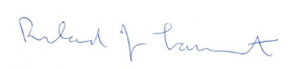5 Dec 2024  _________________________________________  Signature of Department Chair Date
Name and Title of Department Chair

Richard J. Lamont
Professor

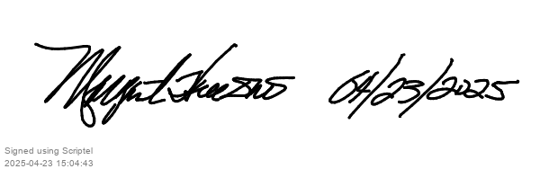
ADMINISTRATION
_____________________________________________
Signature of Dean Date

